We are using TPS54231DR in our design as step down converter with the following specifications,

VIN = 16V

VOUT = 5V

IOUT = 750 mA

We did the Pre-compliance test for conducted emission as per EN 55032 and we have the following issues.

We are facing the conducted emission failure in switching frequency and its harmonics, please refer conducted emission graph

1. With Ferrite Bead (failure in switching frequency and its harmonics)

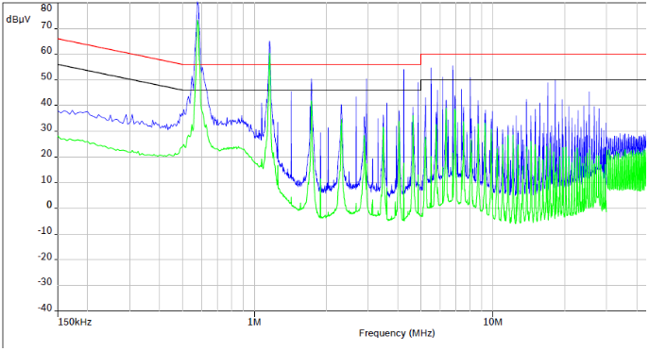

Instead of ferrite bead L6 (Marked in Round below schematic) we are using the common mode choke part number 744227 @ impedance max 5.5K in series in dual then only the conducted emission reduced below the specified range, kindly refer below graph

2. With Common mode choke Part Number 744227

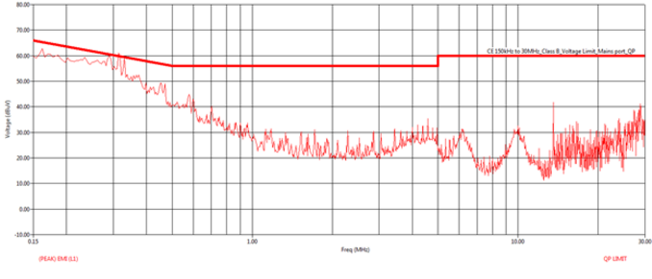

Please refer the below Schematic and kindly give the solution to reduce the conducted emission level in DC power line without using common mode choke in front of the switcher.

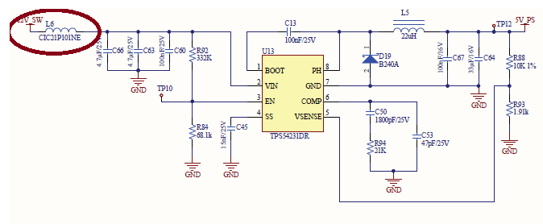

PCB Layout:

Bottom Layer:

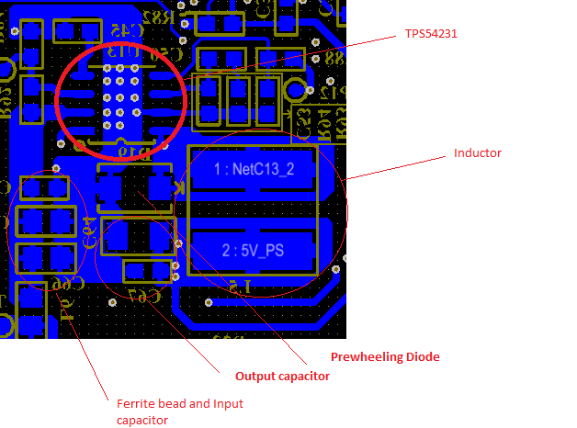

Thanks and Regards,

Arumugam.C