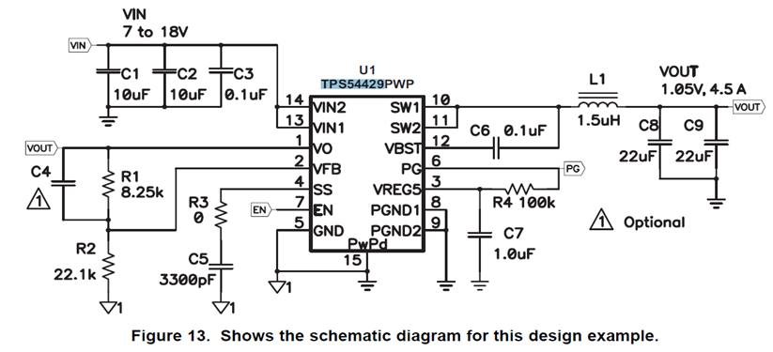

C8 = 47uF

C9 = 47uF

