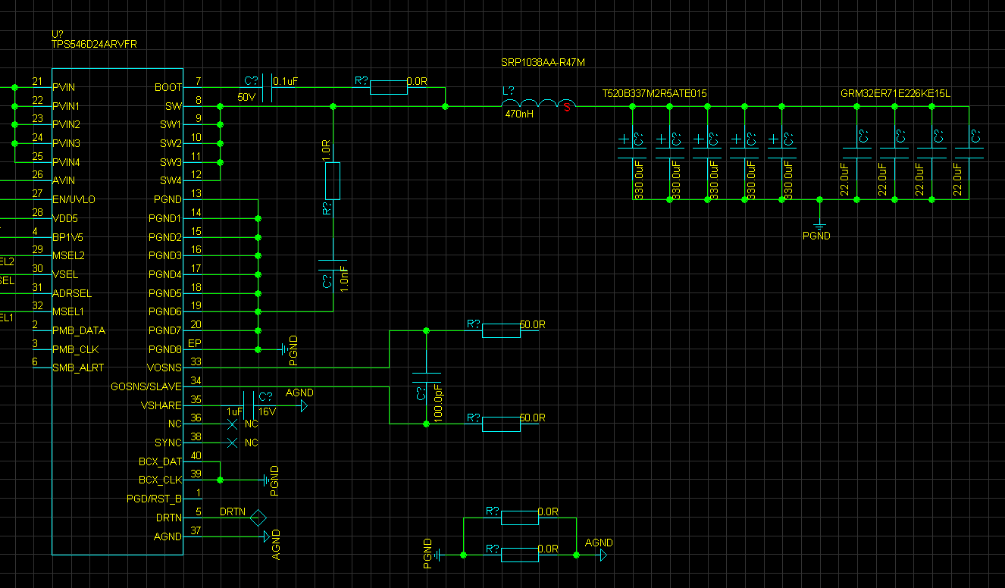TPSS564D24ARVFR – SCHEME

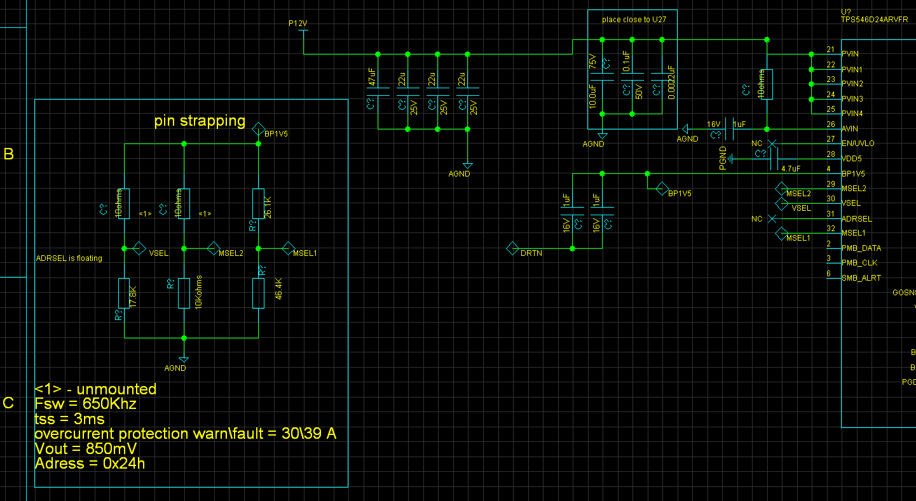

PMbus parameters

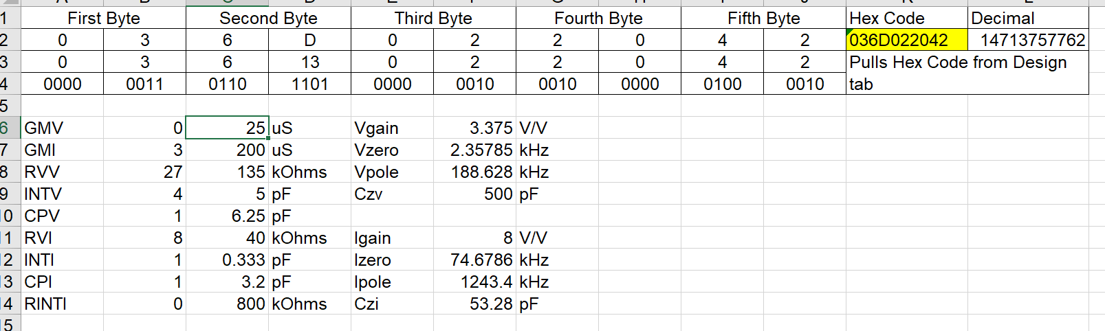

RFSOC conception –

Designed for rfsoc core voltage – XCZU47DR by xlinx.

Spec – 0.85v @ 25A static current, and 5A step load with 4A/ns slew rate ,

**The voltage should be within 850mv +-25mv**

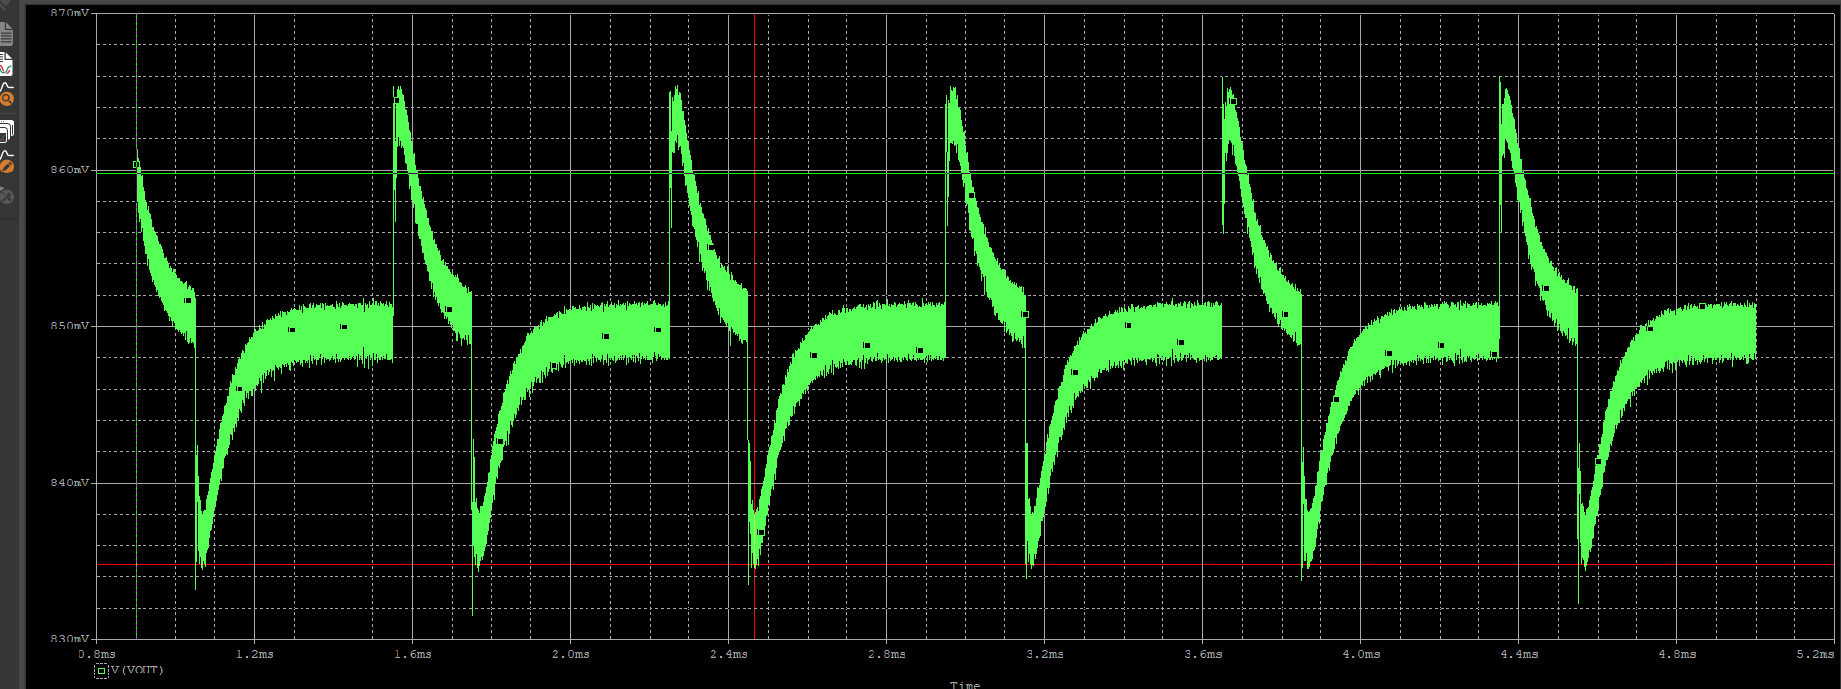

Over\under – 834mv TO 865Mv . 4mv ripple pk2pk