TOP LAYER of 6 layer board.

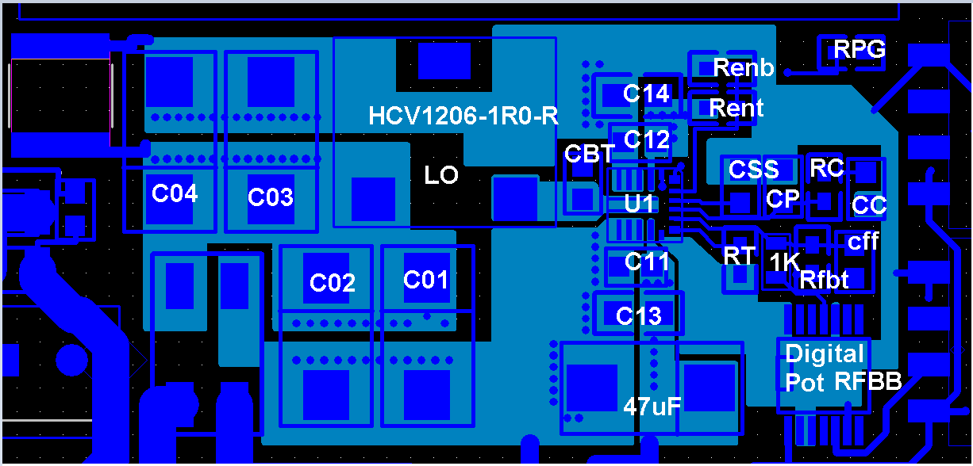

SECOND LAYER – Trace is CBOOT path, will this work if not on layer 3 as recommended? Plane is GND

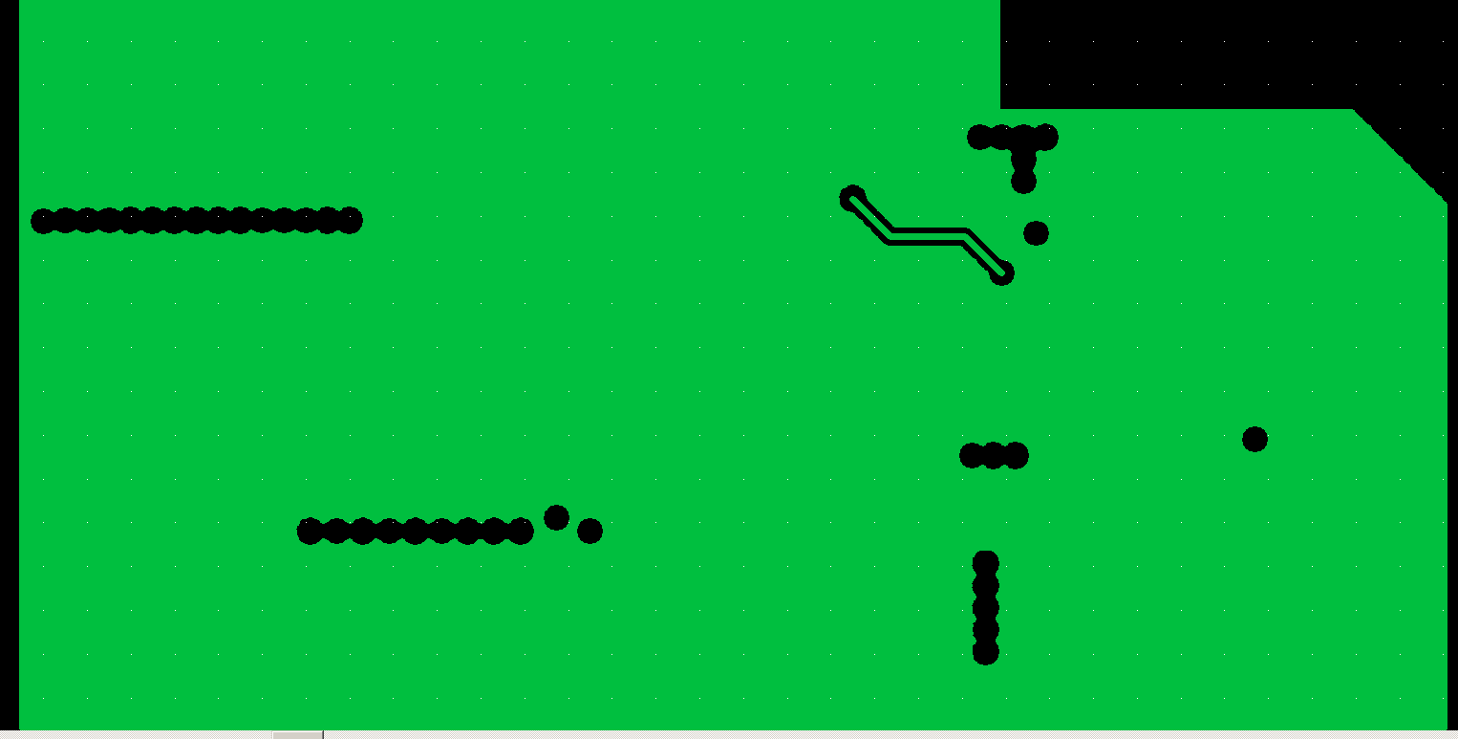

Third Layer – big flood is GND, left flood is VOUT right flood is VIN, stitching vias not showing up for some reason, but they are there...

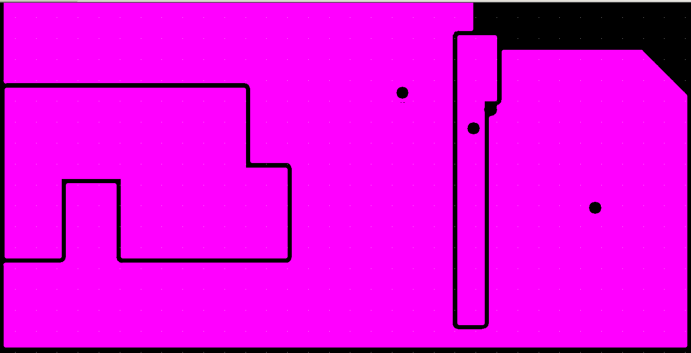

Layer 4 – Trace is FB trace Plane is GND

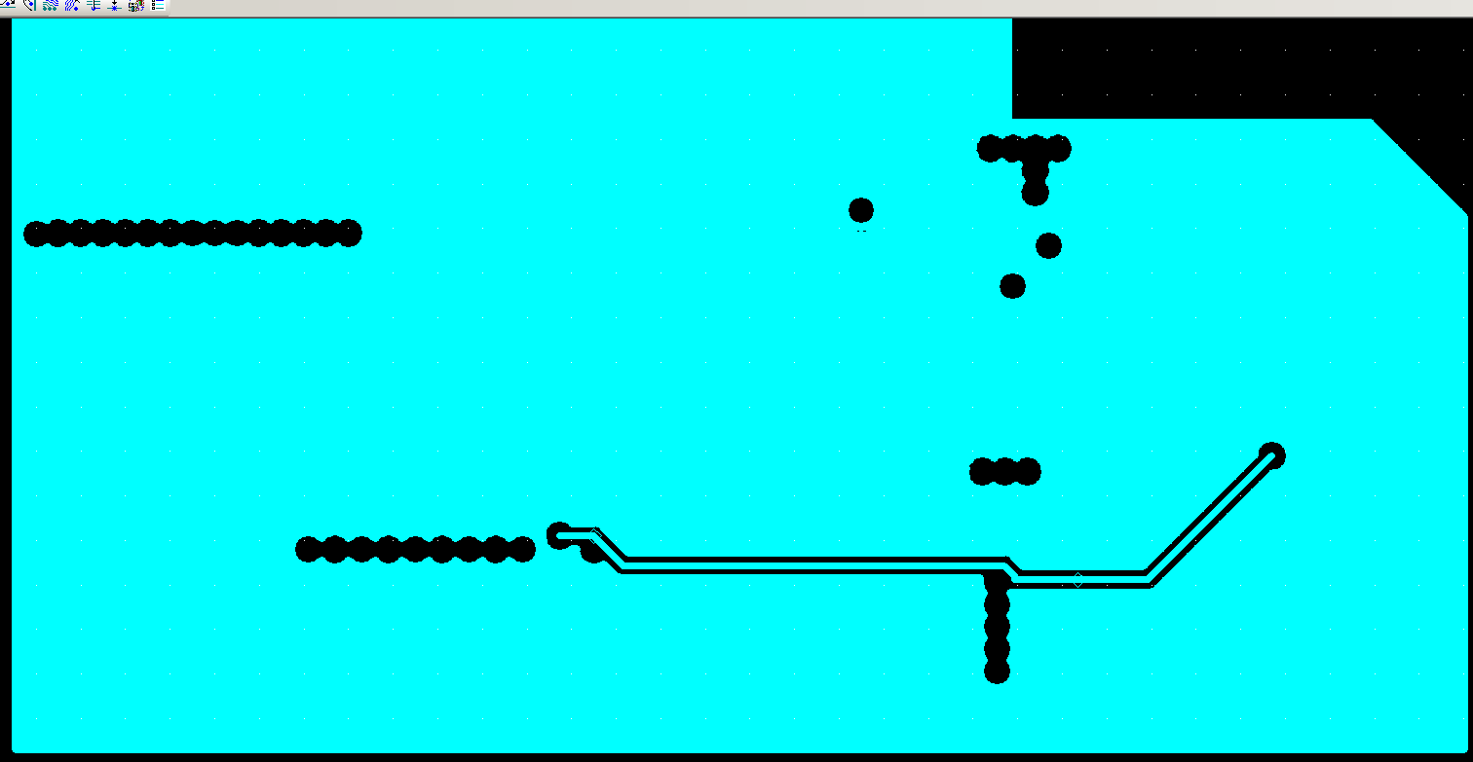

Layer 5- trace to RPG resistor, just going to use resistor pad as probe spot since no room

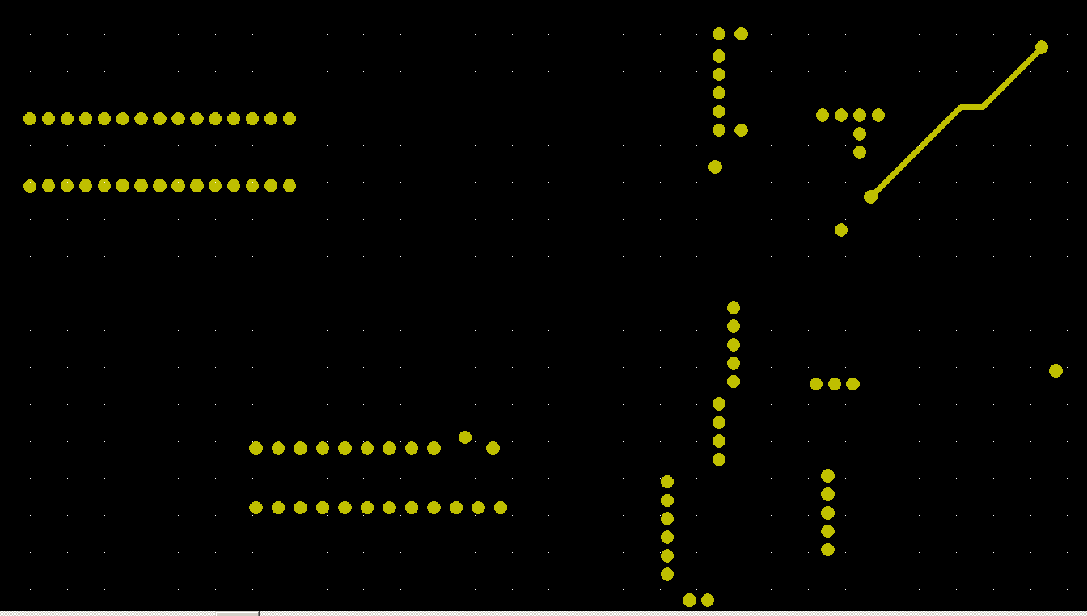

Bottom Layer- This PS drives a filament of a pulse transformer. On both VOUT and GROUND I have very large Inductors to protect the regulator from transients. There is also a common mode choke. The current is DC, so there should be no AC magnetic field from the inductor, but can it cause a potential problem since it is right there on the bottom of the board? IHLP6767GZER101M11

