Orginal SCH and PCB

This board are designed for demo and test the chip. Everything works well.(Via Size: 12mil for hole and 16mil for copper)

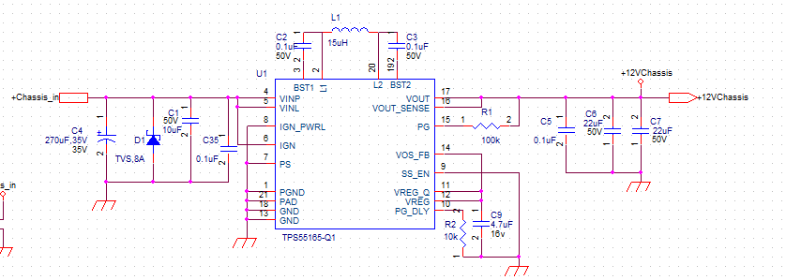

It’s a 4 layers pcb, 1Oz for each layer. (Via Size: 12mil for hole and 22mil for Copper)

Top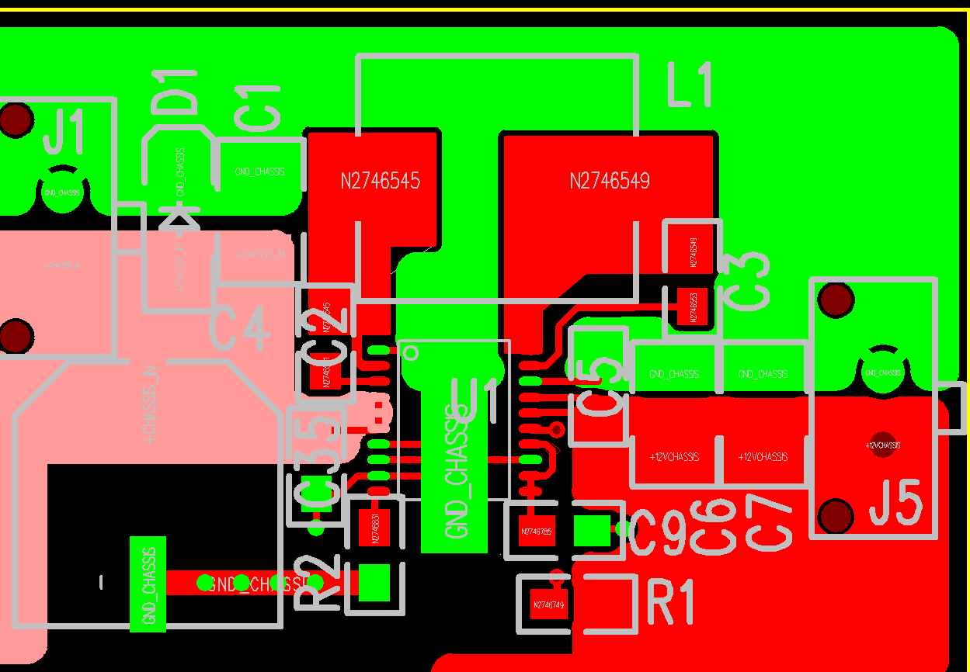

2nd Layer(GND)

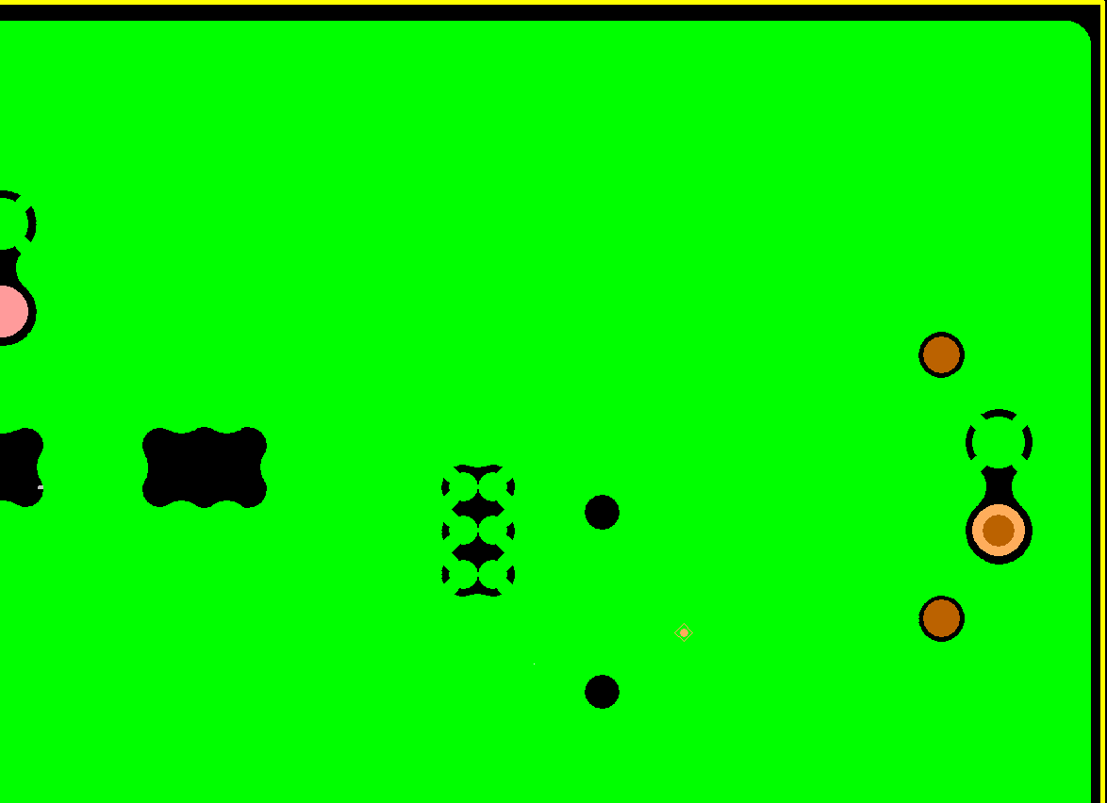

3rd Layer (Empty for this DC/DC)

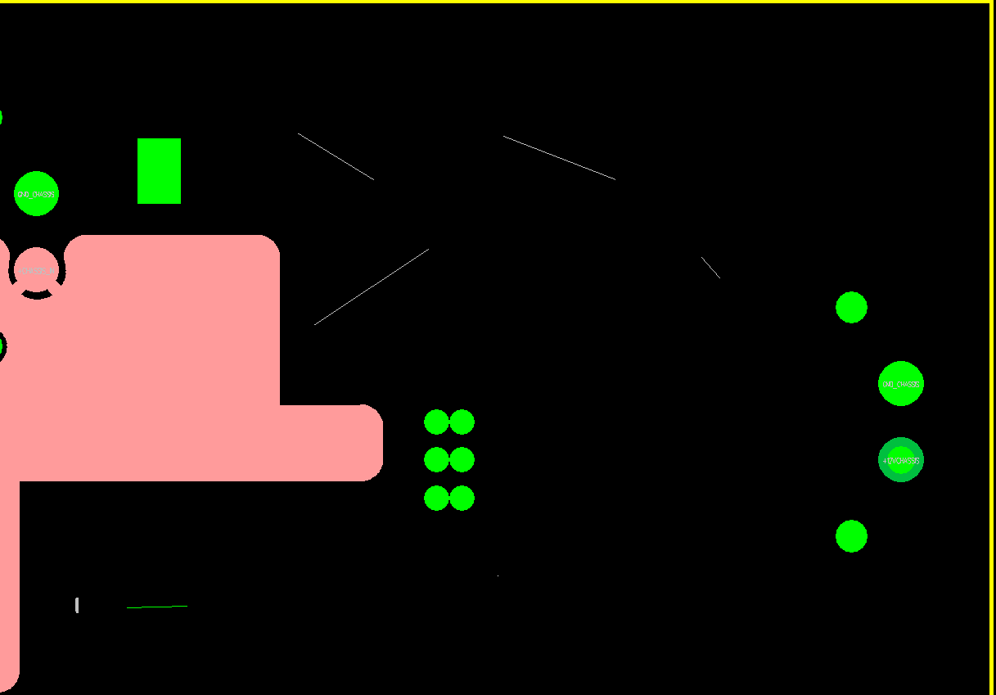

Bottom Layer (Empty for this DC/DC)

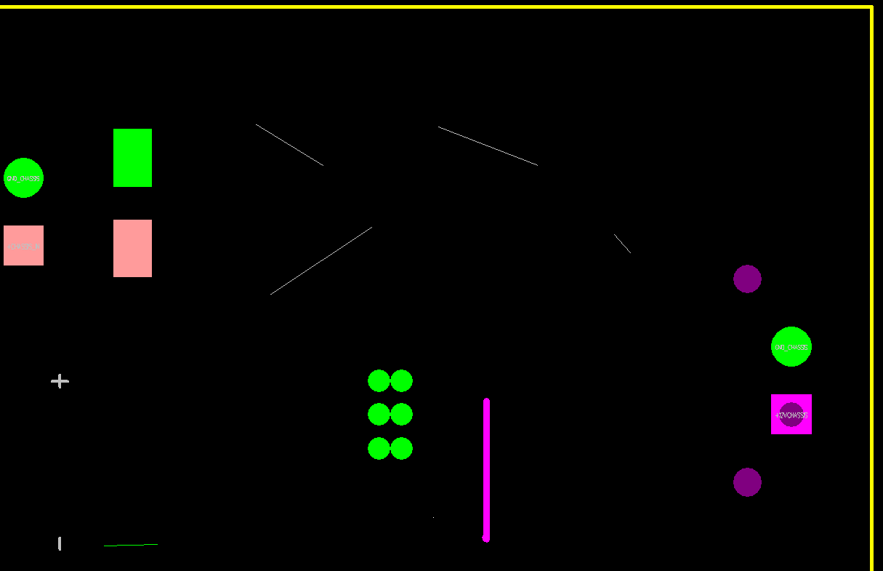

2nd SCH and PCB

This Board are designed for product prototype.

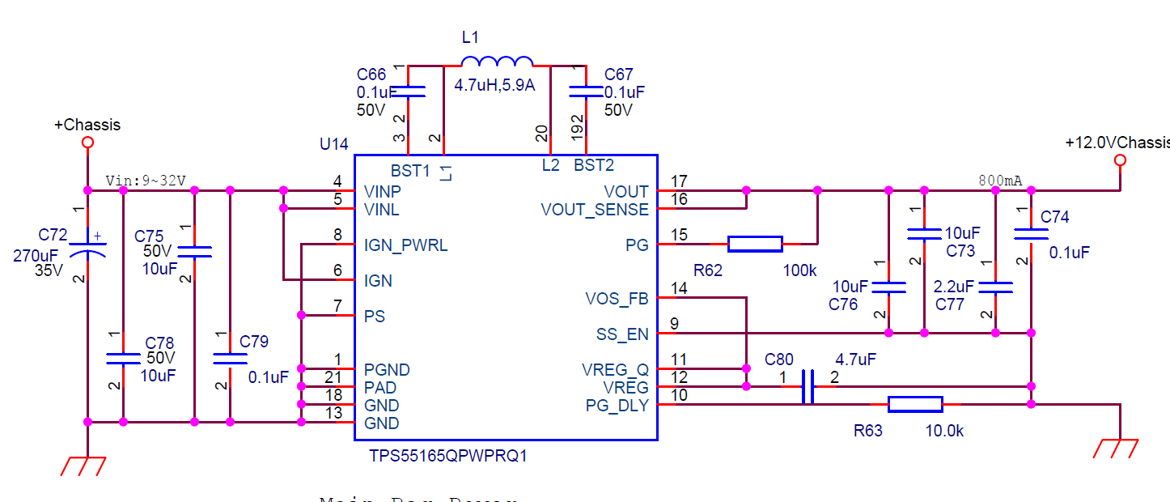

It’s a 6 Layer Board 1Oz PCB.

Top Layer

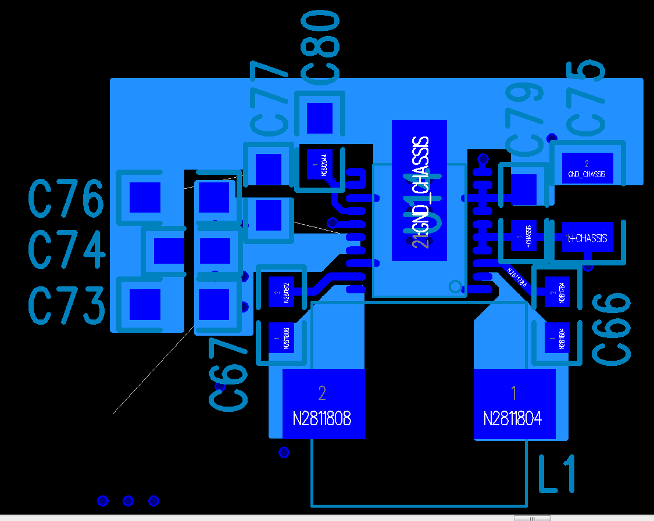

2nd Layer (GND)

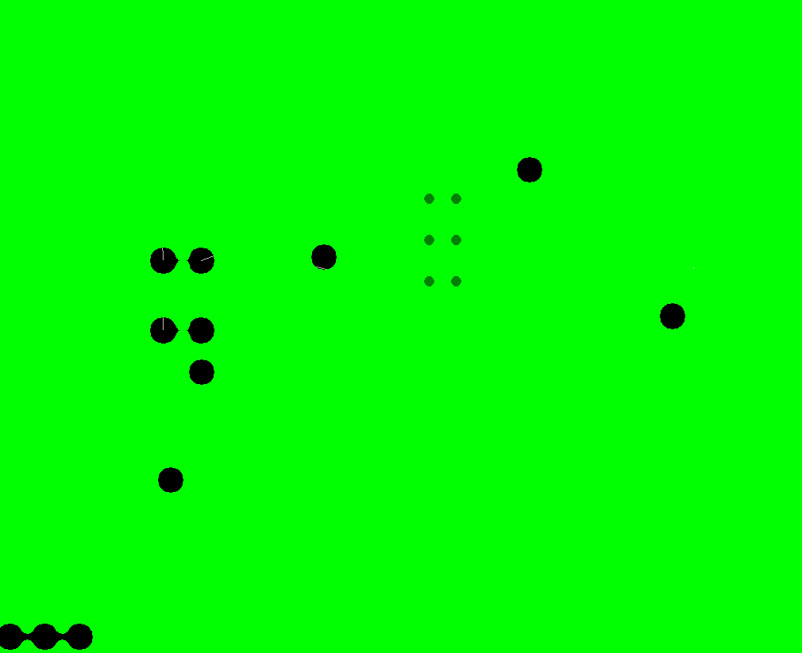

3rd Layer (Empty)

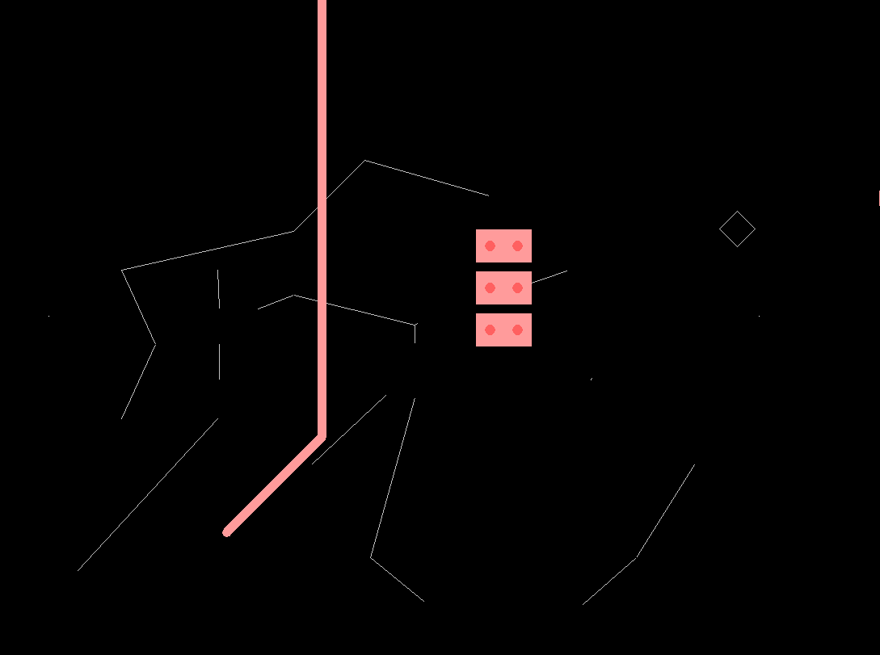

4th Layer ( +12V output Copper )

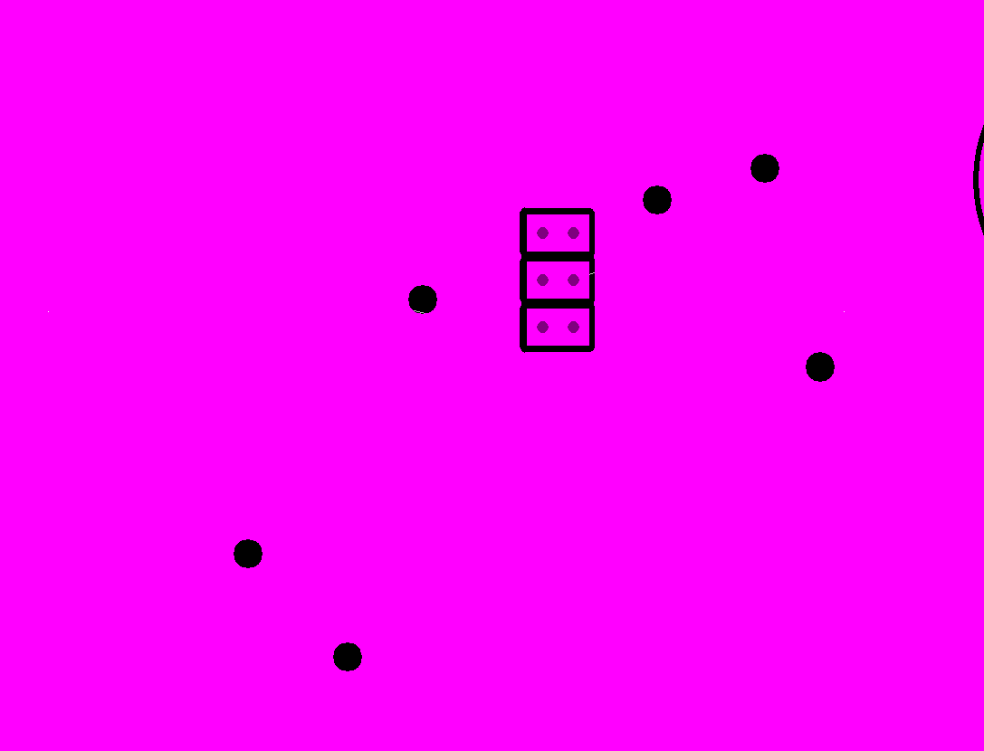

5th Layer(GND)

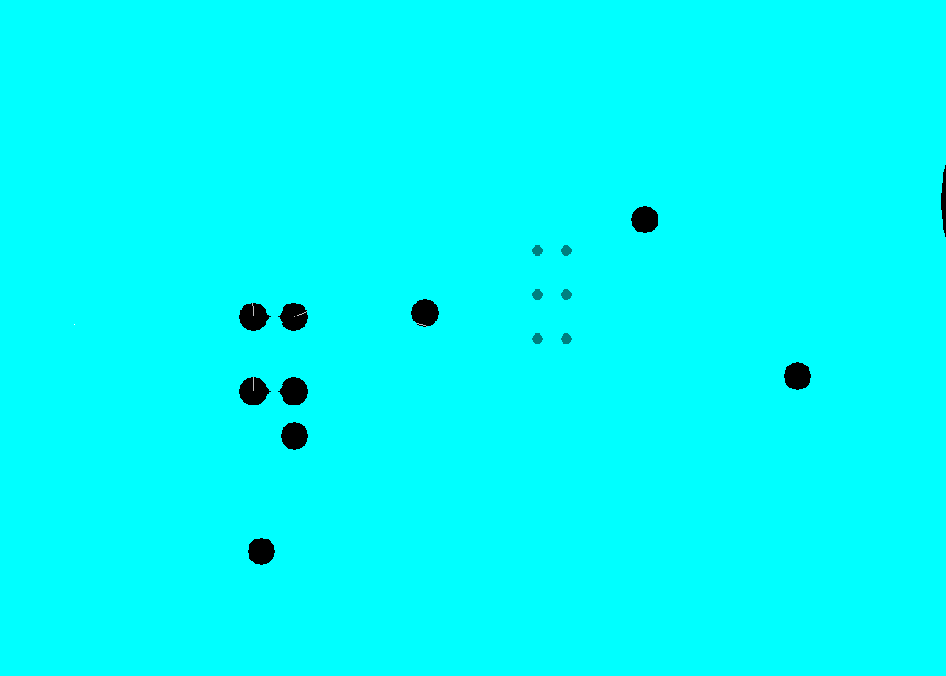

6th Layer( Resistor for PG_DLY and PG and input + copper )

3nd SCH and PCB

This Board are designed to make a small DC/DC convertor bd which can put on 2nd PCB(Product) instead of non-working DC/DC on 2nd PCB.

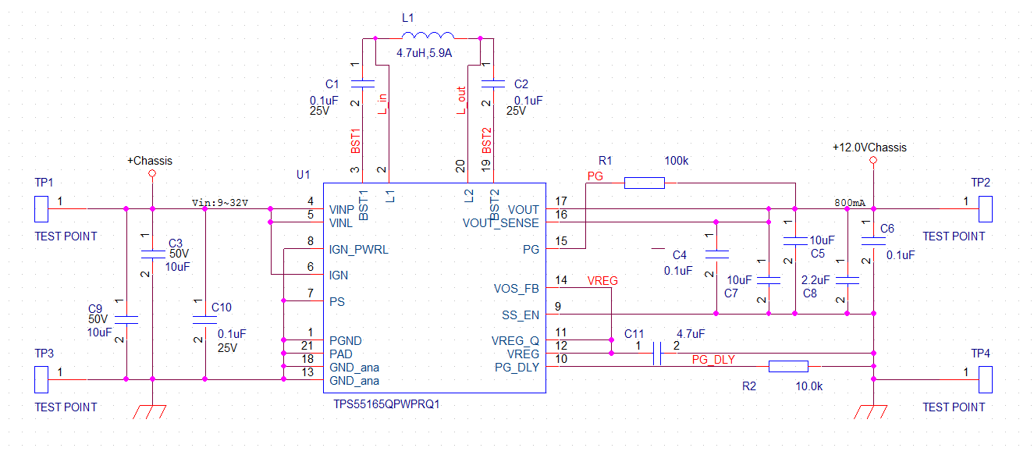

It’s a 2 Layer PCB with 1Oz Copper (Via Size, 12mil for hole, and 24mil for copper)

Top Layer(All Via is GND via)

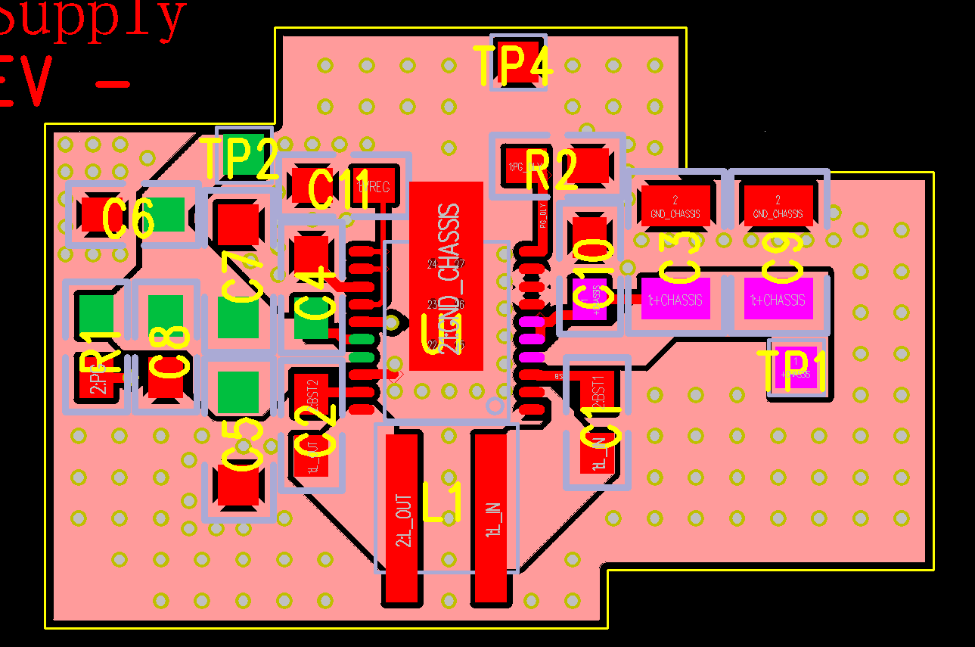

Bottom Layer(GND)

