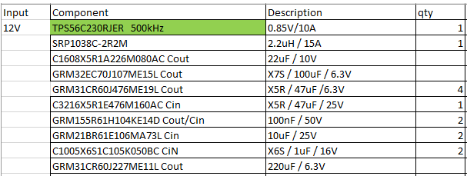

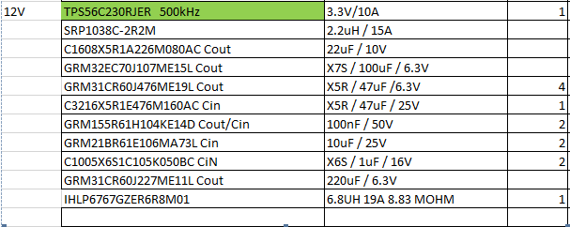

It’s the simulation values using the Power stage designer and the TI Buck spreadsheet. Our power source is 12V 10% of tolerance. Using small inductors I will have bigger current ripples. I’d like keep it working with a maximum of 10% and decrease the inductor saturation current.

