測試日期(Test Date) 2020.01.17 Inductor 22uH 5A
CH1 Panel Power CH2 Panel Current CH3 TPS61199 PWM
電解(E-Cap) 22uF MLCC 10uFx2
電壓漣波小(small voltage ripple) 電流漣波小(low current ripple) PWM 波形正常(wave form normal (無高頻音 no audio noise)
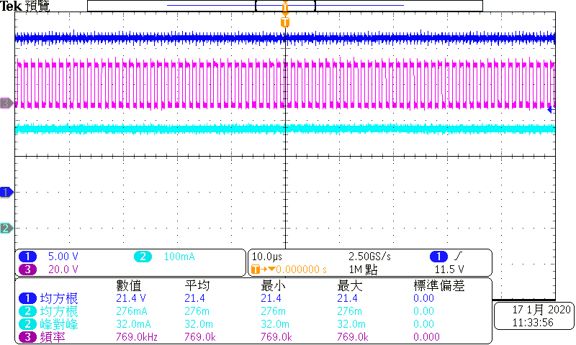 | 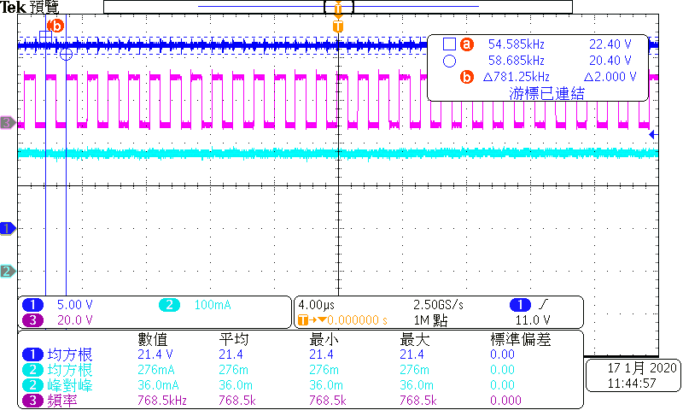
電解(E-CAP)10uF MLCC 10uFx2
電壓漣波略大(Voltage ripple slightly larger) 電流漣波略大(Current ripple slightly larger) PWM 波形正常 (無高頻音) PWM waveform is normal
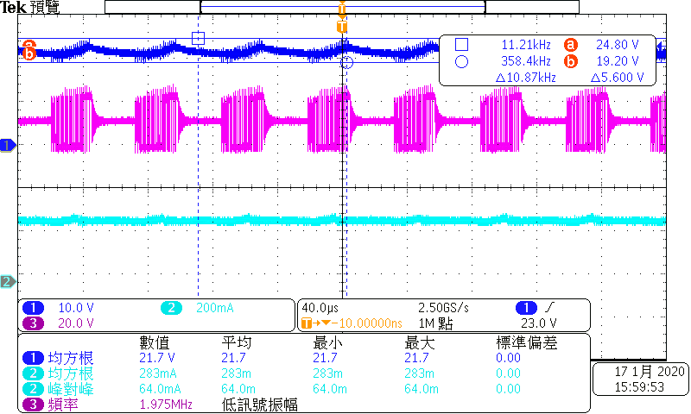 | 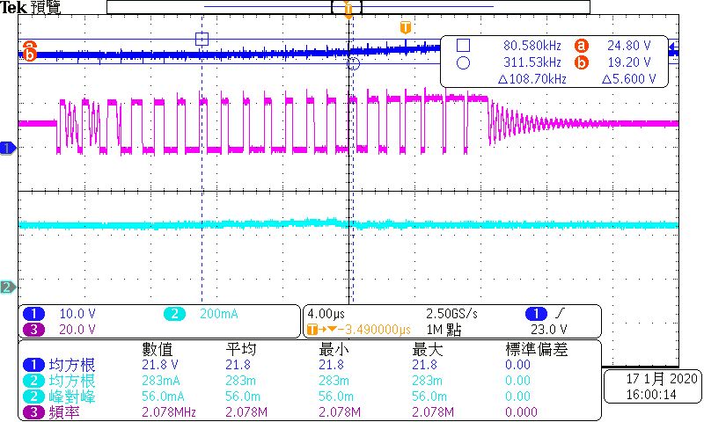
電解NA(no E-CAP) MLCC 10uFx2
電壓漣波大 電流漣波大 PWM 波形異常 高頻音嚴重
(Large voltage ripple, Large current ripple, PWM waveform abnormal, High frequency sound)
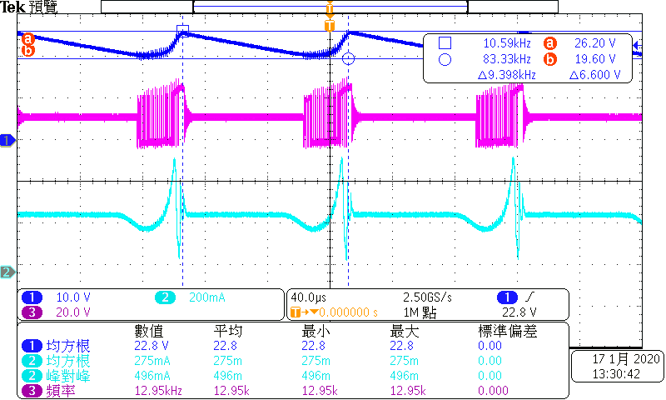 | 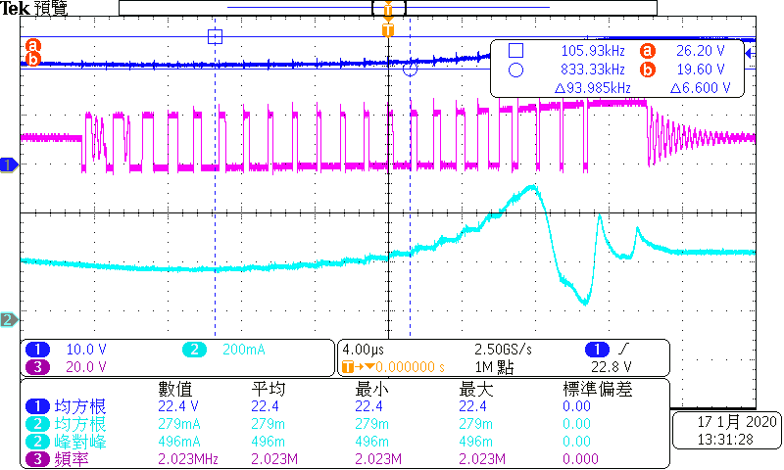
電解NA(No E-CAP) MLCC 10uFx7
電壓漣波大 電流漣波大 PWM 波形異常 有高頻音
(Large voltage ripple, Large current ripple, PWM waveform abnormal, High frequency sound)
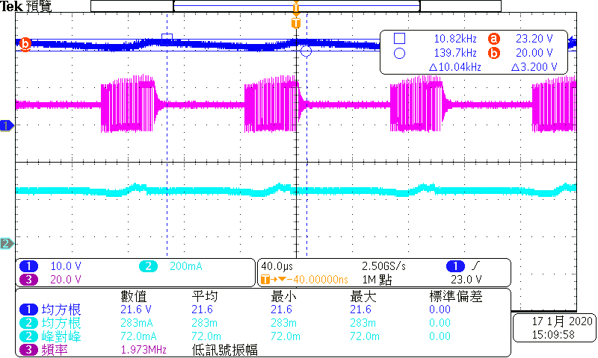 | 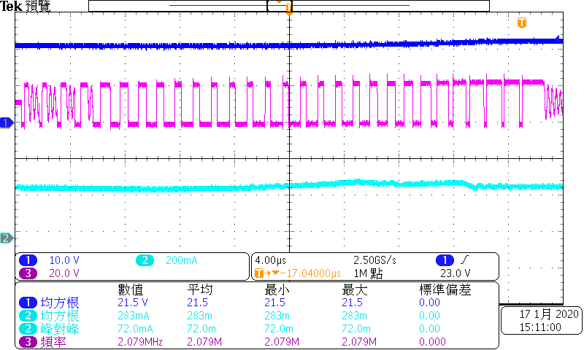

測試日期 2020.01.17 Inductor 10uH 3.8A
CH1 Panel Power CH2 Panel Current CH3 TPS61199 PWM
電解(E-CAP)10uF MLCC N/A
電壓漣波略大 電流漣波略大 PWM 波形正常 (無高頻音)
Voltage ripple is slightly larger, Current ripple is slightly larger, PWM waveform is normal (no high frequency sound)
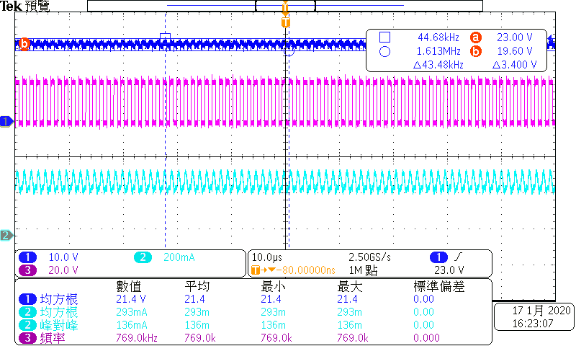 | 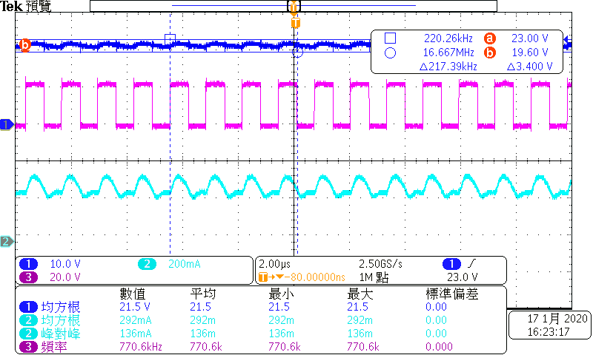
電解(E-CAP) 10uF MLCC 10uFx1
電壓漣波略大 電流漣波小 PWM 波形正常 (無高頻音)
Slightly larger voltage ripple, small current ripple, PWM waveform is normal (no high frequency sound)
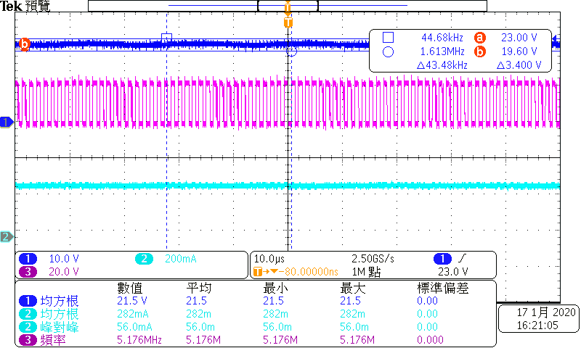 | 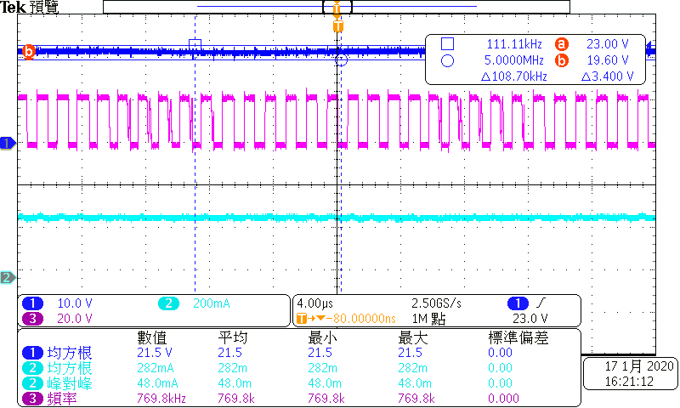
電解(E-CAP) 10uF MLCC 10uFx2 ➔ 與22uH 電解10uF MLCC 10uFx2 比對已有明顯不同 (Compared with 22uH and output E-CAP 10uF+ MLCC 10uFx2)
電壓漣波小 電流漣波小 PWM 波形正常 (無高頻音)
Low voltage ripple, small current ripple, PWM waveform is normal (no high frequency sound)
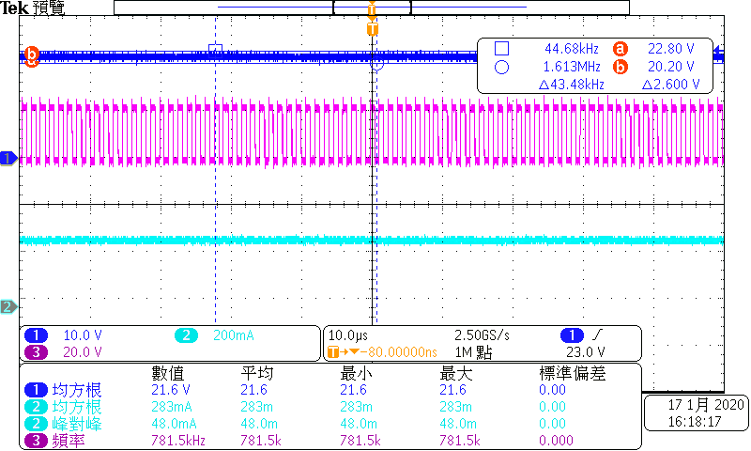 | 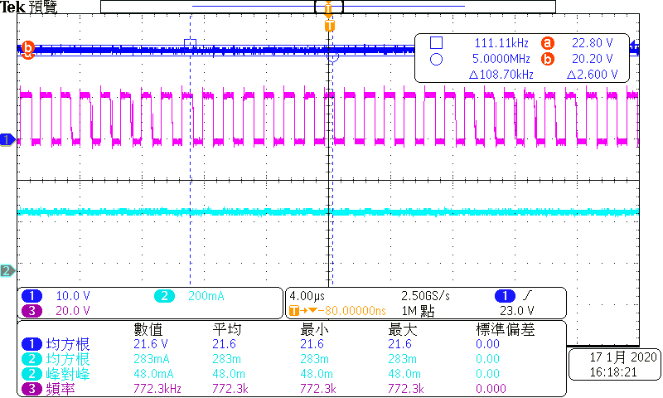

測試日期 2020.01.14 Inductor 10uH 3.8A
CH1 Panel Power CH2 Panel Current CH3 TPS61199 PWM
電解(E-CAP) 22uF MLCC 10uFx2
電壓漣波小 電流漣波小 PWM 波形正常
(Low voltage ripple, small current ripple, PWM waveform is normal)
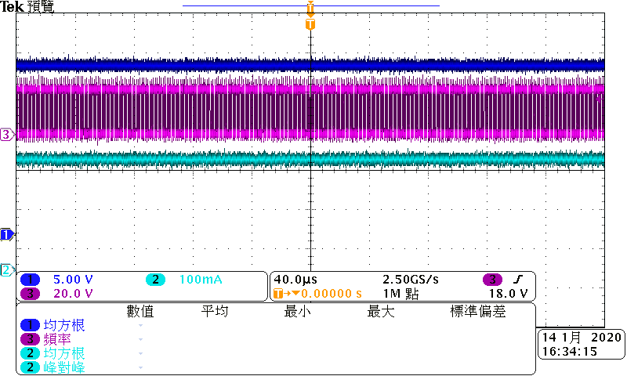 | 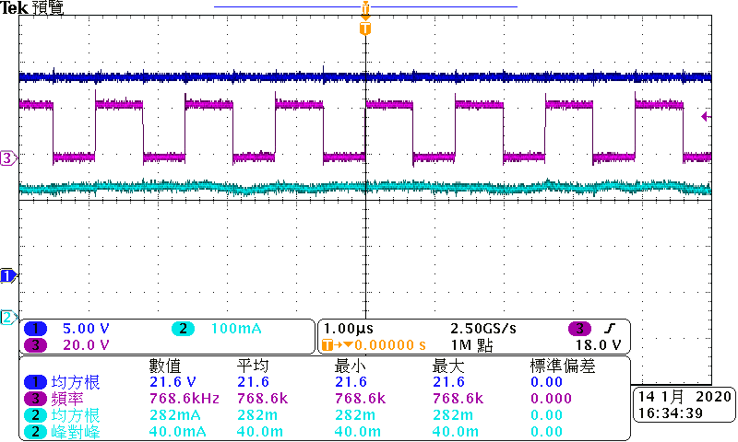
電解 (E-CAP)22uF MLCC NA
電壓漣波小 電流漣波略大 PWM 波形正常
(Small voltage ripple, slightly larger current ripple, PWM waveform is normal)
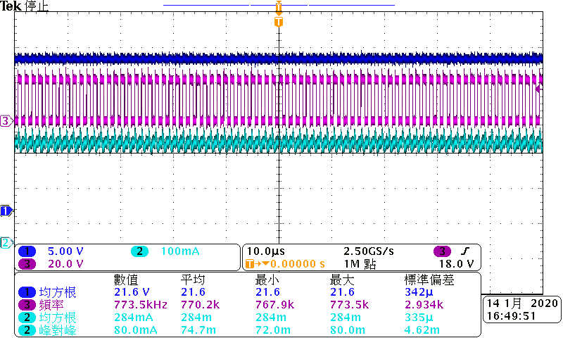 | 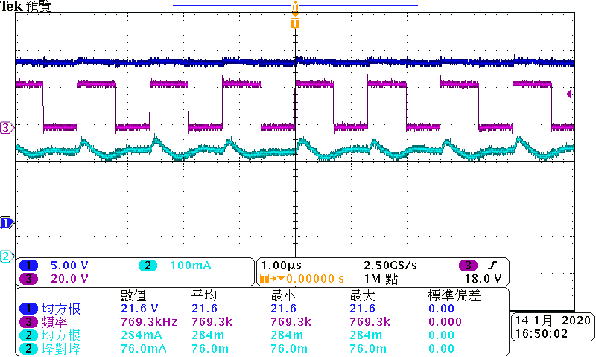
電解(E-CAP) 22uFx2 MLCC NA
電壓漣波小 電流漣波略大 PWM 波形正常
(Small voltage ripple, slightly larger current ripple, PWM waveform is normal)
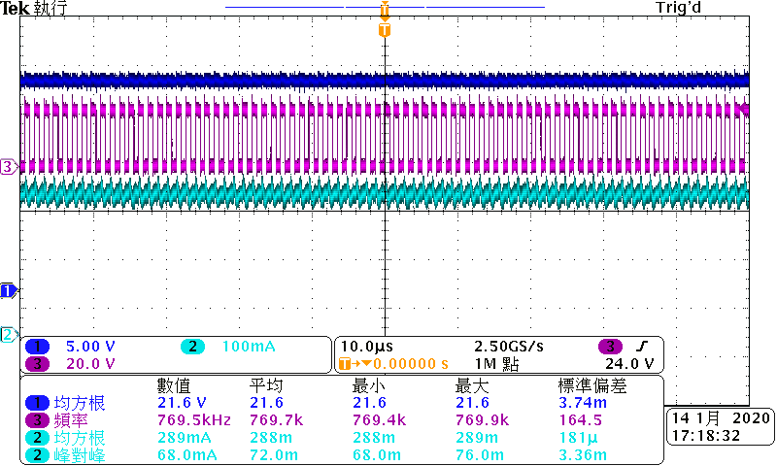 | 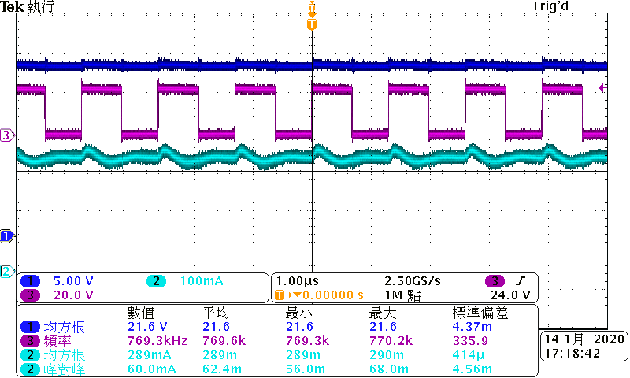
電解NA(No E-CAP) MLCC 10uFx2
電壓漣波大 電流漣波大 PWM 波形異常
(arge voltage ripple Large current ripple PWM waveform abnormal)
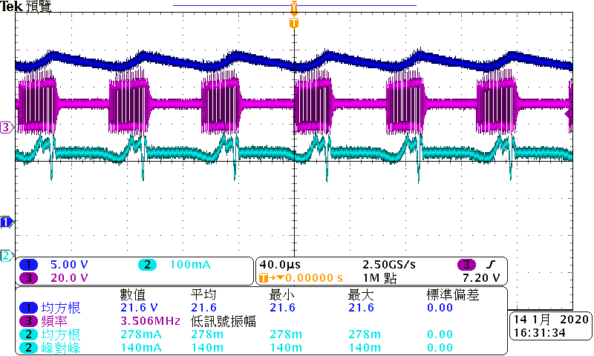 | 