I`ve facing a problem with my power management circuit based on TPS61202 IC. When supplied by single cell Li-ion the IC and inductor burn and do not work (no 5V in Vout).
I ask expert team to help me reviewing the design and suggesting ways for fixing this issue.

- Circuit Detail:
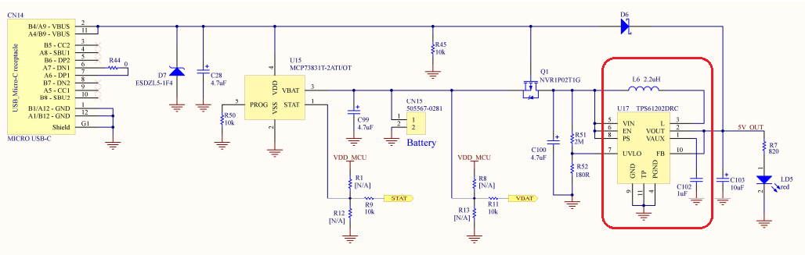
Vin = 2.5V ~ 3.7V
Expected Vout = 5V
Iout = 0.3A

- Bill of material:

Designator | Quantity | Manuf_part_1 | Manuf_1
C3 | 1 | CC0402KRX7R7BB104 | YAGEO
C4 | 1 | DNP
C28 | 1 | TAJA475K016R | AVX
C29 | 1 | TAJA106K016R | AVX
C37 | 1 | TAJA106K016R | AVX
C41 | 1 | CC0402KRX7R7BB104 | YAGEO
C99 | 1 | TAJA475K016R | AVX
C100 | 1 | TAJA475K016R | AVX
C102 | 1 | LMK107B7105MAHT | Taiyo Yuden
C103 | 1 | TAJA106K016R | AVX
CN14 | 1
CN15 | 1 | 505567-0281 | MOLEX
D6 | 1 | RSX071VYM30FHTR | Rohm Semiconductor
D7 | 1 | ESDZL5-1F4 | ST
L6 | 1 | LQH3NPN2R2MJRL | Murata
Q1 | 1 | NVR1P02T1G | ON Semiconductor
R1 | 1 | DNP
R2 | 1 | RC0603FR-07510RL | YAGEO
R3 | 1 | RC0603FR-07680RL | YAGEO
R4 | 1 | RC0603FR-07680RL | YAGEO
R5 | 1 | RC0603FR-07680RL | YAGEO
R6 | 1 | RC0603FR-07100KL | YAGEO
R7 | 1 | RC0603FR-07820RL | YAGEO
R8 | 1 | DNP
R9 | 1 | RC0603FR-0710KL | YAGEO
R10 | 1 | RC0603FR-07100RL | YAGEO
R11 | 1 | RC0603FR-0710KL | YAGEO
R12 | 1 | DNP
R13 | 1 | DNP
R18 | 1 | RC0603FR-07330RL | YAGEO
R19 | 1 | RC0603FR-07220KL | YAGEO
R44 | 1 | RC0603JR-070RL | YAGEO
R45 | 1 | RC0603FR-0710KL | YAGEO
R50 | 1 | RC0603FR-0710KL | YAGEO
R51 | 1 | CRCW06032M00FKEAC | Vishay
R52 | 1 | RC0603FR-07180RL | YAGEO
SB1 | 1 | DNP
SB8 | 1 | DNP
SB22 | 1 | DNP
U7 | 1 | LD1117S33TR | ST
U15 | 1 | MCP73831T-2ATI/OT | Integrated Circuits
U17 | 1 | TPS61202DRC | Texas Instruments

