- Schematic:
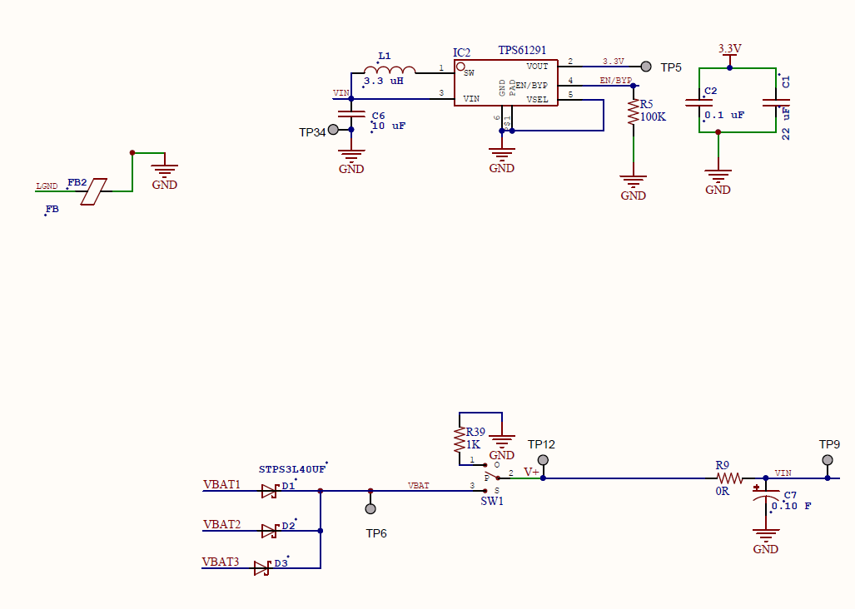
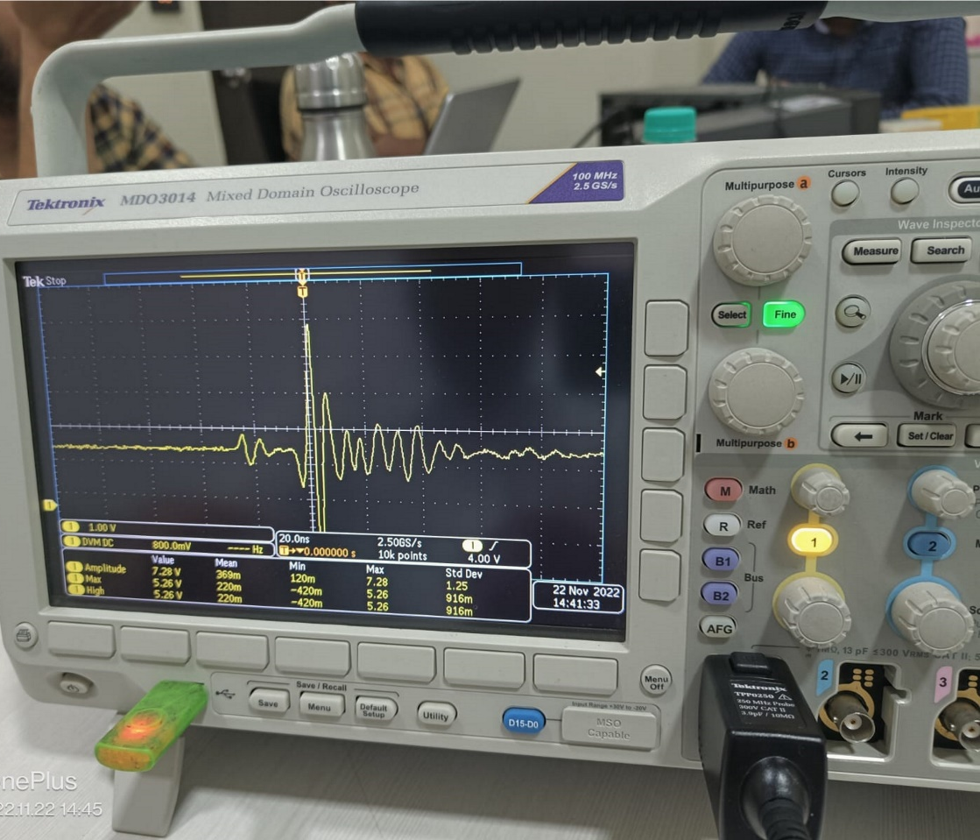
- Traced waveform at TP5:

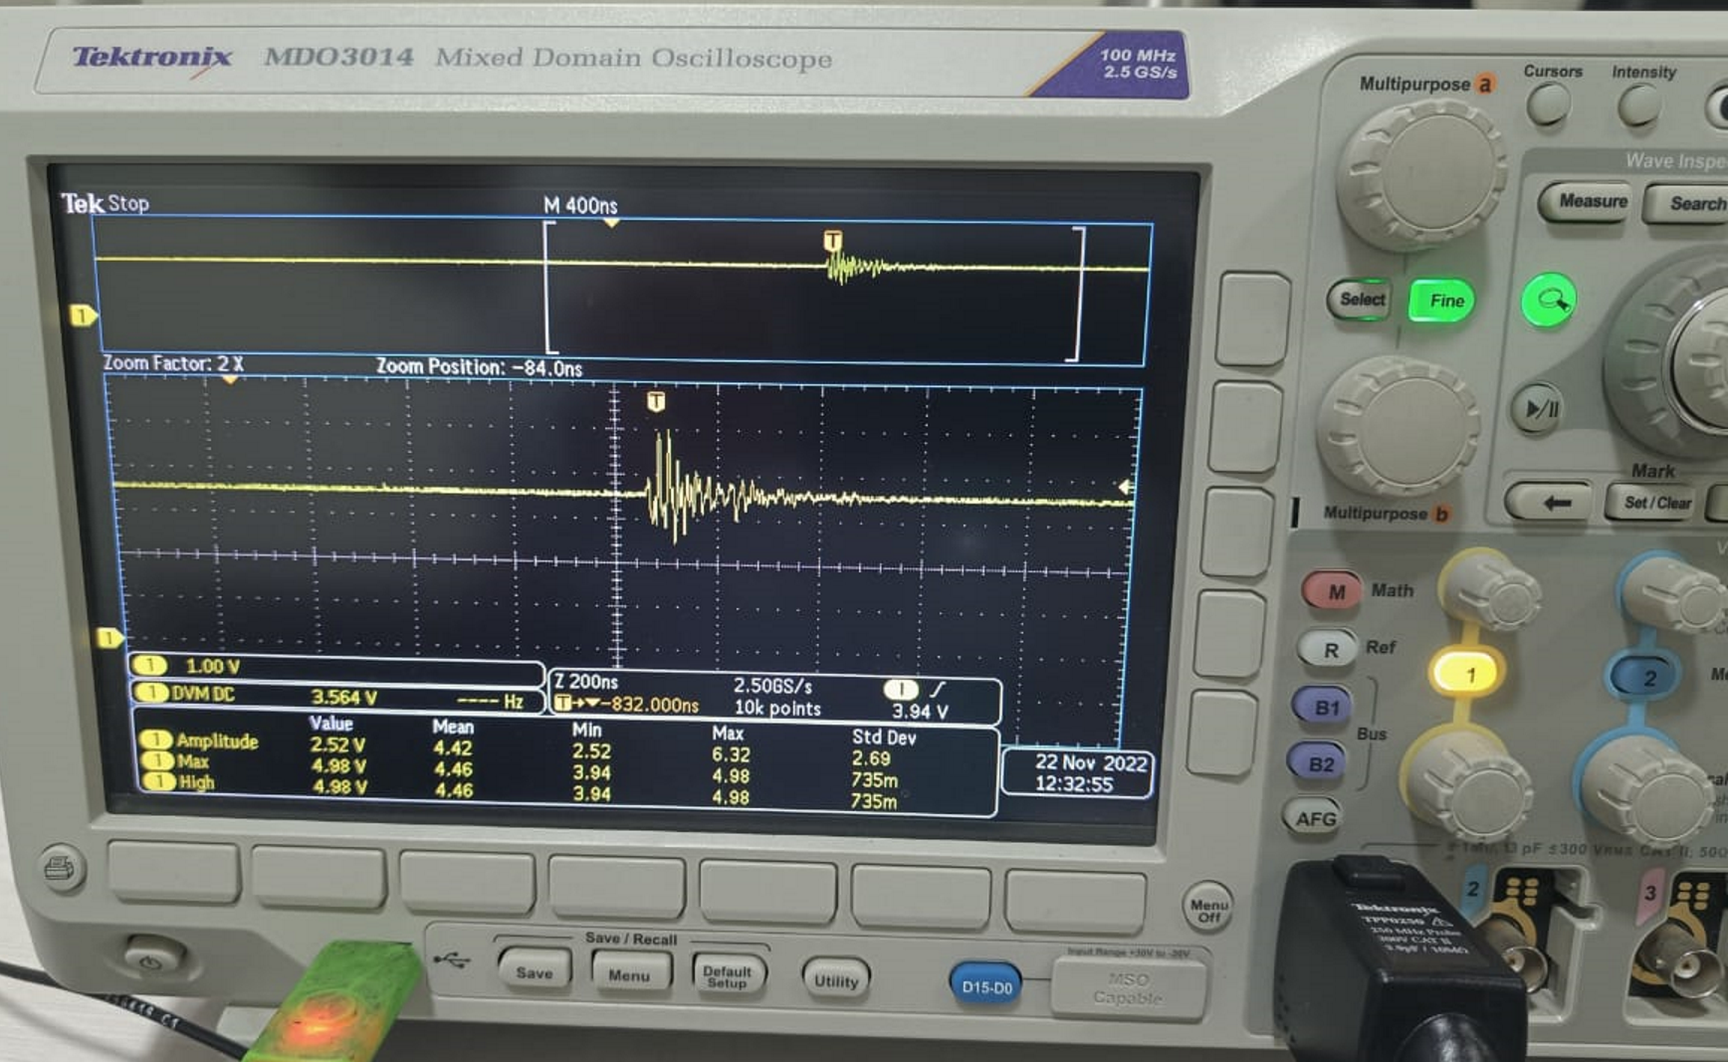
- Input source is 3.6V non rechargeable Battery.
- C7 is open.
- After C1 one more cap of 470uF tantalum cap is also there in parallel with C1.
- On boost mode, maximum current consumption is 150mA
- In Bypass mode, maximum current consumption is 115uA
- During switching ON, converter first goes in boost mode for approx. 1 minute after it works in bypass mode.

