1. Problem description:

VDD1V0 controls VDD1V8, and both channels use TPS62130A, whose output PG has a drop, and the drop time is 40us (red line);

Green line: vdd1v0-pg;

Blue line: vdd1v8;

Red line: vdd1v8-pg;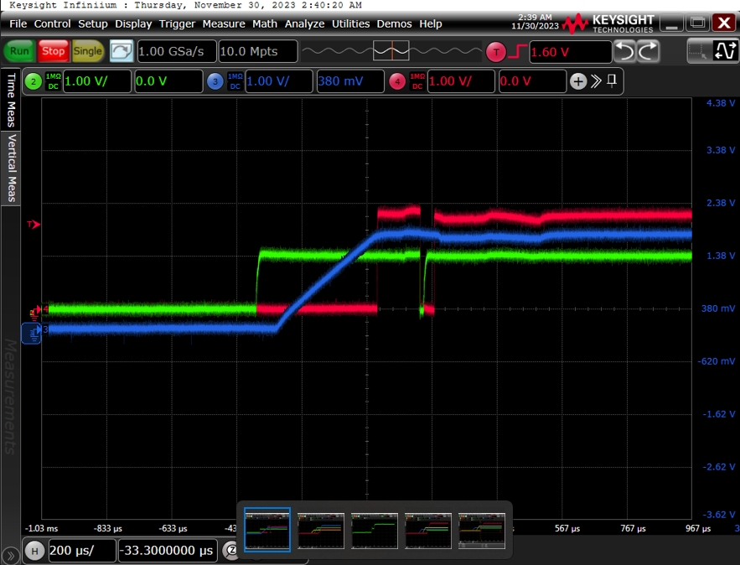

1. The design schematic diagram is as follows：

3. VDDA1V8-PG controls the output of 2.5V. Due to drop, the waveform of 2.5V is as follows.

schematic diagram：

