Hi Engineer,
Since the project is applied to low-power products, the switching power supply chip used is the TPS62162.
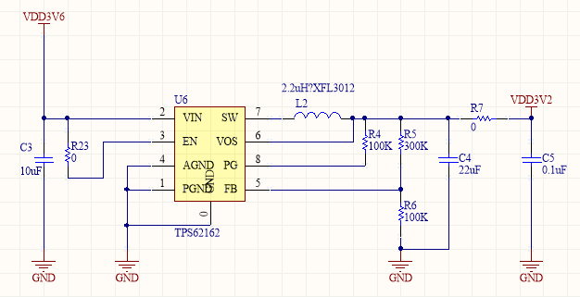
In use, the power supply can output normally, but when it encounters static power consumption, there is no load in the latter stage of this circuit;
Test static power consumption as follows:

输入电压(V) | 输出电压(V) | 静态电流
12 | 3.1 | 18uA
9 | 3.1 | 20uA
5 | 3.1 | 21uA
3.9 | 3.1 | 23uA
3.6 | 3.1 | 2.365mA
3.5 | 3.1 | 1.78mA
Table 1
In the table, it can be seen that the input and output voltages are greater than 0.8V. The static power consumption is within the normal value given in the manual. In the low input voltage difference, the quiescent current consumption is relatively large. For low-power products, this problem is very fatal;
1. Is there a way to solve this problem?
2. Is this problem a defect of the switching power supply itself;
3. If the chip can't avoid this problem, can there be other replacement chips to avoid this problem;

Thanks.

