5V Switcher Schematic

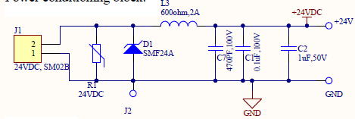

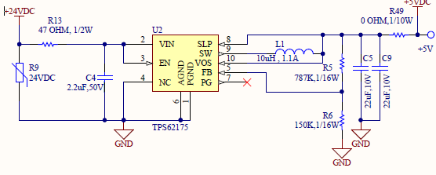

**In above schematic we have not used (DNP) R1, R9 MOVS** and **C9** **.**

**PCB Layout**

**Bottom L4: 62175 placed in Bottom Layer**

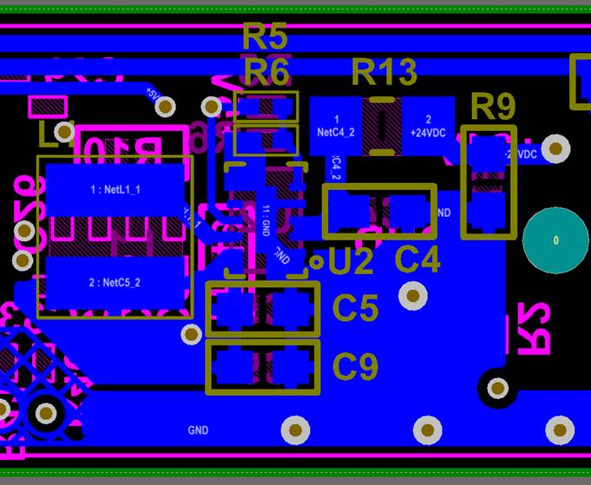

**L3:**

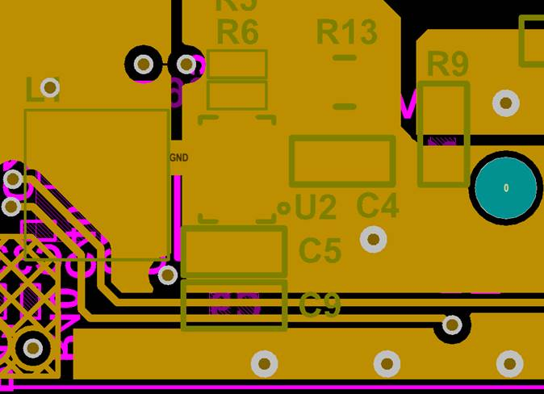

**L2:**

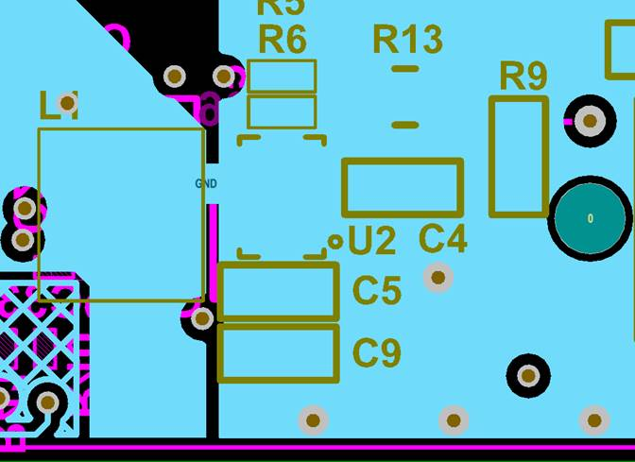

**L1:**

