Thank you for your answer. I bought a new oscilloscope probe and measured it again. After re measurement, the ripple is still 10mV (the oscilloscope uses RIGOL ms05104, and the oscilloscope probe is pvp2350)

The oscilloscope can measure the output voltage ripple less than 8 MV. I have measured the ripple of other power supply at 1 MV before, which can be measured. Besides, I have used a 1 x probe. Ferrite beads are used in poems officially recommended.

The figure below is my oscilloscope and probe.

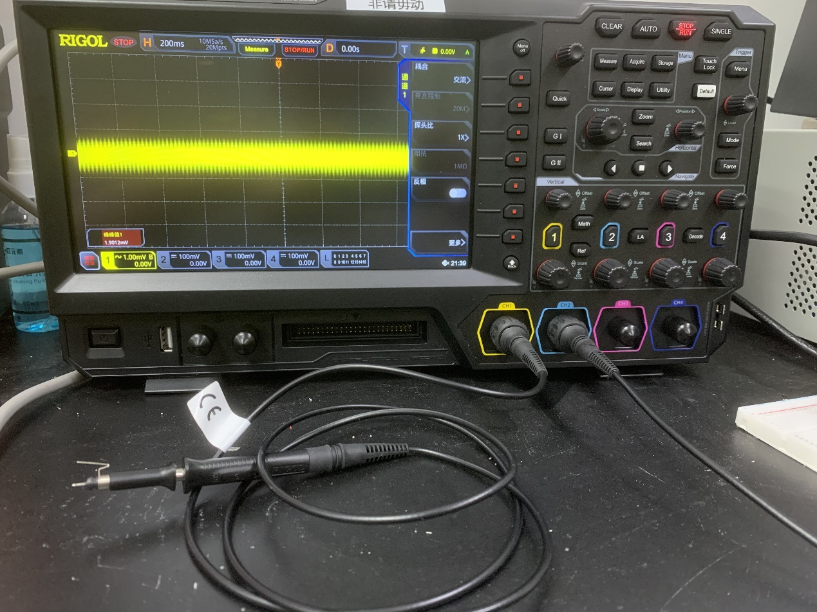

Here are some pictures of my measurements. They are all measured under no-load condition.

