Overview of TPS63806 Chip Issues
In three of the 50 printed circuit boards, the TPS63806 chip was abnormal. And the load of TPS63806 is very simple, with only one NB communication module. The input applied voltage is 3.6V.
The chip will appear this situation, the power supply is applied but not enabled, that is, when the EN pin is low, the chip's VIN will have a current of dozens of mA. After the chip is enabled, that is, the EN pin level is raised, the current of Vin pin continues to increase. Accompanied by the obvious phenomenon of fever. The schematic diagram Figure 1 shown below is the specific environment in which TPS63806 works.
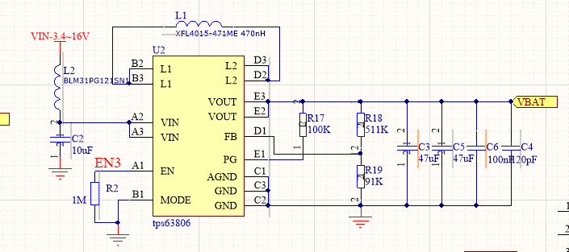
Figure 1

Comparison TABLE
PCB | Enable | $I_{V_{in}}$(mA) | $V_{V_{FB}}$(V) | $V_{V_{OUT}}$(V) | $$NOTE$$
NORMAL | 0 | 0 | - | -
NORMAL | 1 | 10 | 0.5 | 3.3
Exception 1 | 0 | 127 | - | -
Exception 1 | 1 | 368 | 1.39 | 2.26
Exception 2 | 0 | 61 | - | -
Exception 2 | 1 | 95 | 0.0 | 0.0

Printed circuit board NOMAL
3.6V voltage applied to the chip, when not enabled, the INPUT current:
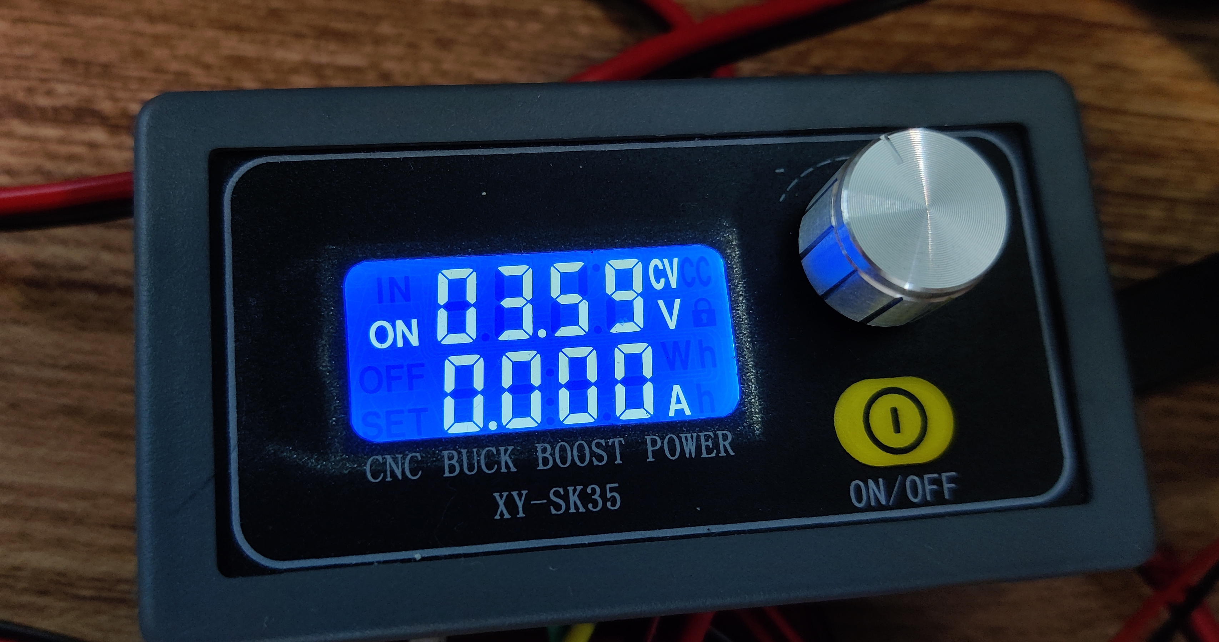
Figure 3
3.6V voltage applied to the chip, when enabled, the INPUT current:
$$v_{out}=3.29V$$
$$v_{FB}=0.5V$$
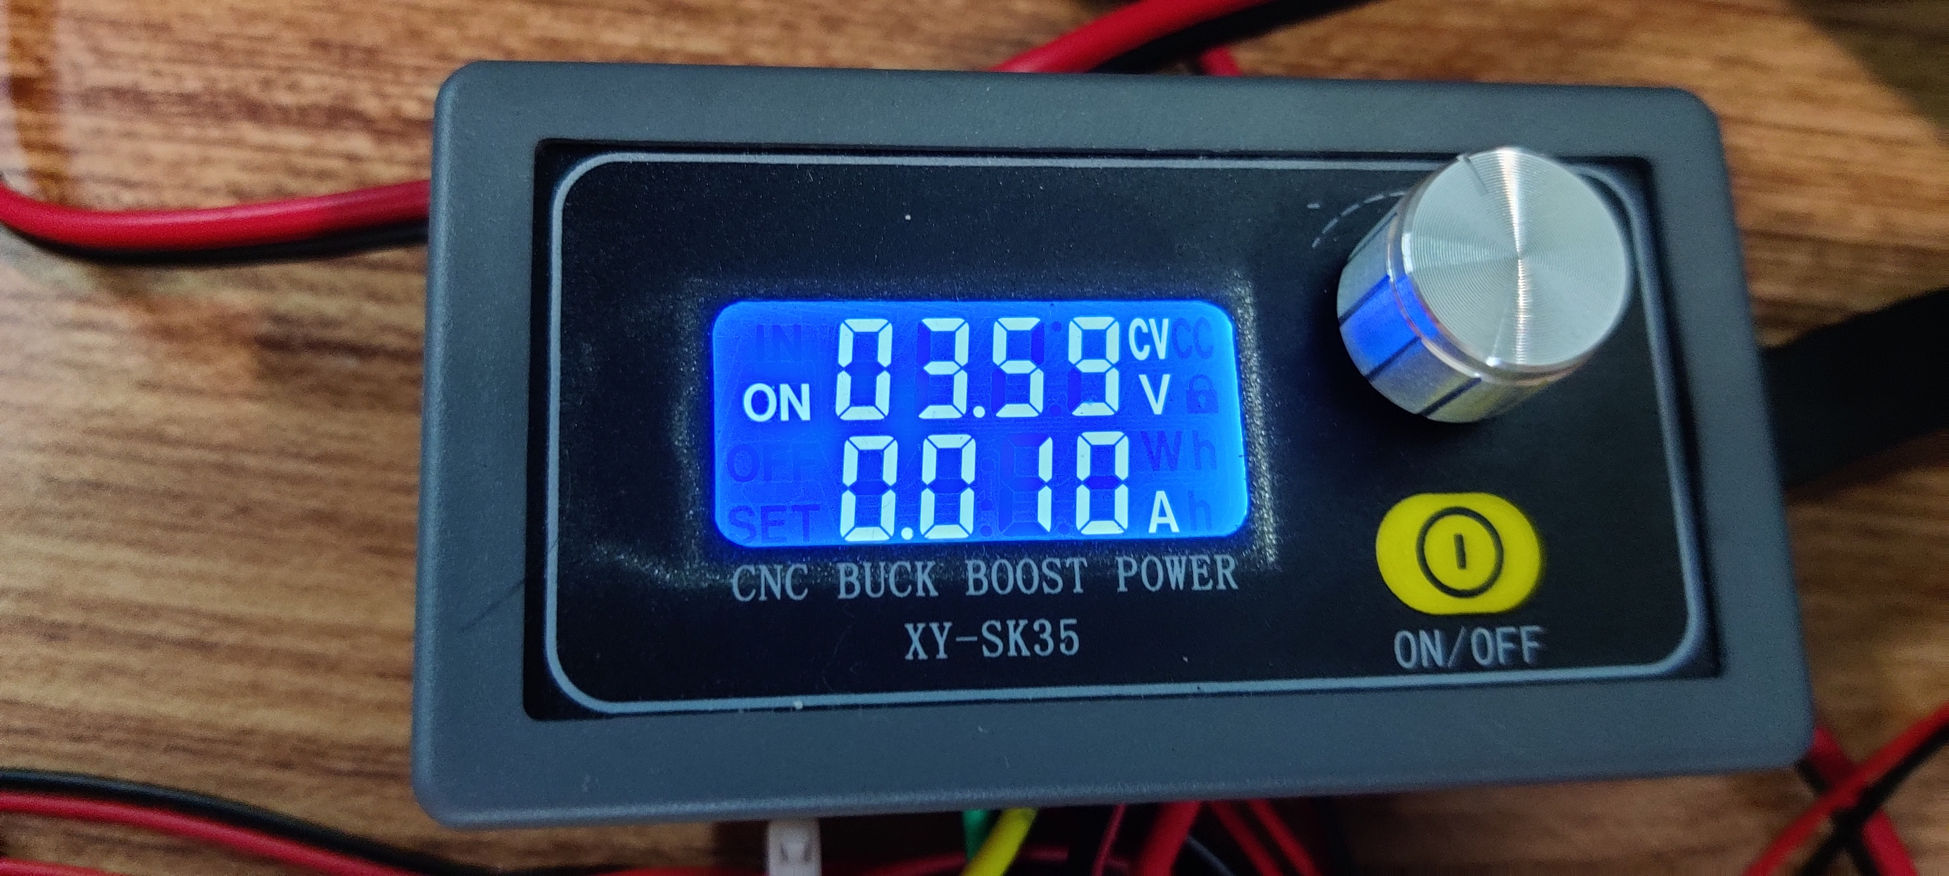
Figure 4
Printed circuit board 1
3.6V voltage applied to the chip, when not enabled, the INPUT current:
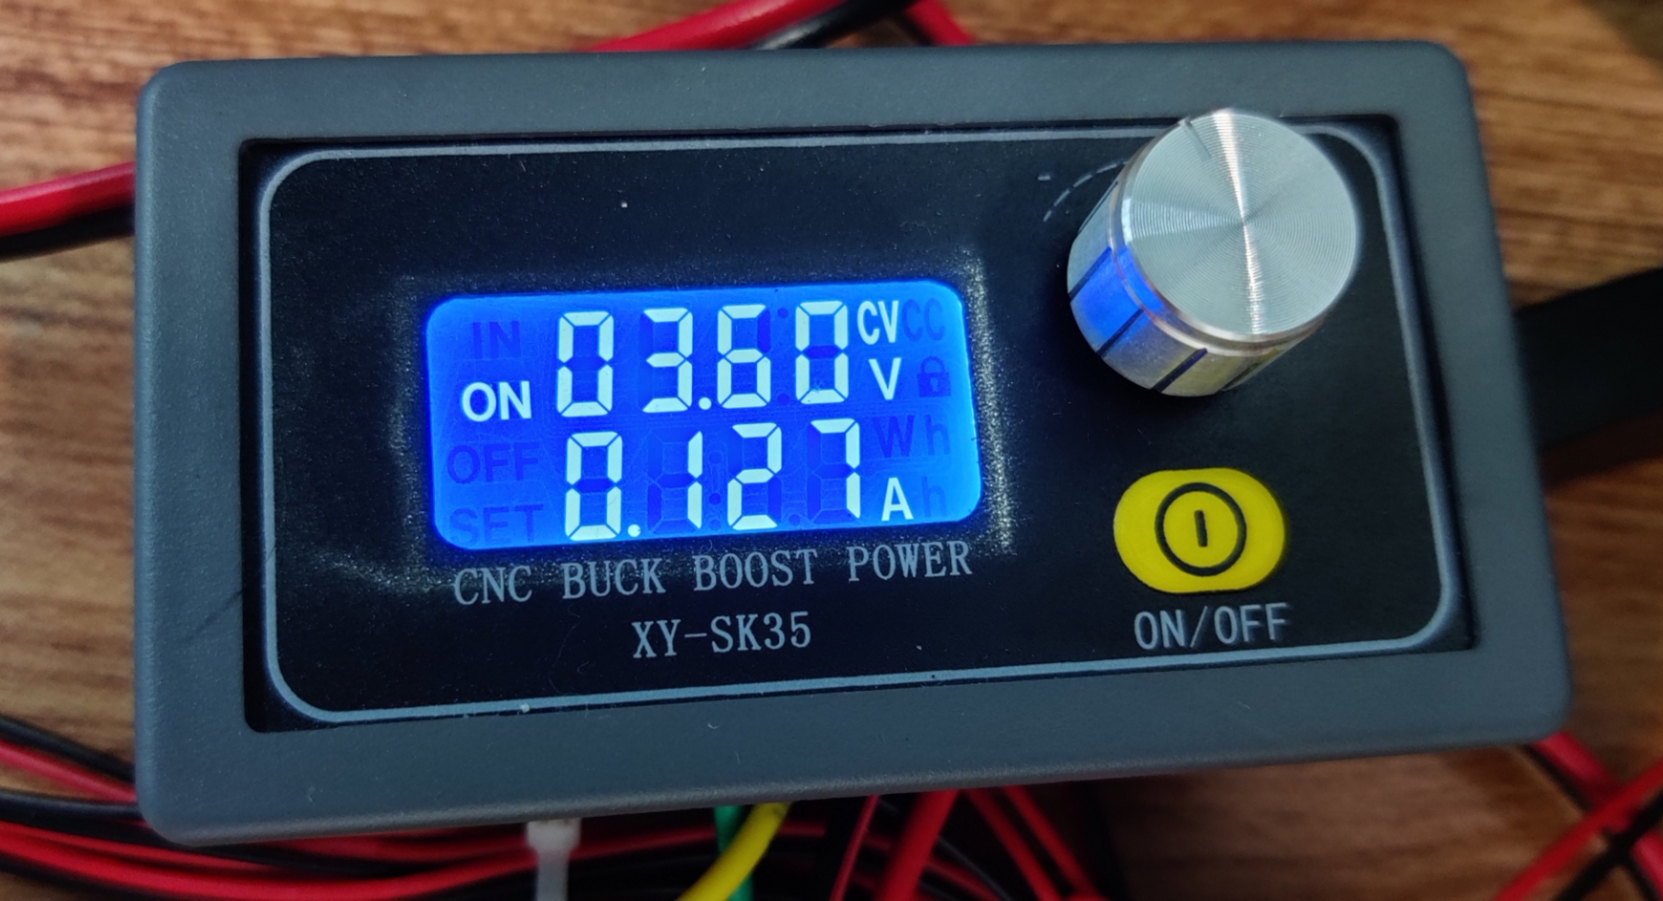
Figure 5
3.6V voltage applied to the chip, when enabled, the INPUT current:
$$v_{out}=2.26V$$
$$v_{FB}=1.39V$$
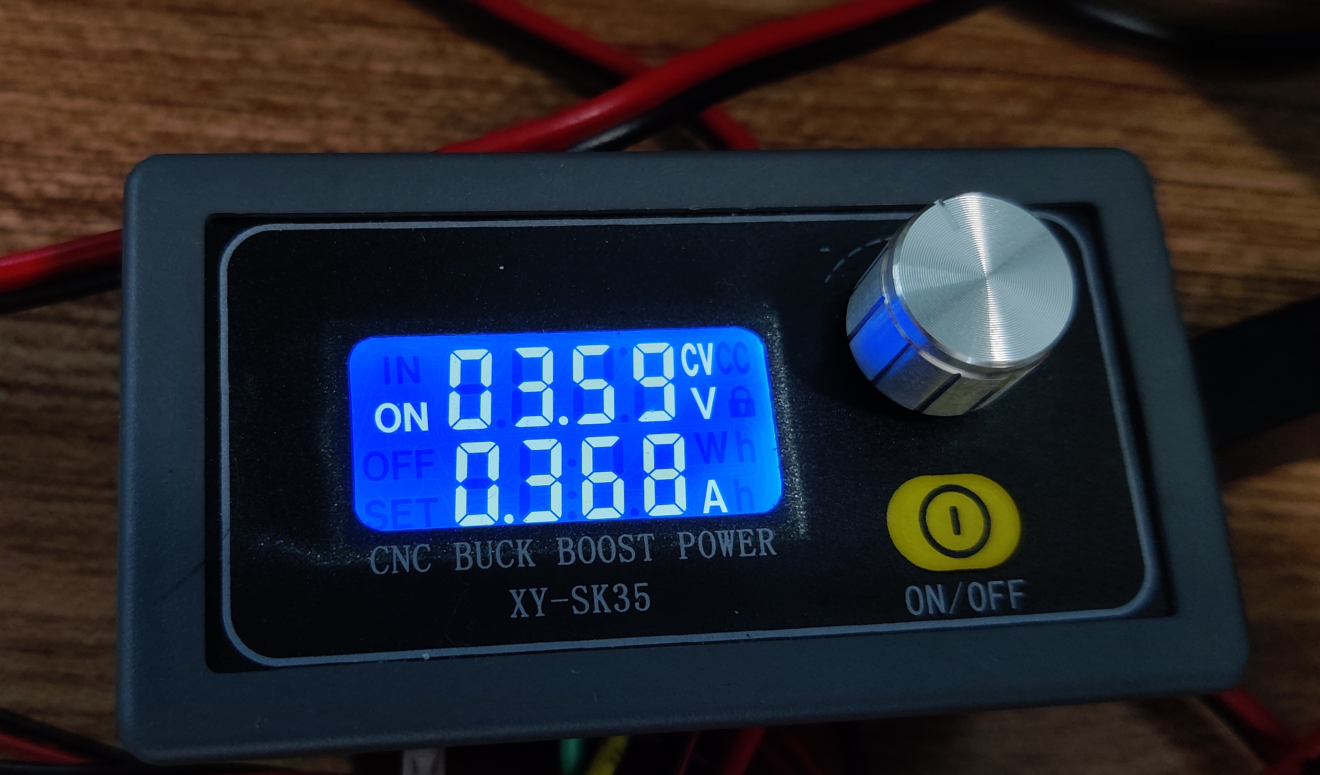
Figure 6
Printed circuit board 2
3.6V voltage applied to the chip, when not enabled, the INPUT current:
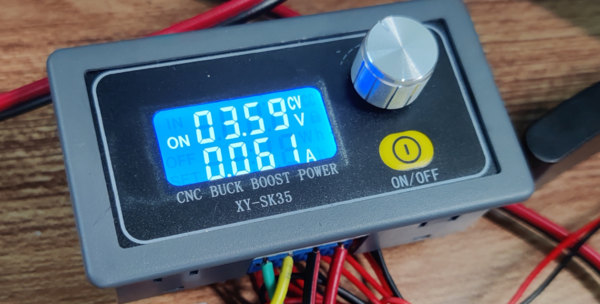
Figure 7
3.6V voltage applied to the chip, when enabled, the INPUT current:
$$v_{out}=0V$$
$$v_{FB}=0V$$

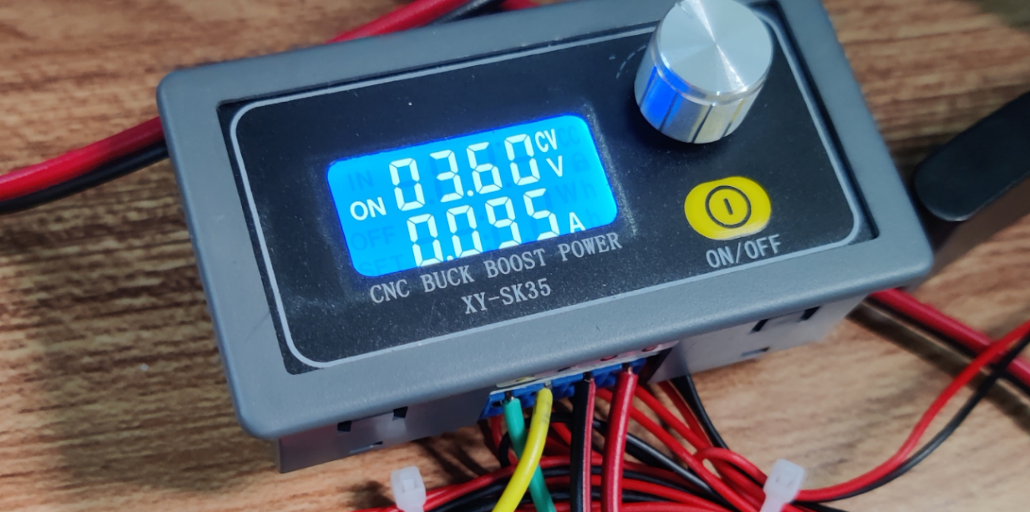
Figure 8

