- Phase of TPS650940 output with obvious pause intervals (no significant difference between light load
and Heavy load)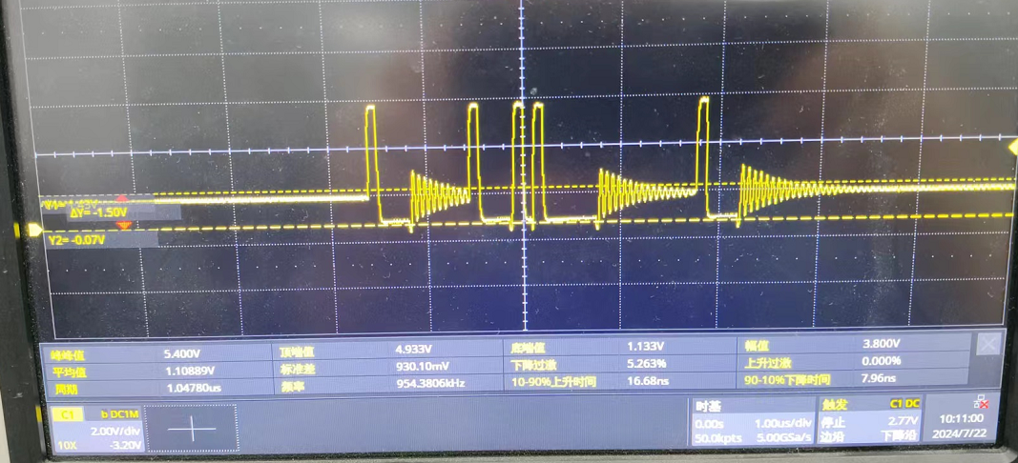
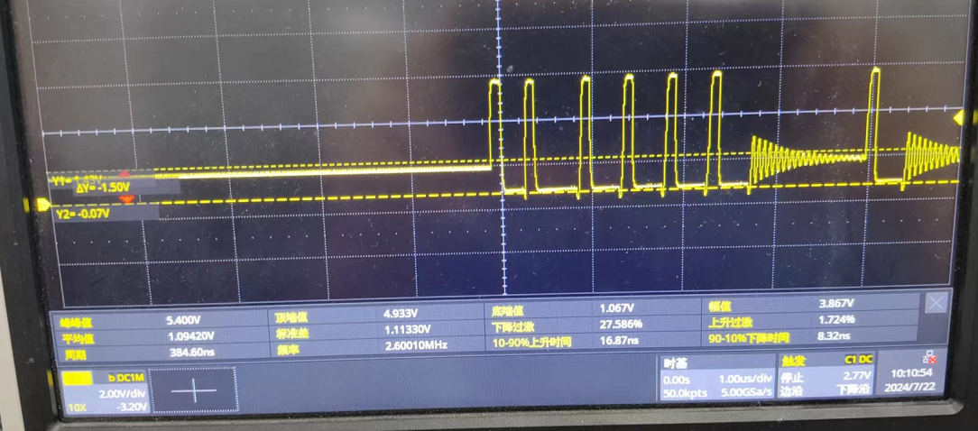
We change the minimum measurement unit to 5us and the waveform refer to below:
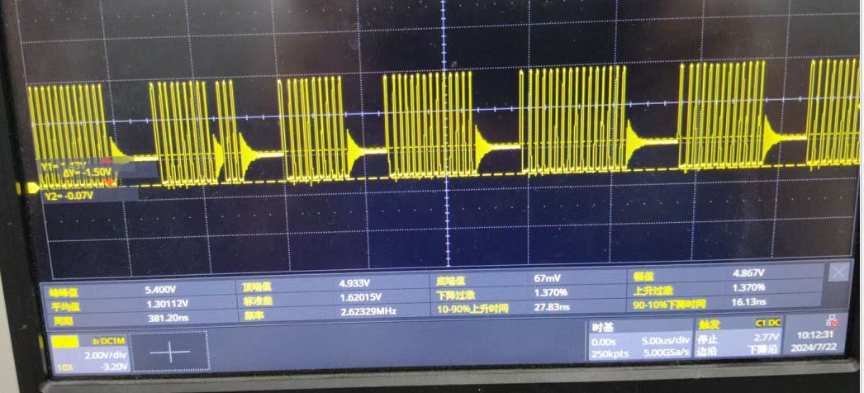

2、We test the other customer TPS650945 waveform, the frequency has light difference（2.8M、2.1M、2.5M）
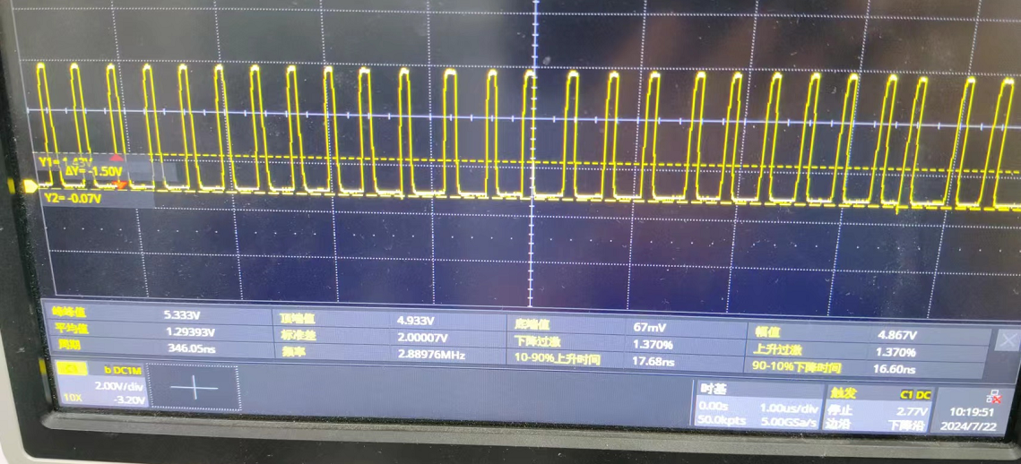
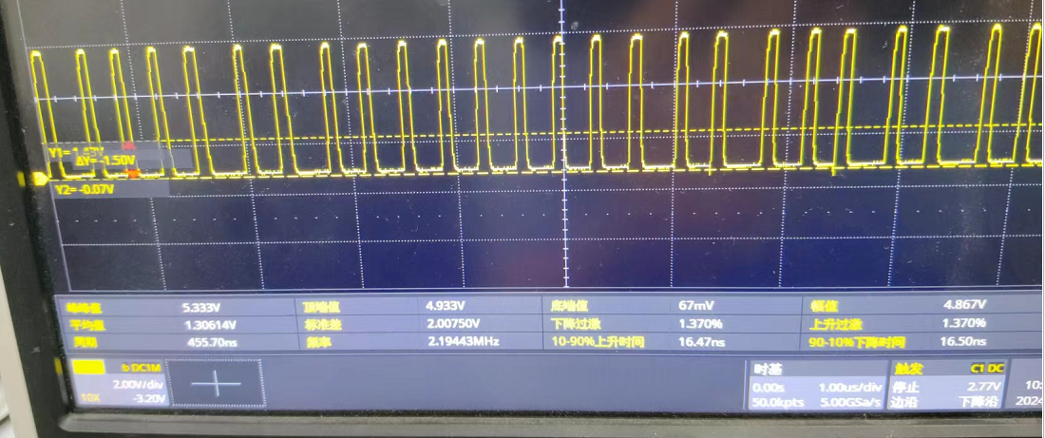
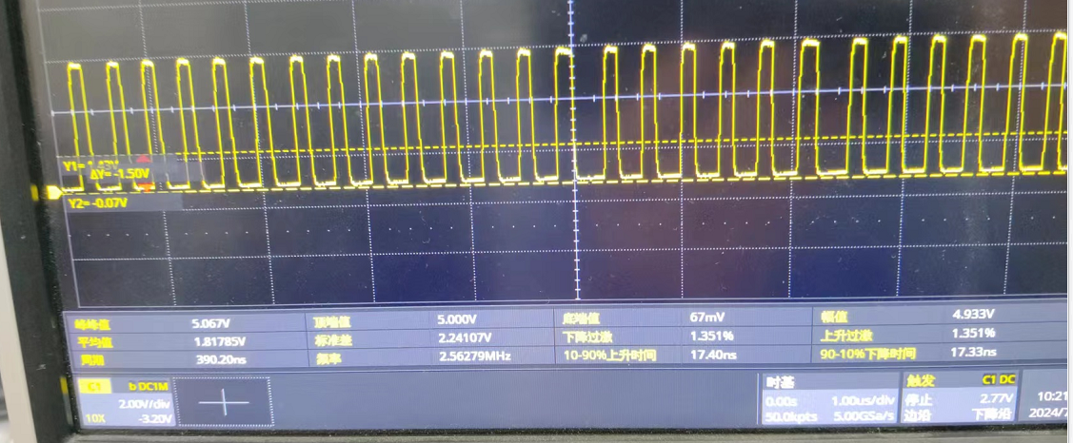

3、We replaced the TPS650945 board, but the frequency change is still quite significant Replace the ROM file of the PMIC, which is closer to the waveform of a competitor. As it is a .bin file, it is not possible to see the difference. Is there a suitable ROM recommended?
