Schematic circuit shown as below:

Screenshot (First schematic circuit)

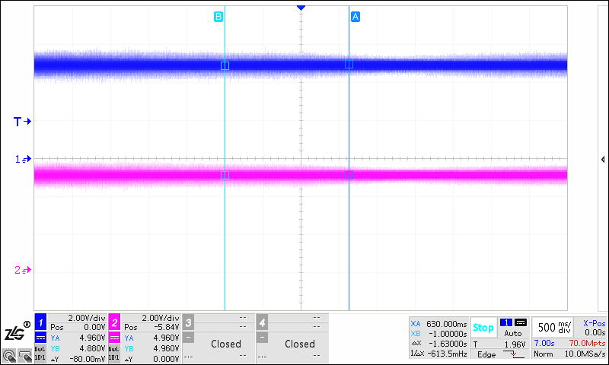

CH1--+5V_LCD(pin4) CH2--+11V_AVDD_LCD(pin6)

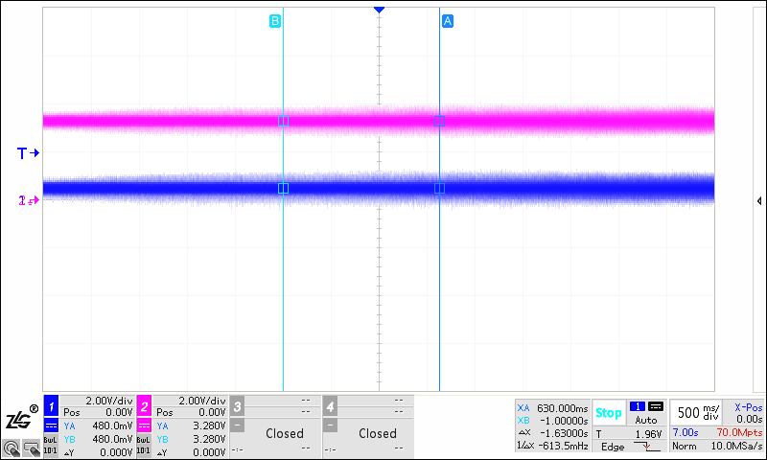

CH1--+9.6V_VCC_LCD(pin10) CH2--+3.3V_VDD_LCD(pin2)

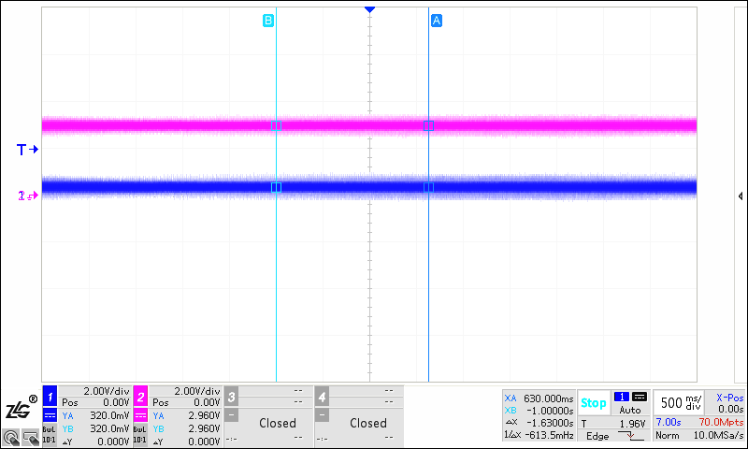

CH1-- - 6V_VGL_LCD(pin18) CH2-- +20V_VGH_LCD(pin13)

汉川公安局波形如下：(Second schematic captured waveform)

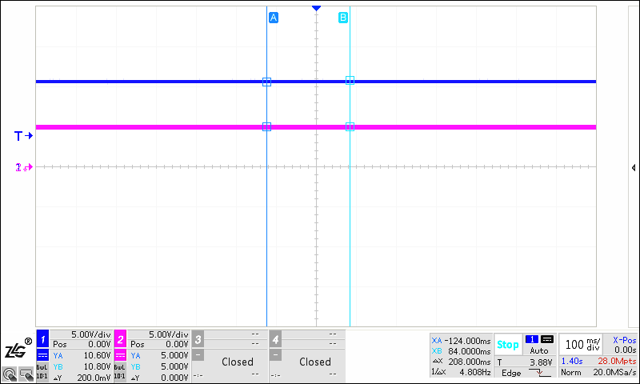

CH1--+11V_AVDD_LCD(pin11) CH2-- +5V

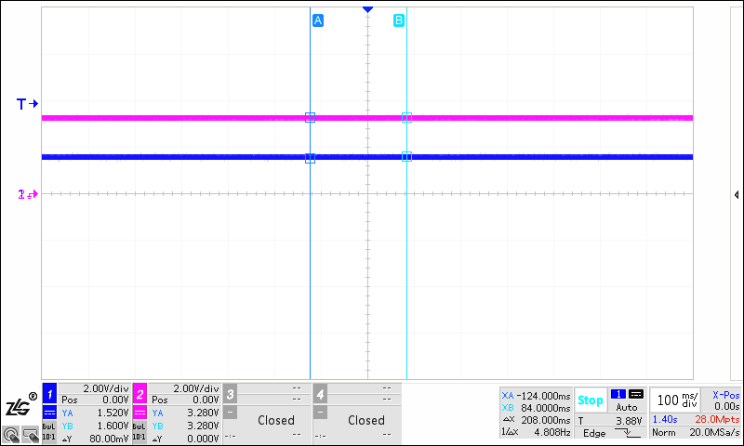

CH1--+9.6V_VCC_LCD(pin10) CH2--+3.3V_VDD_LCD(pin2)

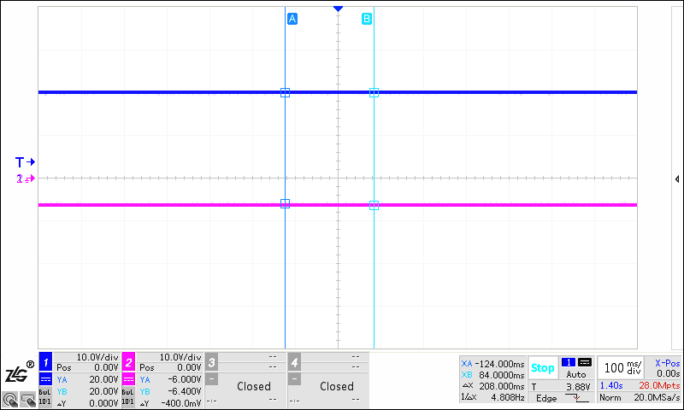

CH1-- +20V_VGH_LCD(pin13) CH2-- - 6V_VGL_LCD(pin18)