Problem Statement
- We’ve found our board provides significantly less charging current for devices that are limited to 5V operation
  - With 5V VBUS muxed at the TPS65988 input, we only see about 600mA drawn by these devices
  - With a modification to bump the 5V rail to 5.35-5.4V we see considerably higher charging current (1.26A). This change was made to compensate for the forward voltage drop of the power mux diode.
- The waveforms captured here intend to provide an overview of native charger performance, negotiation/behavior (if we can access the data lines) and compare our board against the reference design we started with (the TPS65987D based Power Duo)
- Our board uses eight TPS65988’s to provide sixteen 45W USB C compliant charging ports. The schematic has been provided to TI confidentially through email.
- Testing here has found that both devices require a 5.1k pull down on a config channel (CC) in order to enable VBUS
- One anomalous response between the SEUIC device and our board showed the SEUIC device would draw current without the CC pull down. That has not been repeatable and may not be a valid result.

Devices Under test
- SEUIC Cruise 1 with a native wall-wort charger providing up to 2A through USB A-C cable
- Zebra WT6000 with native 5.4V, 3A power supply and a 12V/4A supplied dock that generates 5.3V. My testing yields similar results for both.
- Our board, the schematic for which has been separately emailed to you
- The TPS65987D based Power Duo source board with a DELL 19.5V/9A supply.

Device Native Chargers
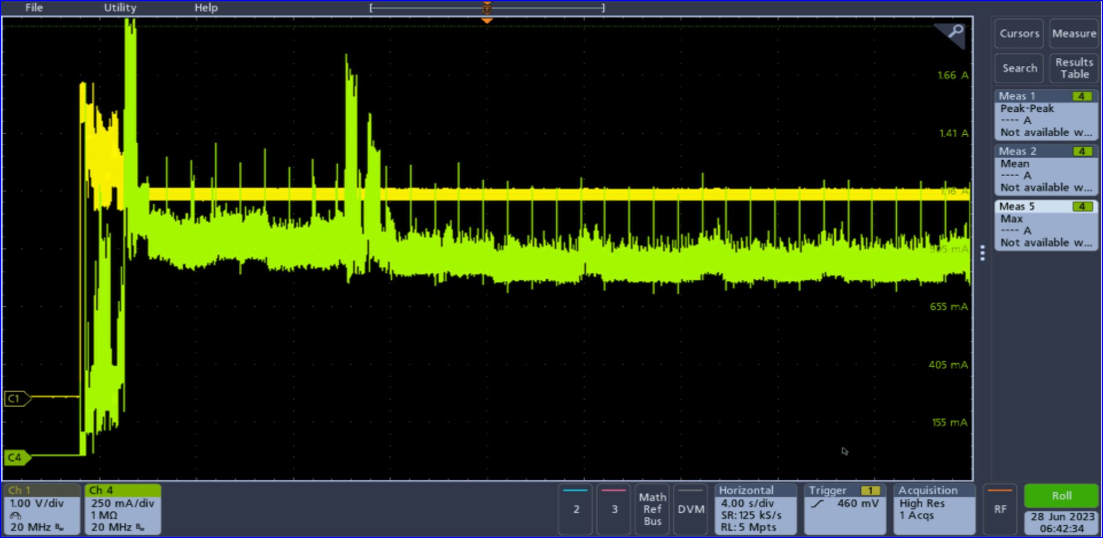WT6000 native charger (dock) current profile. Ch1 – VBUS (V), CH 4 – VBUS (A) Data line voltages unavailable.
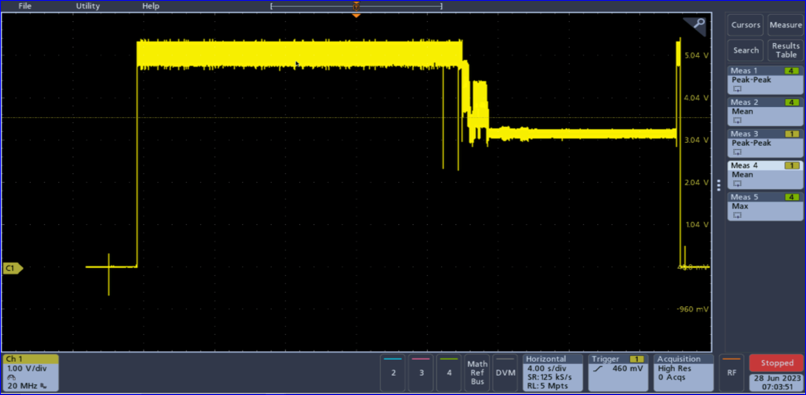 WT6000 in Zebra Dock. Ch 1 : VBUS (V) Unloaded VBUS is 5.3V, device charging causes droop to 3.5V

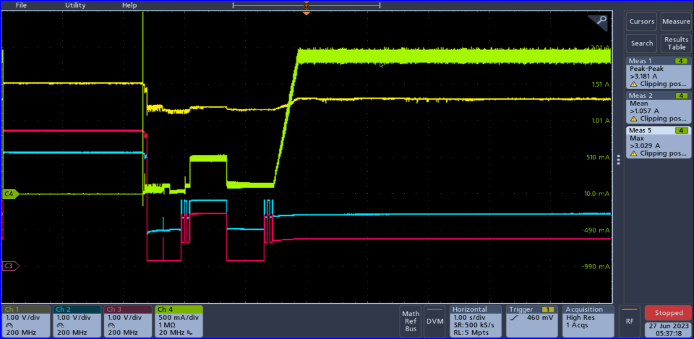Seuic Cruise 1 with native charger. Ch1 – vbus (V), Ch2 & Ch3 – data lines (V), Ch 4 vbus current
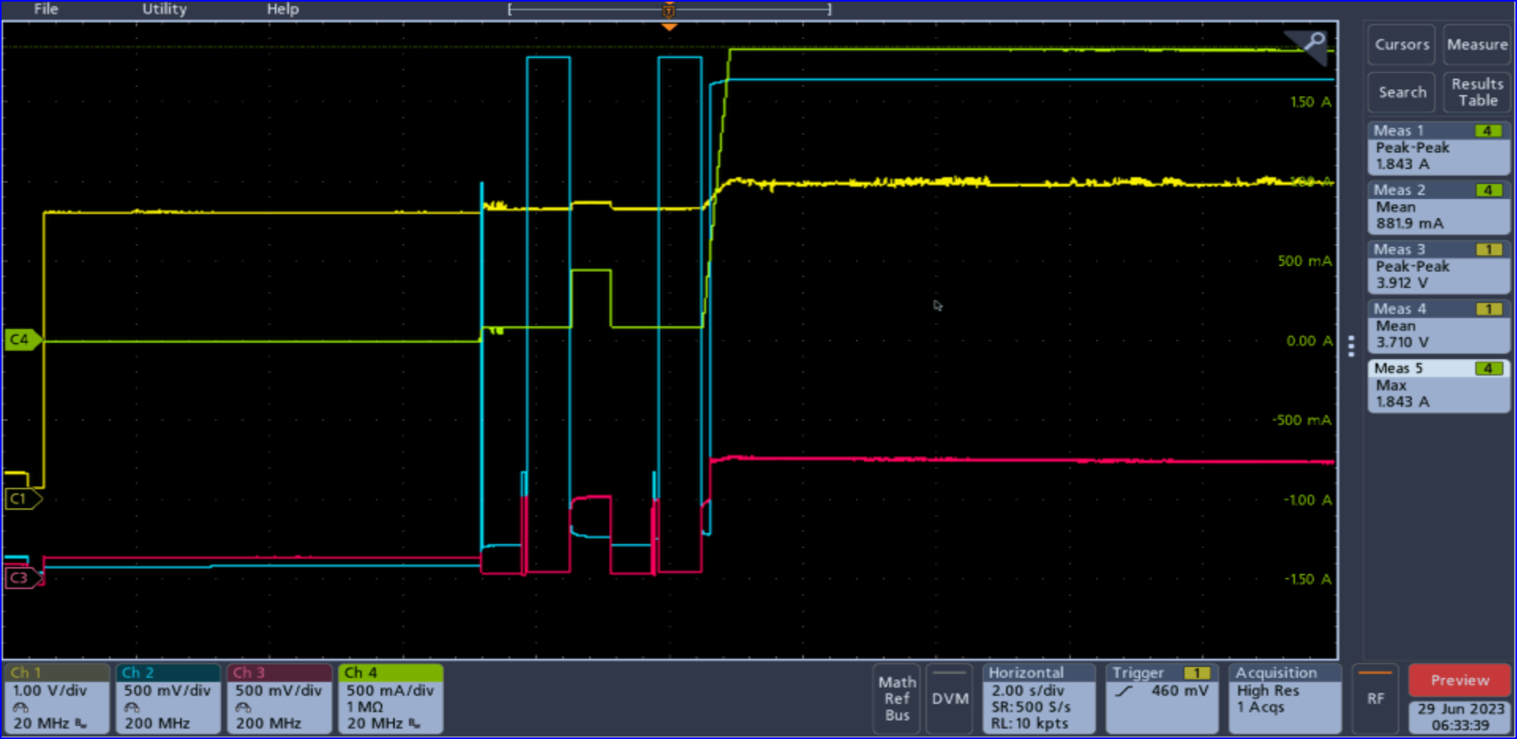Seuic Cruise 1 with native charger. Ch1 – CC (V), Ch2 – Data+ (V), Ch3 – Data- (V), Ch 4 vbus current. CC line goes high when cable is plugged into device. Cable attachment to charger occurs at the 1st spike on Ch 2.

Power Duo Source
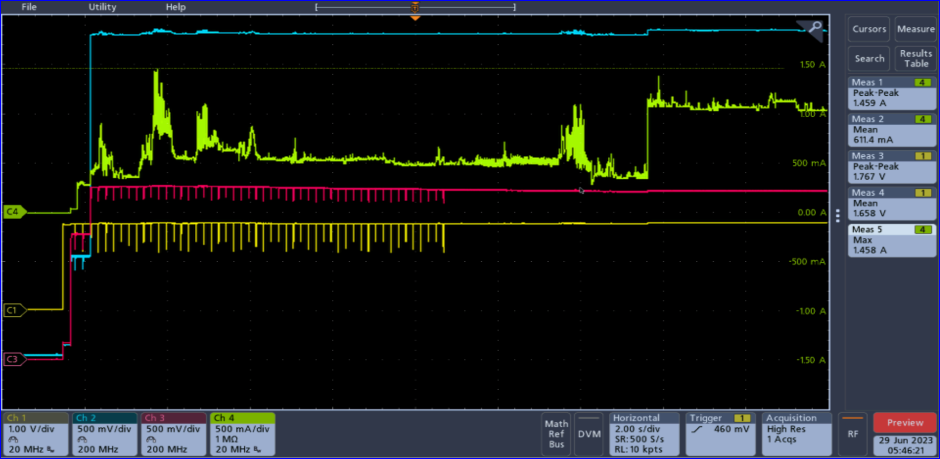WT6000 with CC pull down. Attached to power duo source.
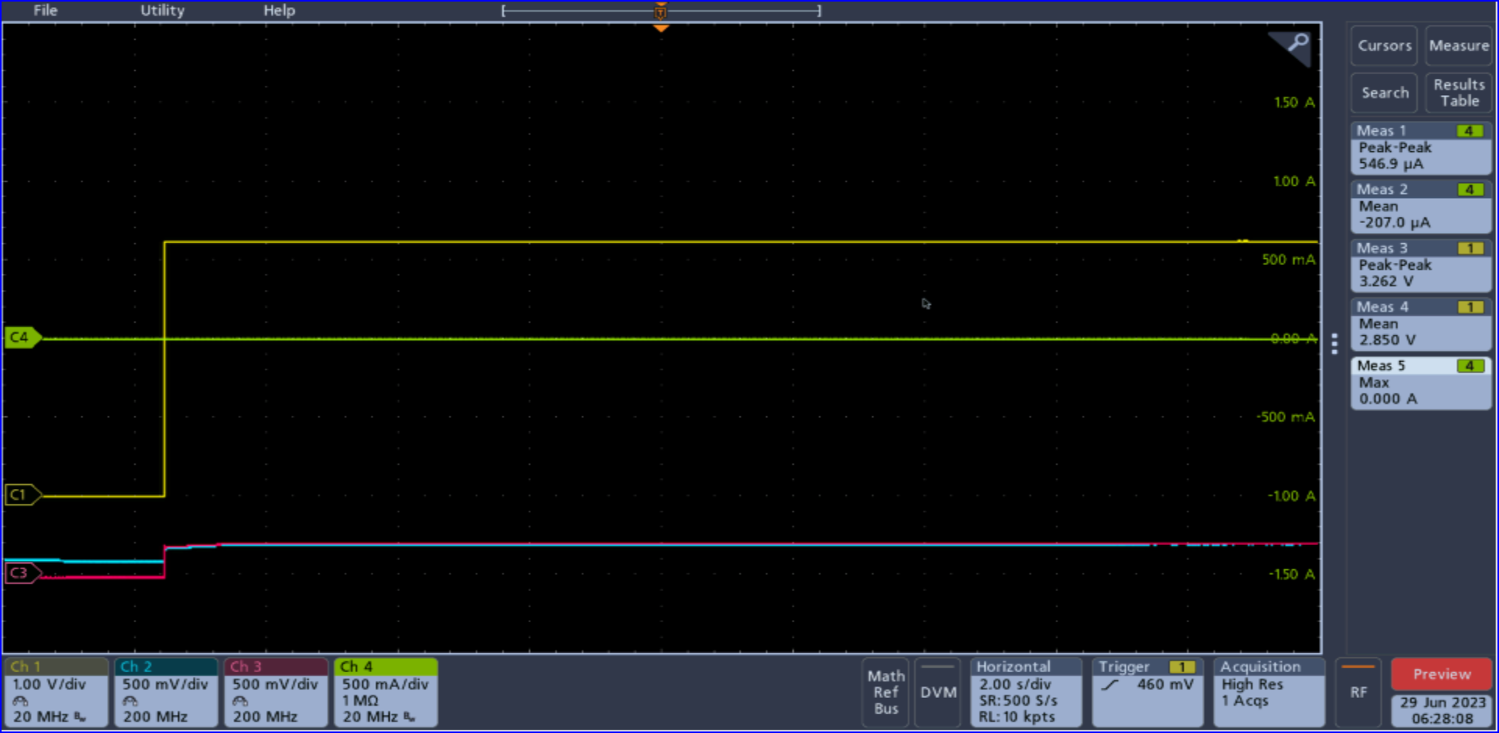WT6000 without CC pull down. Attached to power duo source.

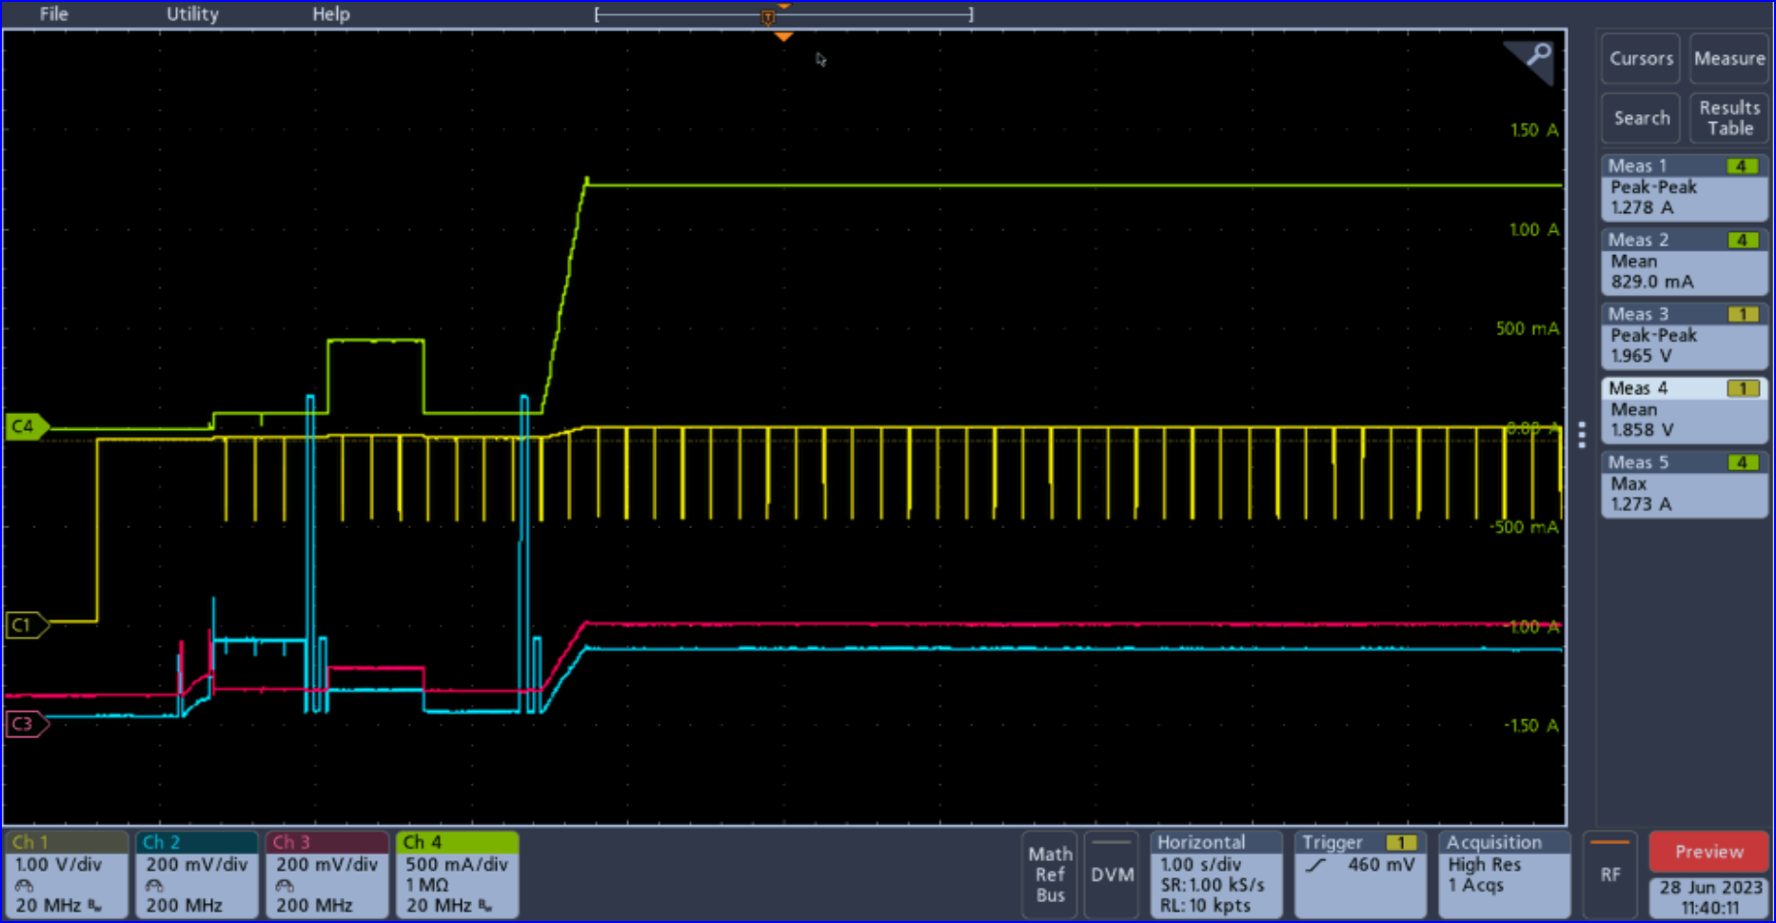 SEUIC with CC pulldown. Attached to power duo source.
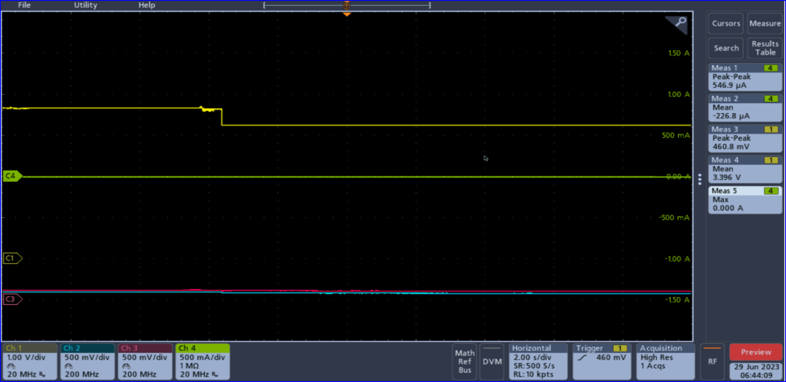SEUIC without CC pulldown. Attached to power duo source.

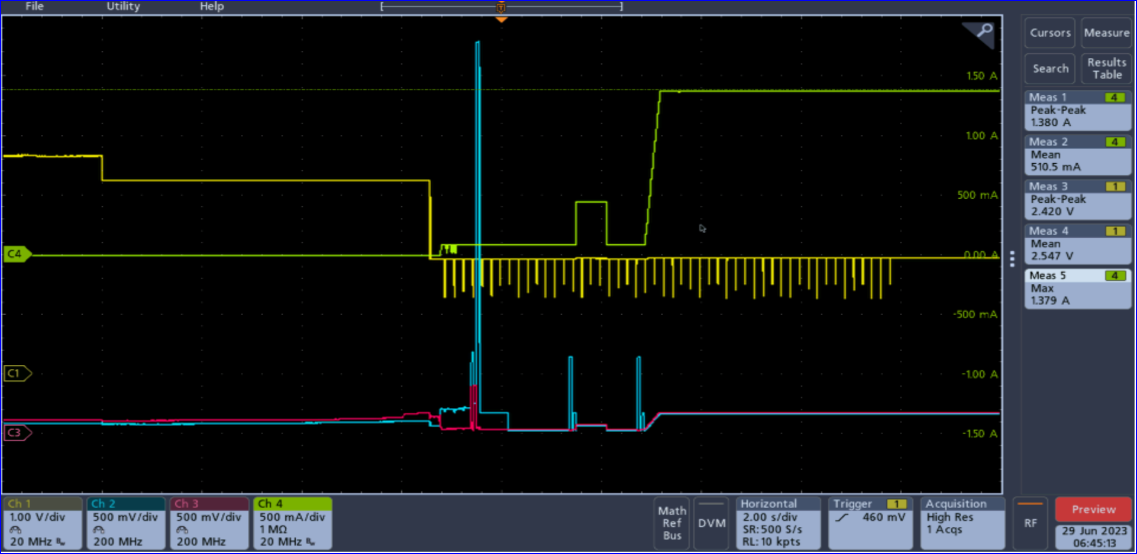Seuic with power duo source. Initial attachment where CC line drops is without cc pull down. Second drop in CC is attachment of the pull down resistor on CC. Then the device charging works as expected.

TPS65988 with 5.0V input to power mux
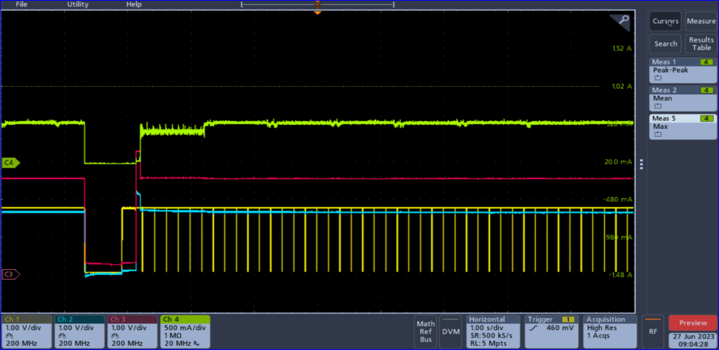WT6000 with our board, pull down on CC in cable. Toggle HRST @ ~1.5 seconds which reboots the TPS65988. Before reboot, the TPS65988 was forced into legacy charging mode by writing 0x46C0091A to the PortControlRegister, 0x29. After the reboot, the TPS65988 reboots to it’s default operation with PD enabled.
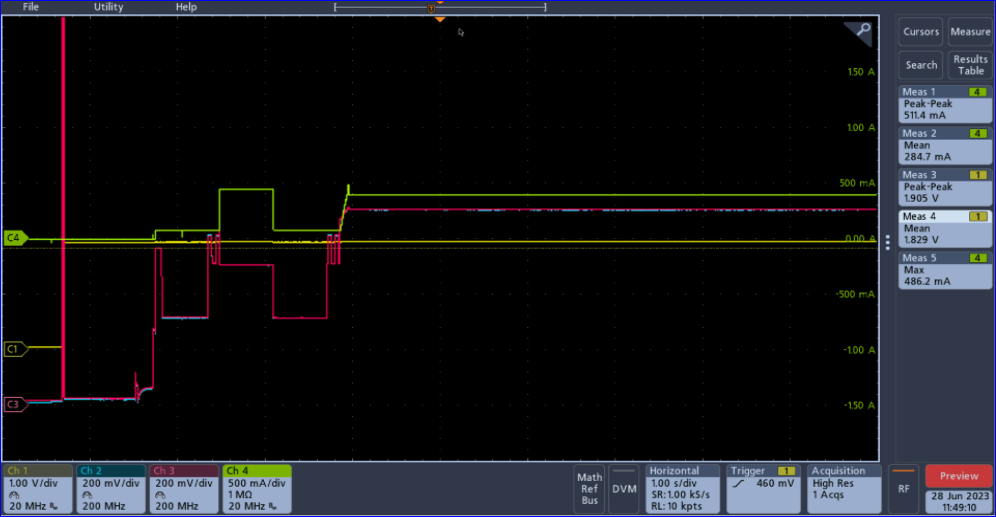New SEUIC with CC pulldown and our board. Poor current draw. VBUS = 5.0V

TPS65988 with 5.35V input to power mux
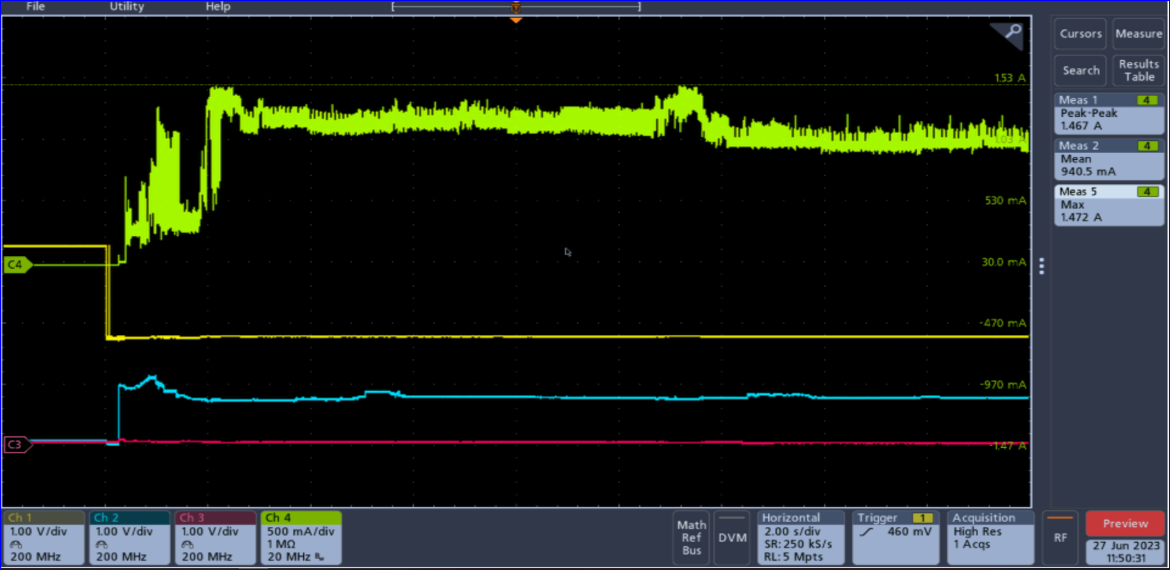Proprietary connector device (no cc pin): Ch1 (yellow) is CC. The first 2 seconds are without a pull down and the remainder is after the pull down was applied in cable.
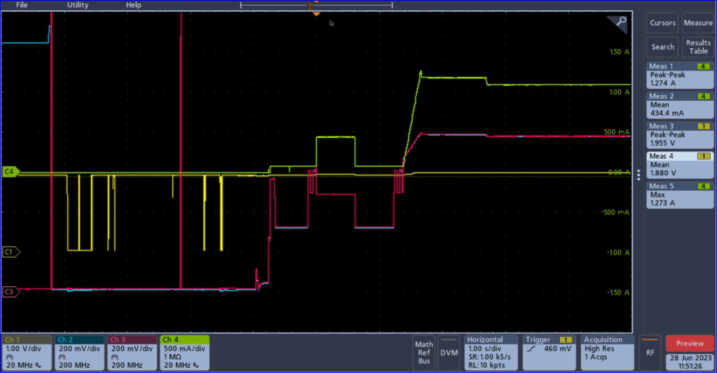New SEUIC with CC pulldown and modified NuBoard with 5.35V rail.
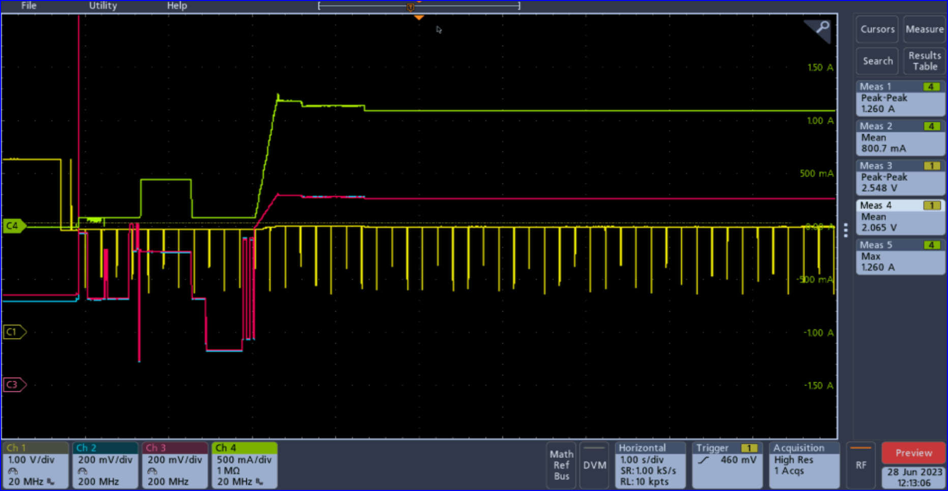New SEUIC on a modified REV F NuBoard, no activity until the pull down resistor is connected. Battery nearly charged. Pk current 1.26A, nominal 1.1A
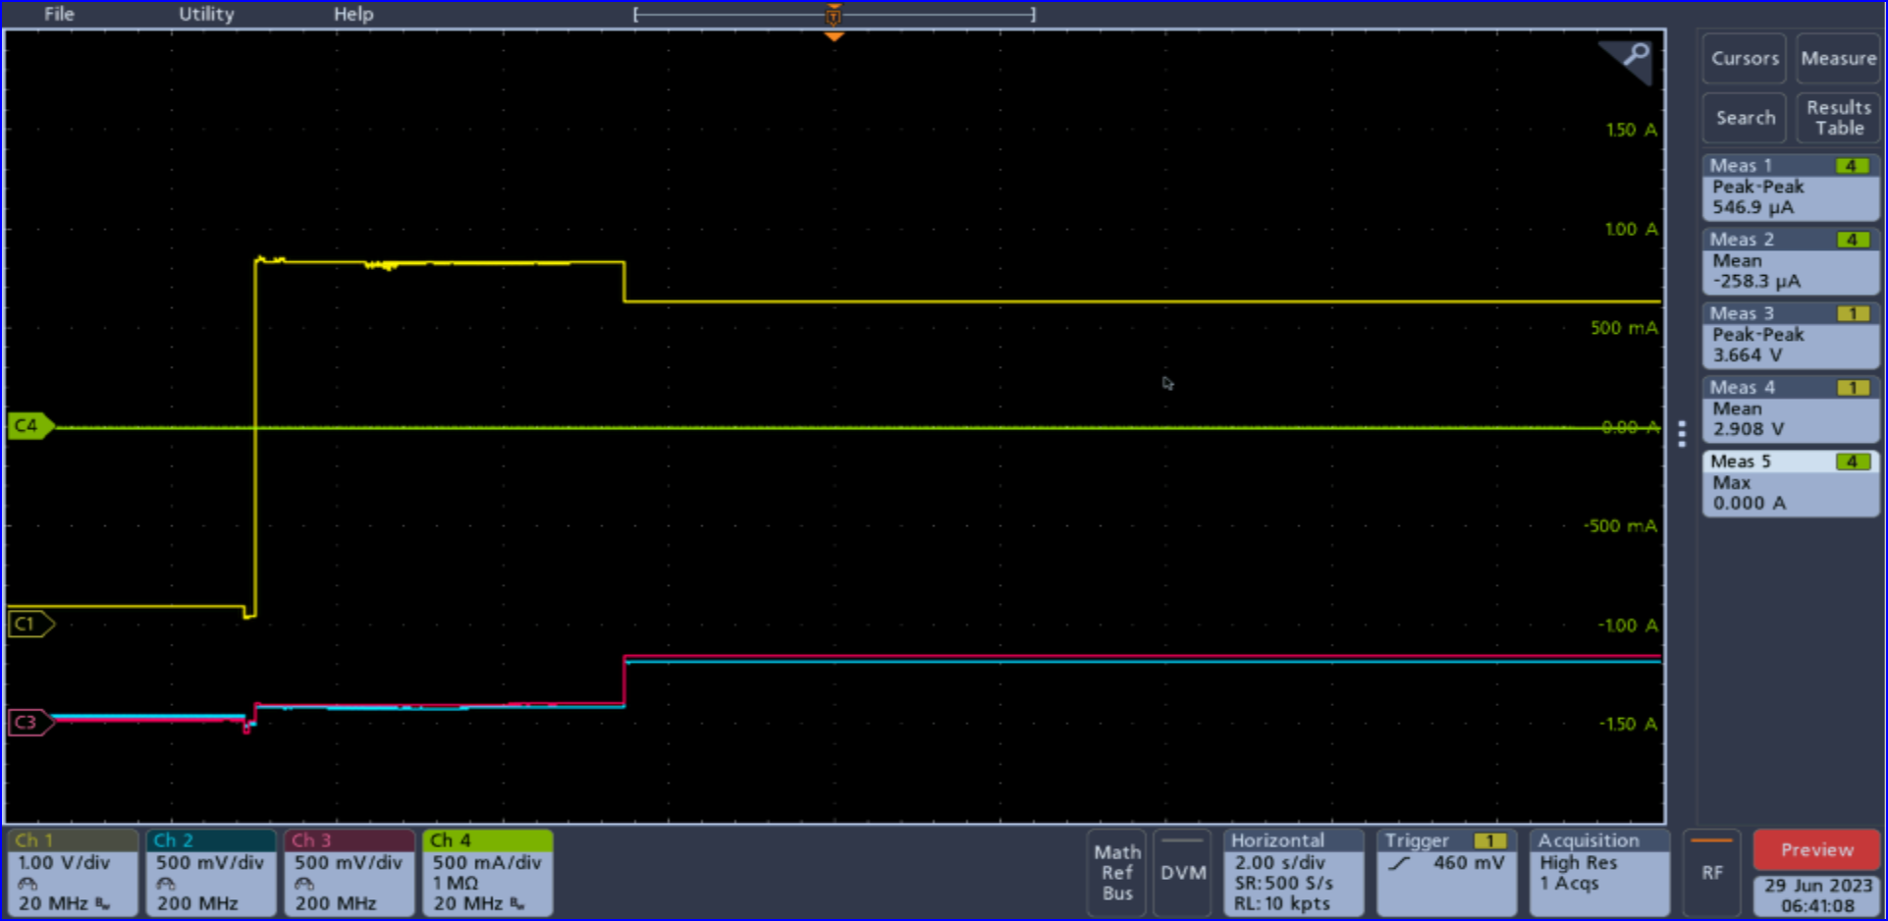SEUIC without CC pulldown. Attached to NuBoard.

