1. Could you please explain what the purpose of Bias pin at TPS7A83A and TPS748? Why TPS7A92 without this pin?
2. Attached PSRR graph for TPS748 :

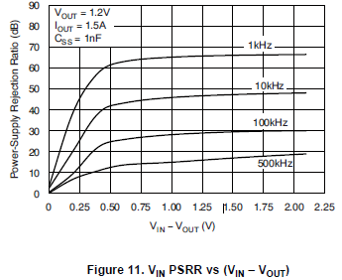

* 1. I need the same graph for Vout = 3.3 and Iout=1.5A, Css=1nF.
  2. Could you please provide this info for TPS7A83A & TPS7A92?

1. What the optimal Vin (best noise performance and High PSRR) when Vout =3.3 @ Iout = 1.5A for all 3 LDO’s ?
2. Please provide graph of Noise Spectral Density 100Hz-10MHz for: Vout=3.3v @ Iout = 1A, according to the datasheet there is info only about Iout = 100mA and Vout= 1.2v

