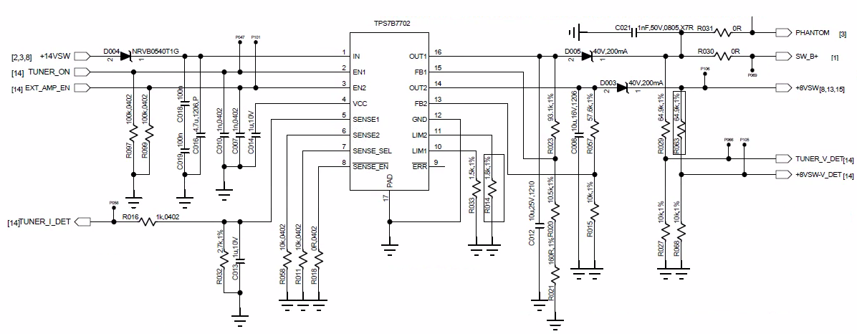

OUT2　Normal Current is about 57mA with multi-meter test:

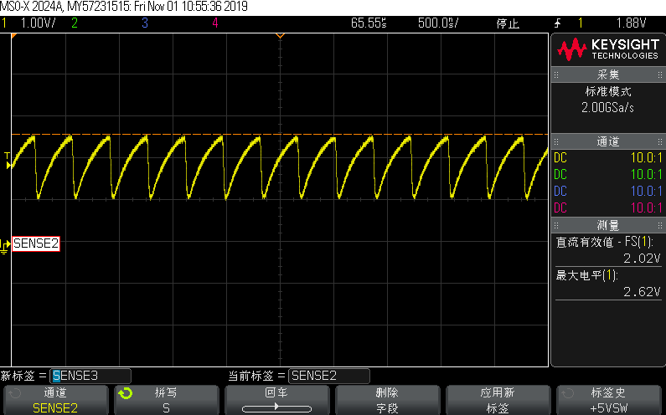

OUT2　short to GND current is about 110mA with multi-meter test: