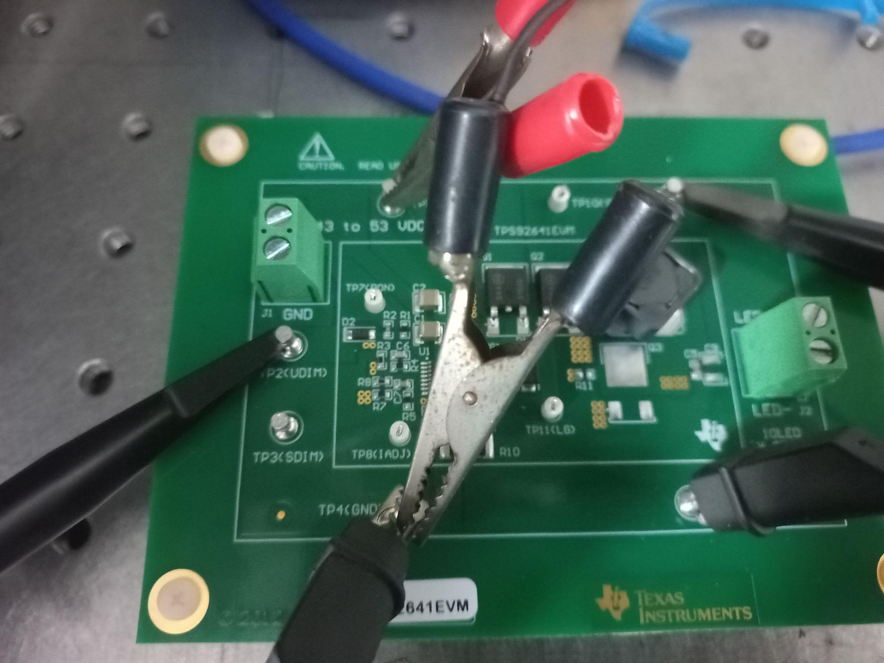

Hello

we have procured the TPS 92641 EVM board and have made connections and testing by following the user guide

Input specifications

1. Power supply **12 V, 1 A**

(Pins involved - TP1(Vin) , TP4(GND))

2) Signal Generator **3V, 200 Hz , D=0.5**

(Pins involved - TP2(Udim) , TP4(GND))

UDIM - PWM dimming control

Output specifications

1. Oscilloscope_LED-

(Pins involved - TP5(LED+) , TP6(LED-))

NO LED across

**We plugged oscilloscope**

**To measure voltage across**

As per the user guide we expected to get across TP5(LED+) and TP6(LED-)

However we got the below outputs

1)A **constant 5V output** across LED+ and LED- pins(**yellow**) for a **square pulse 3V** across UDIM and GND

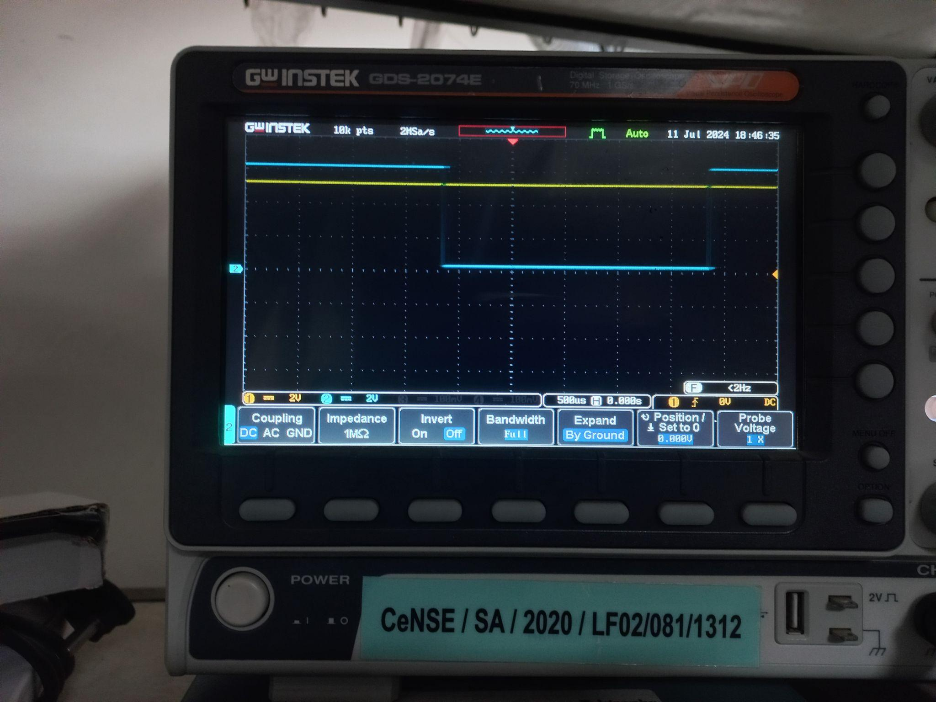

A **constant 5V output** across LED+ and LED- pins(**Yellow**) for no input across UDIM and GND

Making the output independent of the UDIM pulse.

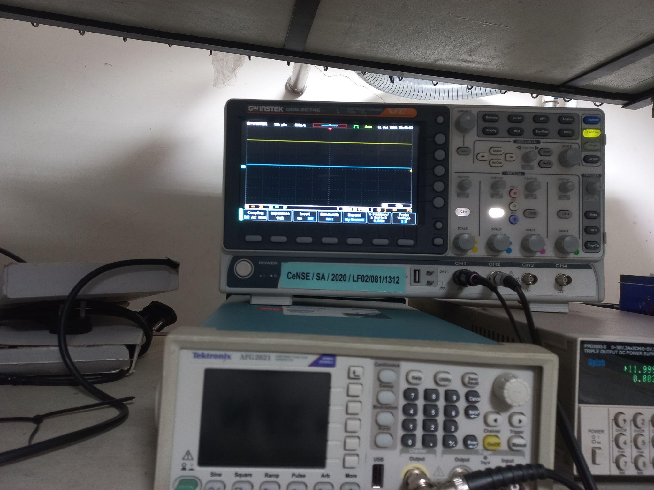

Please clarify as to what can be done to get the expected outputs.

Additionally How do we set the current through the LED.

Thank You