Charge to 24% SOC under 25℃ and store for more than 5 hours before shutdown
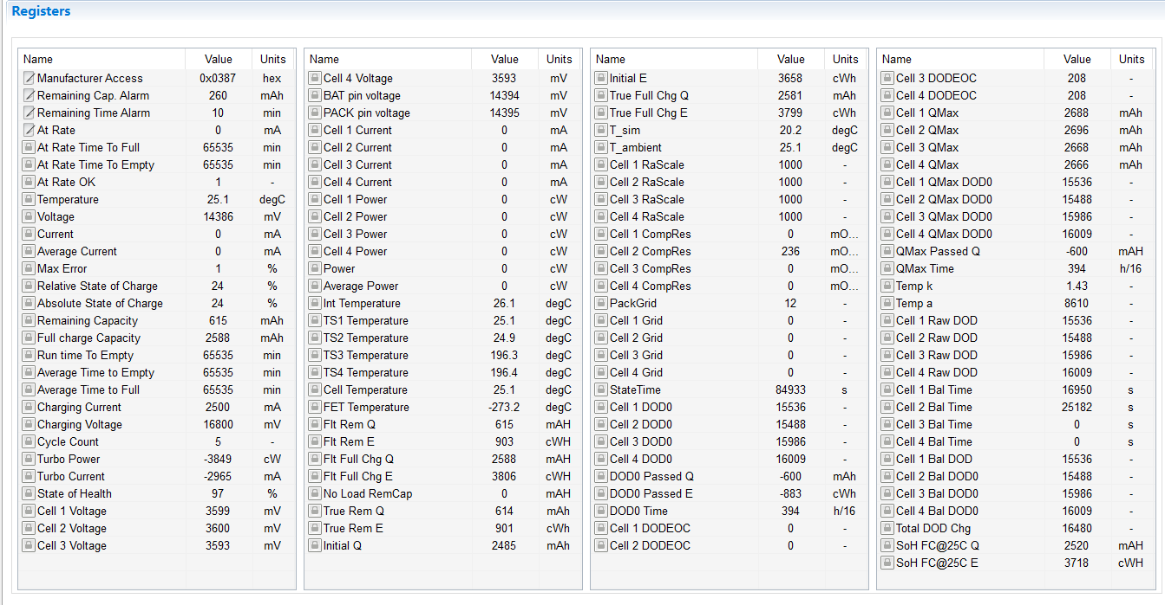

After exiting shutdown, the FCC, SOC and DOD0 jumped and changed a lot.
