# BQ76952EVM Test Results

Test conditions:  
BQ76952EVM with 4 LFP Cells, with and without 100 Ohm load resistance

| Test | Load | ALL_FETS_ON Command | Steps | PDSG Behavior | PACK VOLTAGE Behavior |
| --- | --- | --- | --- | --- | --- |
| 1 | 100 Ohm | Present | 1. Set PDSG TIMEOUT to 2 Sec 2. Set DFETOFF to 1 3. Send ALL_FETS_OFF  4. Set DFETOFF to 0 5. Send ALL_FETS_ON | Asserted, then de-asserted after 2 sec | 0.32V → 12.29V after 2 sec |
| 2 | 100 Ohm | Present | 1. Set PDSG STOP DELTA to 255 2. Set DFETOFF to 1 3. Send ALL_FETS_OFF  4. Set DFETOFF to 0 5. Send ALL_FETS_ON | Remains asserted | Stays at 0.32V |
| 3 | 100 Ohm | Absent | 1. Set PDSG TIMEOUT to 2 Sec 2. Set DFETOFF to 1 3. Send ALL_FETS_OFF  4. Set DFETOFF to 0 | Asserted, then de-asserted after 2 sec | 0.32V → 12.29V after 2 sec |
| 4 | 100 Ohm | Absent | 1. Set PDSG STOP DELTA to 255 2. Set DFETOFF to 1 3. Send ALL_FETS_OFF  4. Set DFETOFF to 0 | Remains asserted | Stays at 0.32V |
| 5 | No Load | Absent | 1. Set PDSG TIMEOUT to 2 Sec 2. Set DFETOFF to 1 3. Send ALL_FETS_OFF  4. Set DFETOFF to 0 | Asserted, then de-asserted after 2 sec | 0.32V → 12.29V after 2 sec |
| 6 | No Load | Absent | 1. Set PDSG STOP DELTA to 255 2. Set DFETOFF to 1 3. Send ALL_FETS_OFF  4. Set DFETOFF to 0 | Asserted, then de-asserted | 12.41V → 12.53V |
| 7 | No Load | Present | 1. Set PDSG TIMEOUT to 2 Sec 2. Set DFETOFF to 1 3. Send ALL_FETS_OFF  4. Set DFETOFF to 0 5. Send ALL_FETS_ON | Asserted, then de-asserted after 2 sec | 12.41V → 12.53V |
| 8 | No Load | Present | 1. Set PDSG STOP DELTA to 255 2. Set DFETOFF to 1 3. Send ALL_FETS_OFF  4. Set DFETOFF to 0 5. Send ALL_FETS_ON | Remains asserted | Stays at 12.41V |

Test 1: PDSG Timeout 2000 ms  
Source1: Stack Voltage  
Source2: LD Voltage  
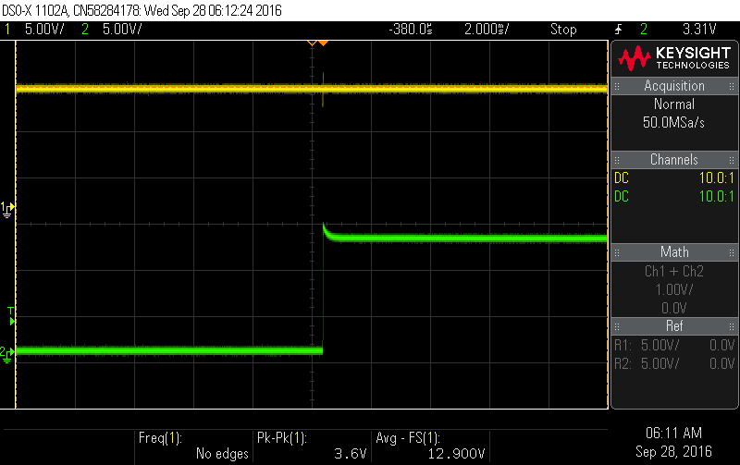

Test 1: PDSG Timeout 2000 ms  
Source1: DSG  
Source2: LD_Voltage  
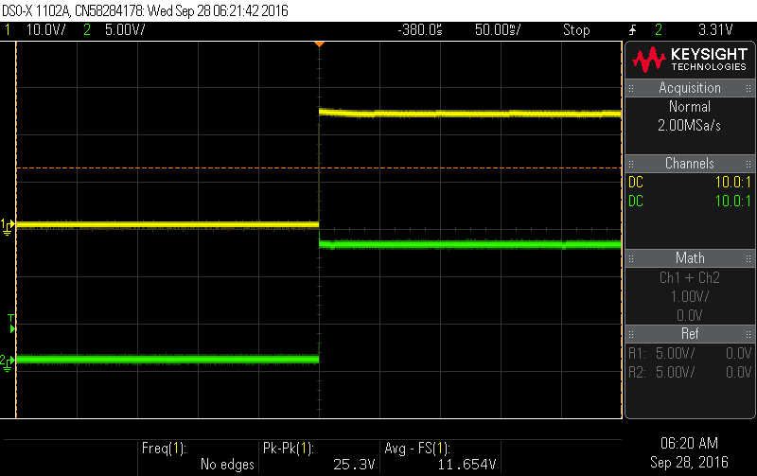

Test 1: PDSG Timeout 2000 ms  
Source1 PDSG  
Source2: LD_Voltage  
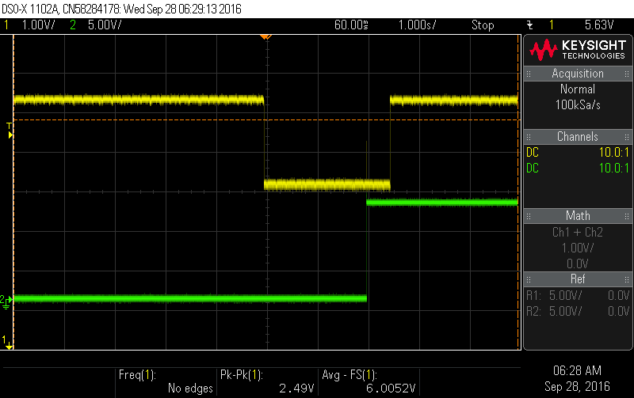

Test 2: PDSG stop delta 255 (=2.55 V)  
Source1: Stack Voltage  
Source2: LD Voltage  
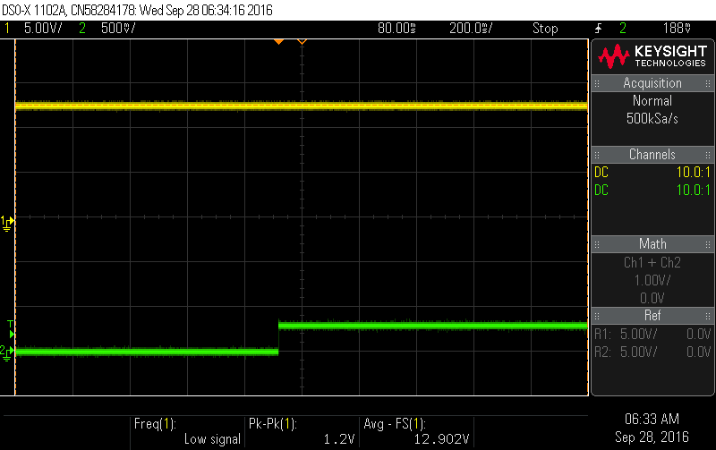

Test 2: PDSG stop delta 255 (=2.55 V)  
Source1: DSG  
Source2: LD Voltage  
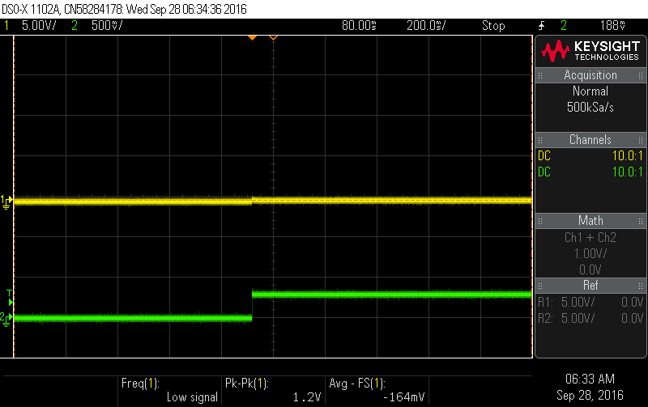

Test 2: PDSG stop delta 255 (=2.55 V)  
Source1: PDSG  
Source2: LD Voltage

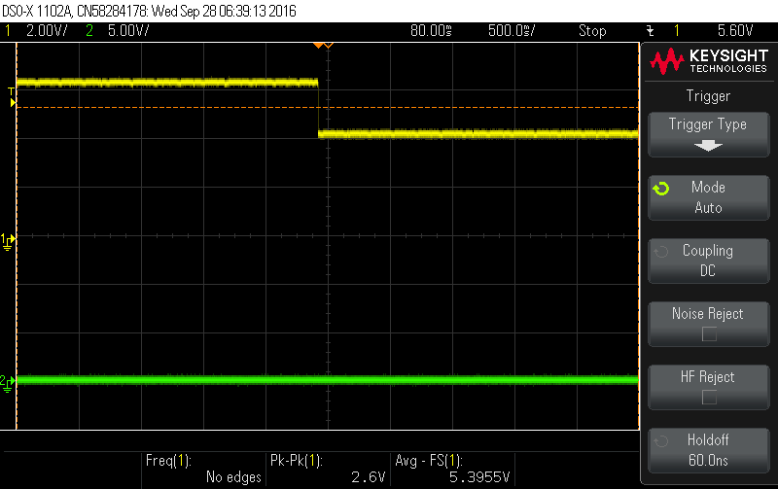

Test 4: PDSG Timeout 2000 ms (No Load)  
Source1: Stack Voltage  
Source2: LD Voltage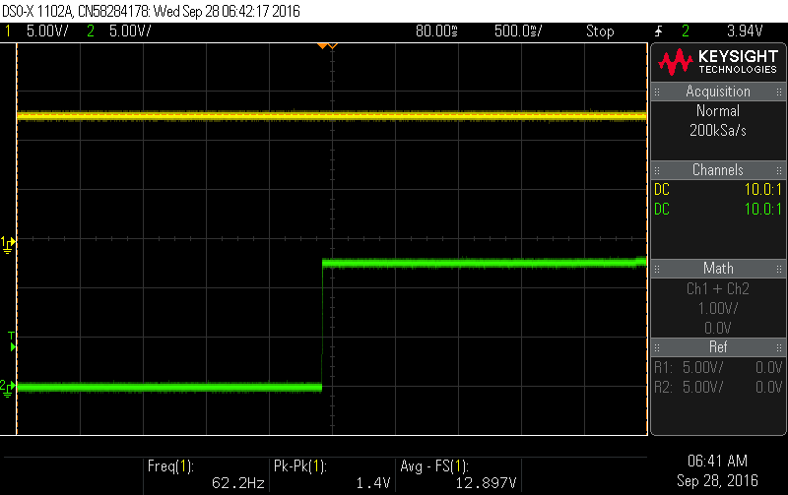

Test 4: PDSG Timeout 2000 ms (No Load)  
Source1: DSG  
Source2: LD Voltage

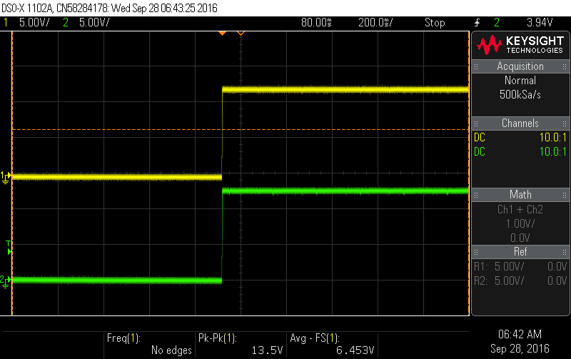

Test 5: PDSG stop delta 255 (=2.55 V) (No Load)  
Source1: Stack Voltage  
Source2: LD Voltage  
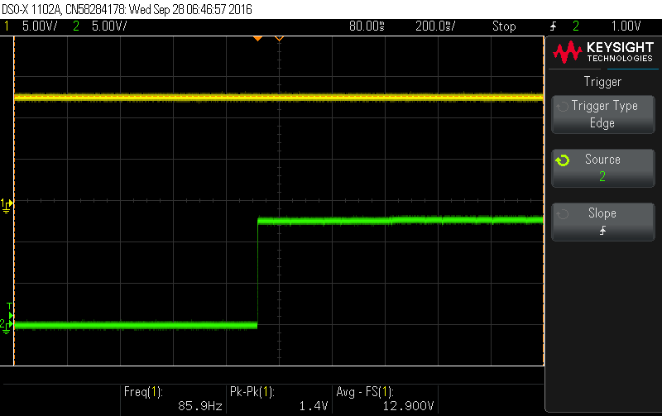

Test 5: PDSG stop delta 255 (=2.55 V) (No Load)  
Source1: DSG  
Source2: LD Voltage

