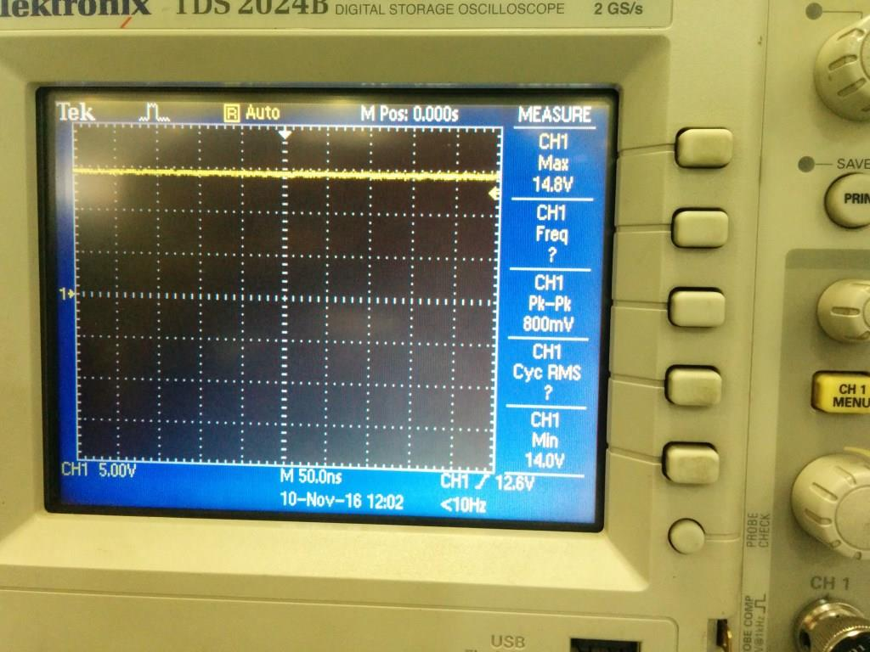
Figure 1 VIN at Normal operation
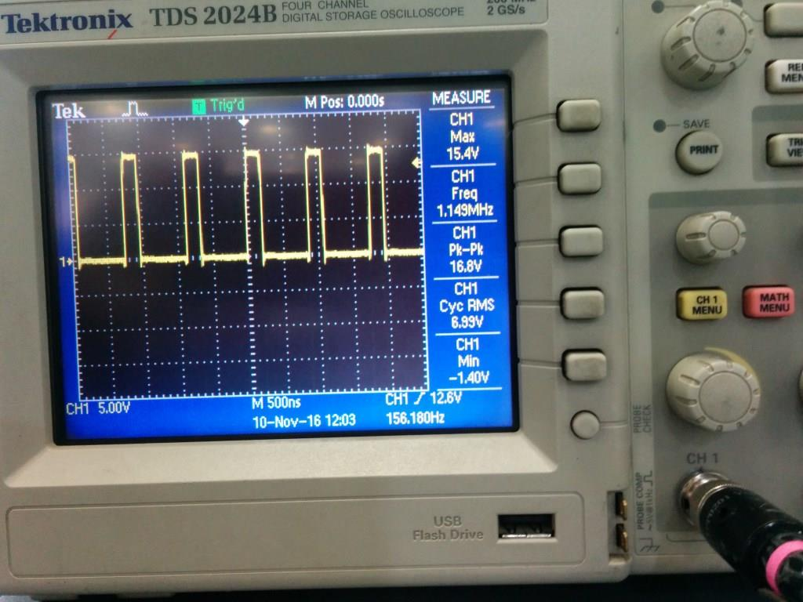
Figure 2 Lx at Normal operation with Normal Load
Figure 3 Vout put at Min load 3.3V

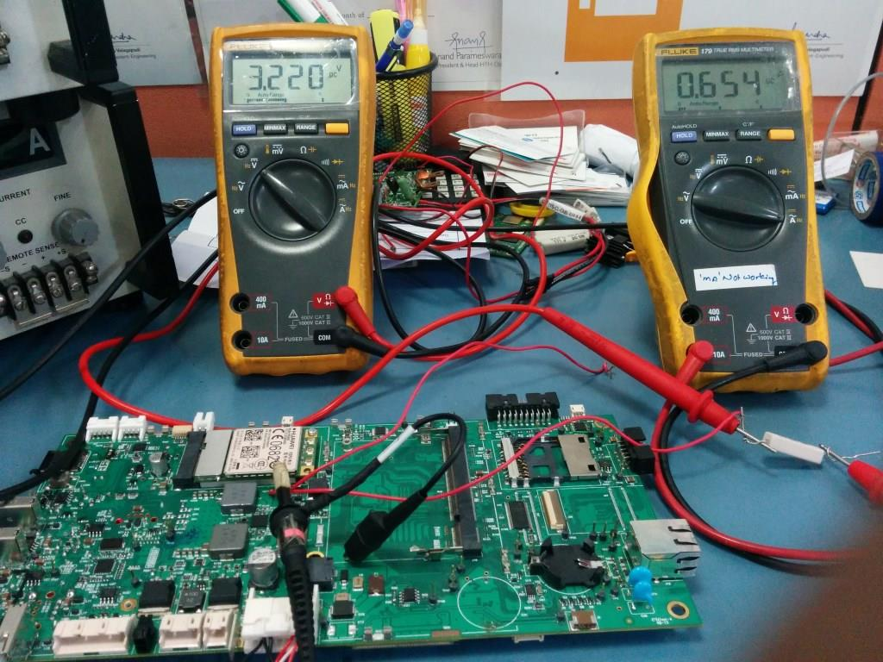
Figure 4 Normal readings with 3.3V@ Normal load
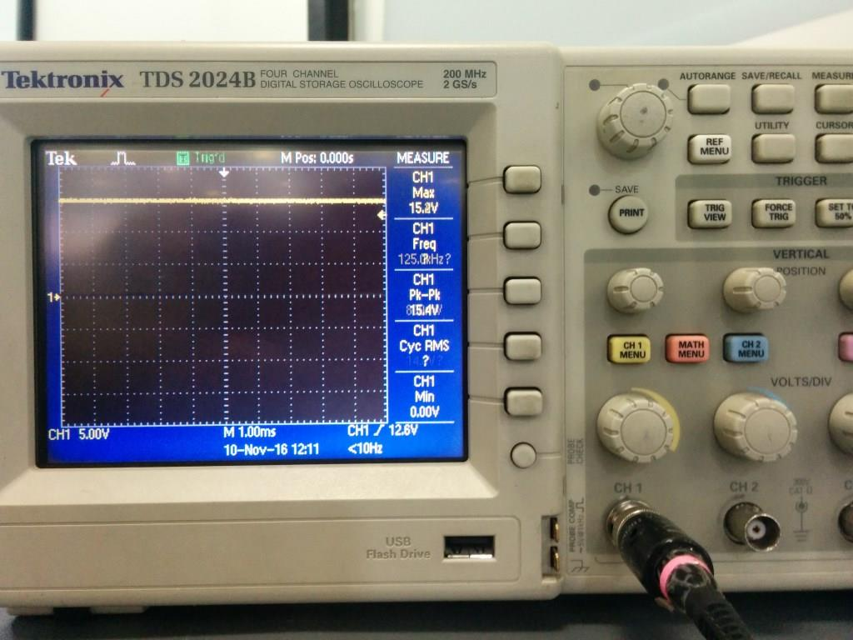
Figure 5 Vin at Peak load

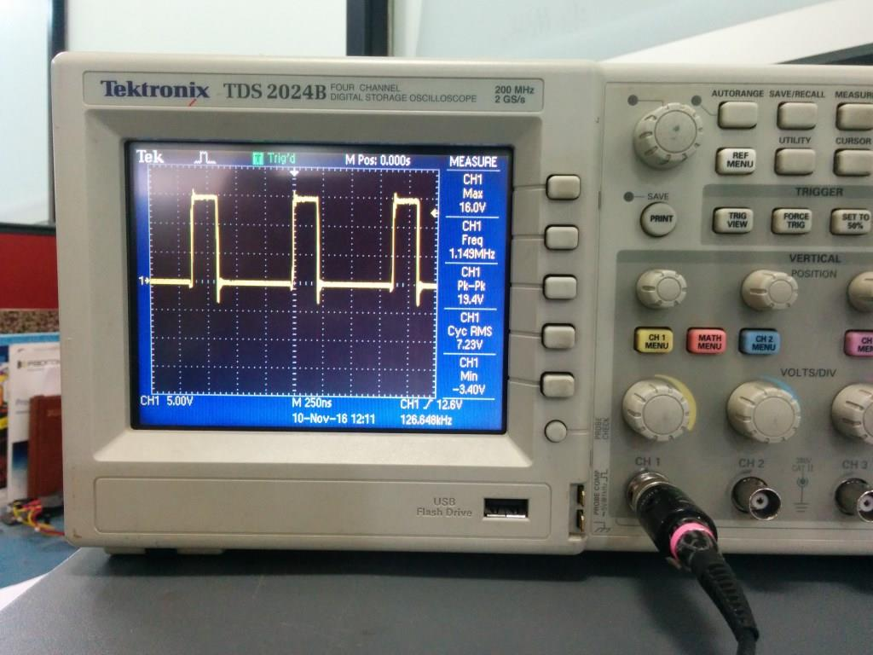
Figure 6 Lx showing when at Max load
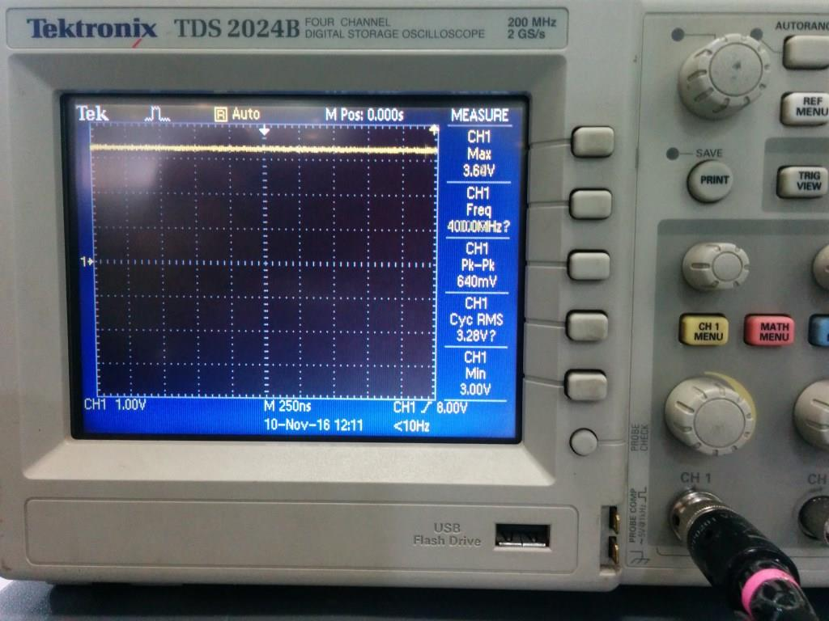
Figure 7 Voutput at max load

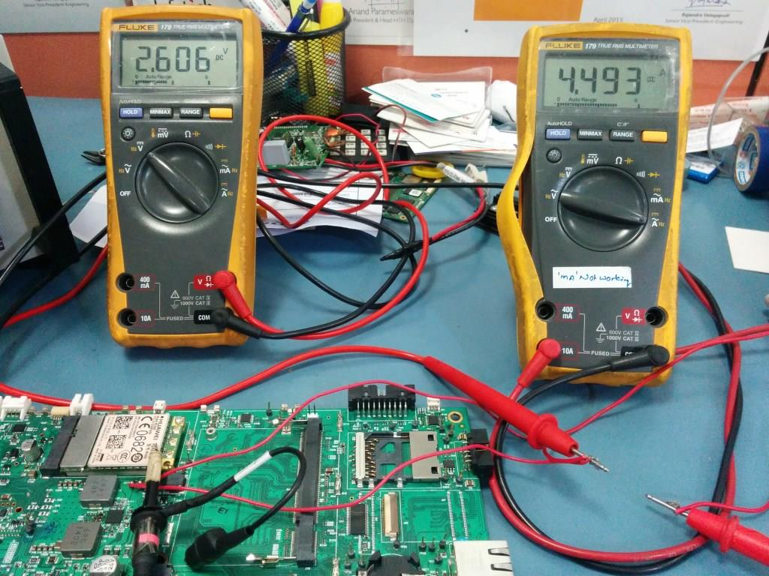
Figure 8 Reading showing Voutput and Max Load current

