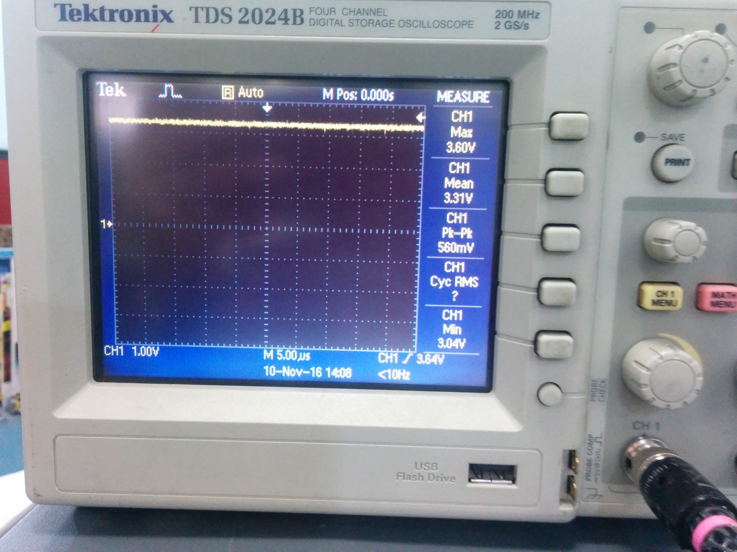
Figure 1: Voltage Measure at Output at max current
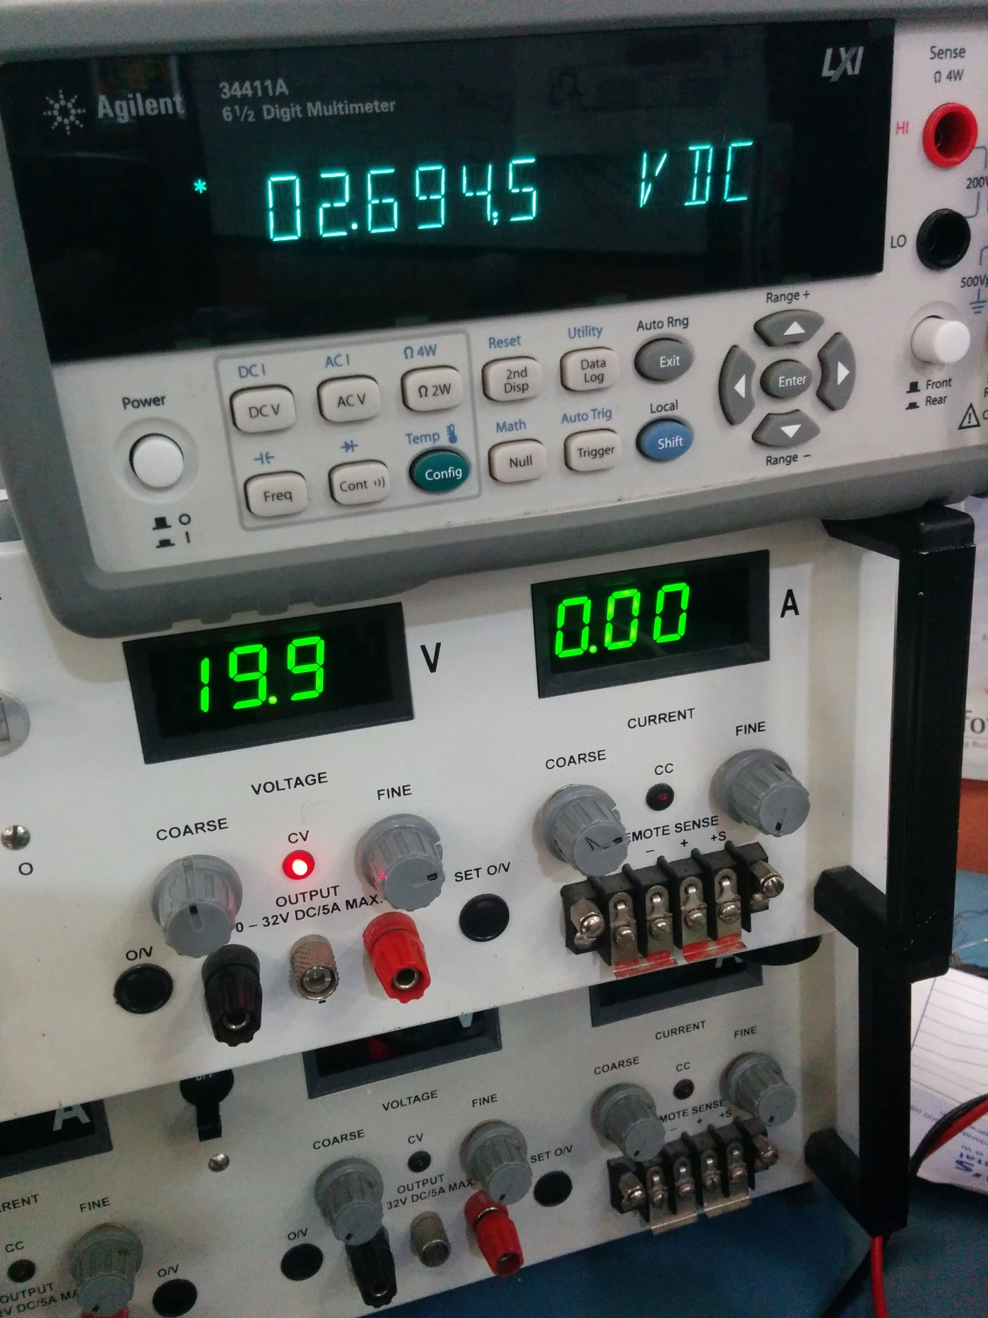
Figure 2: MM Measurement
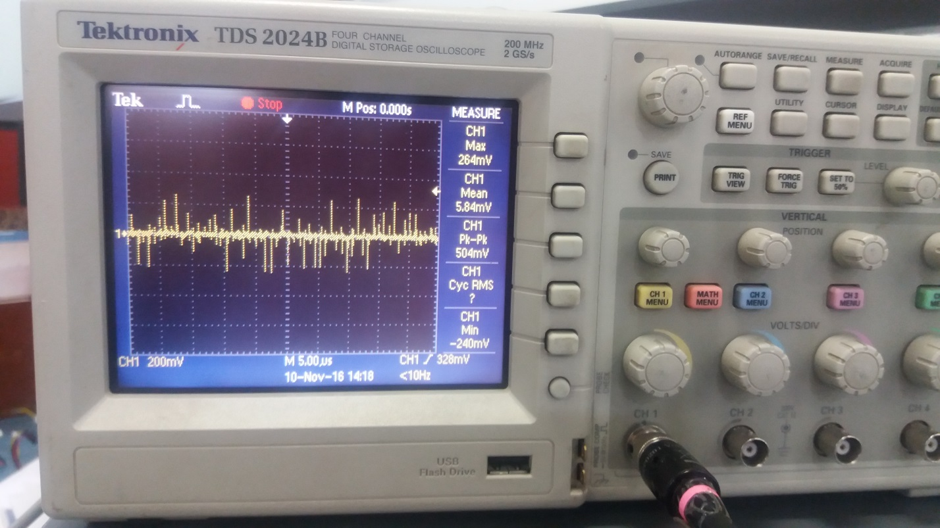
Figure 3: V Ripple at 3.3V Output at Max load

