The difference between LM2576HVT-5.0 and LM2576HVT-5.0/LB03:

1. LM2576HVT-5.0 is a straight lead part. Below is the drawing (KC).

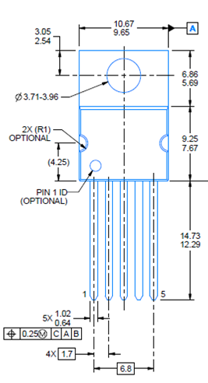

1. LM2576HVT-5.0/LB03 is a staggered lead part. Below is the drawing (NDH).

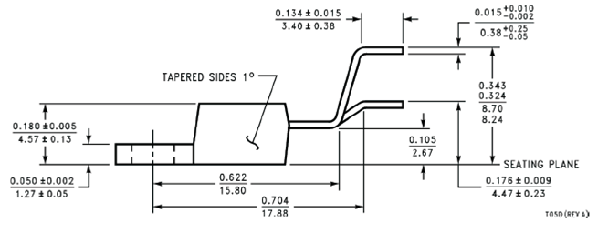

The question from customer is if there is a replacement for flow LB03; there is no replacement because of the lead form difference although standard flow (straight lead) & LB03 flow (staggered lead) are pin to pin compatible.