The power-on waveform of the new screen is as follows:

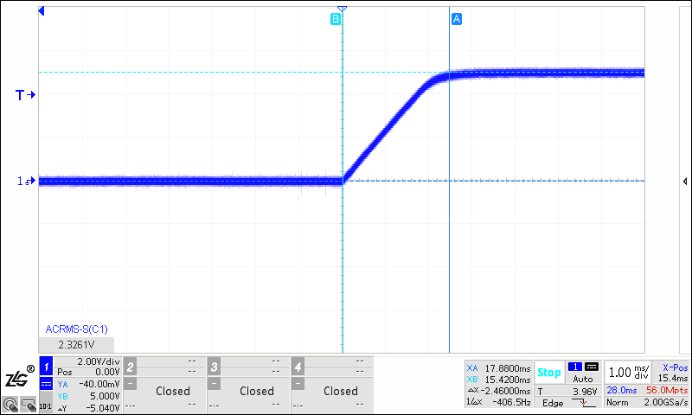

CH 1-- +11V_AVDD_LCD

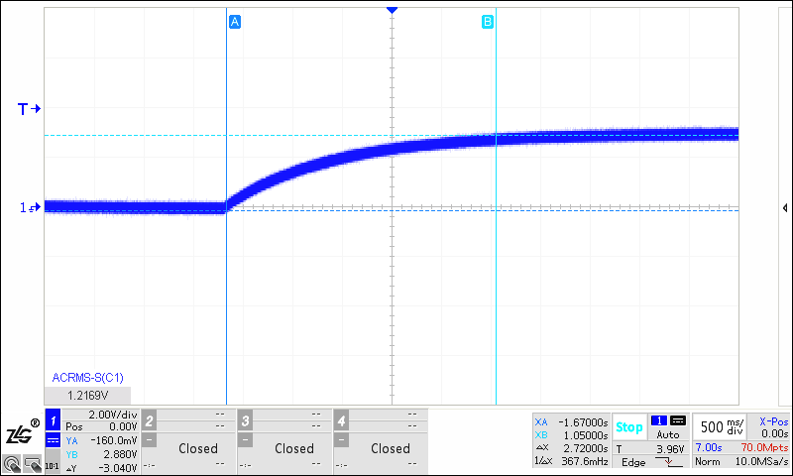CH1-- +20V_VGH_LCD

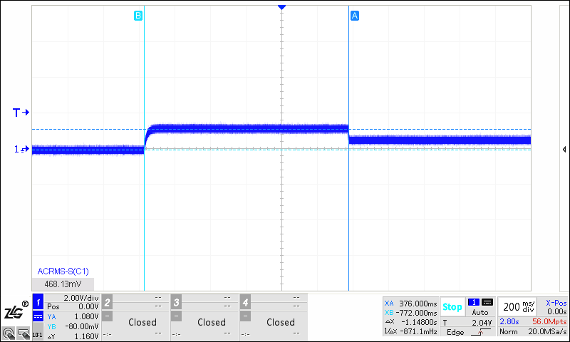

CH1-- +9.6V_VCC_LCD

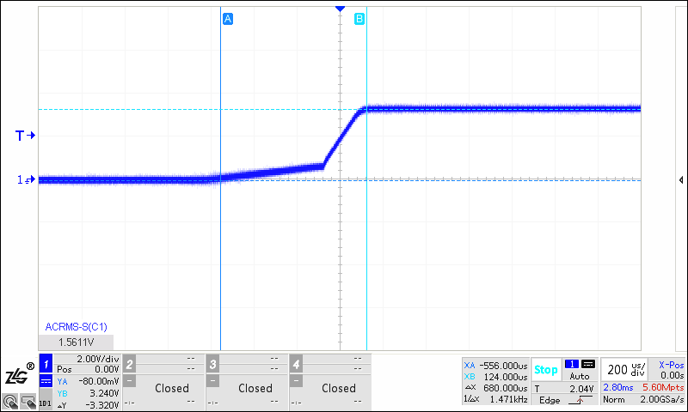

CH1-- +3.3V_VDD_LCD

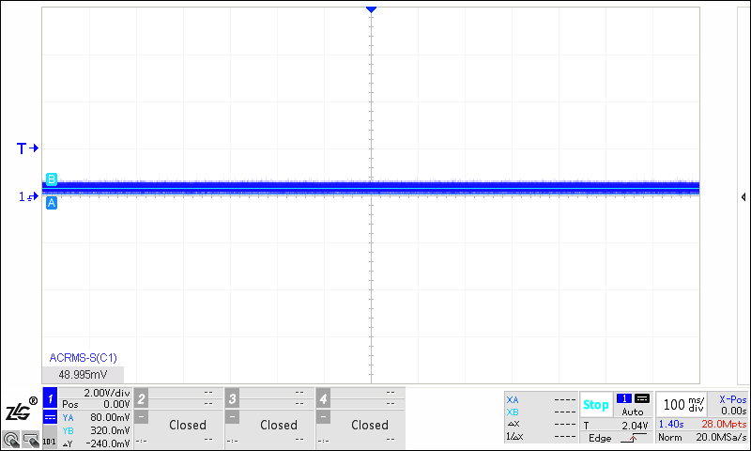

CH1-- - 6V_VGL_LCD

power-on waveform of Hanchuan Public Security Bureau is as follows:

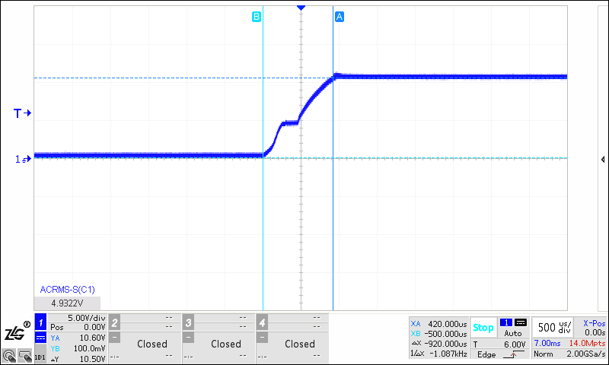

CH1 -- +11V_AVDD_LCD 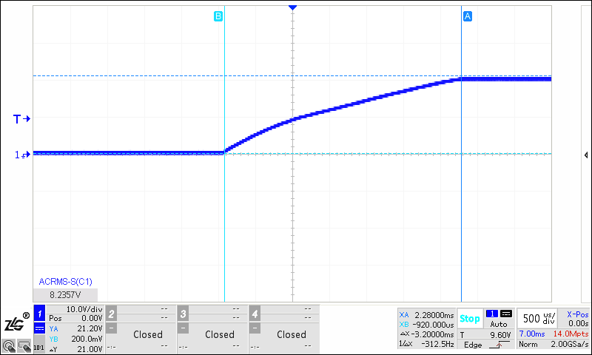

CH1-- +20V_VGH_LCD

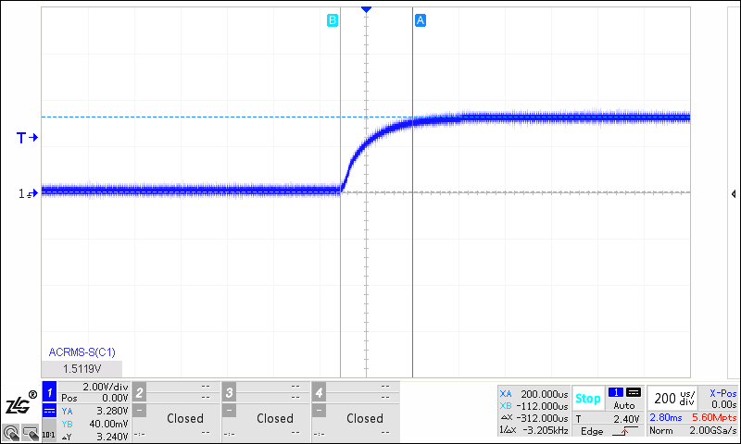

CH1-- +3.3V_VDD_LCD

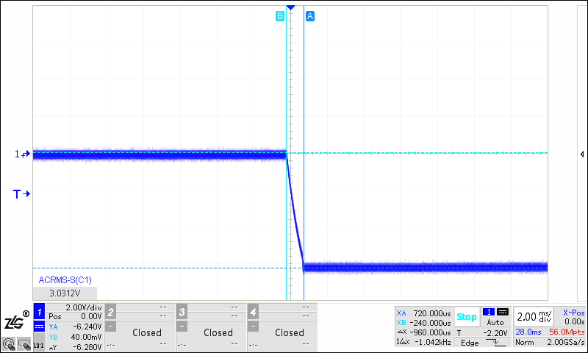

CH1-- - 6V_VGL_LCD

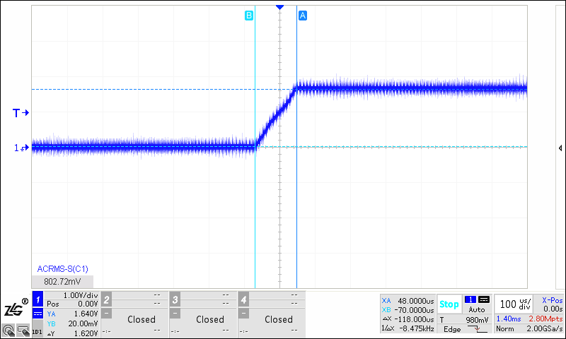

CH1-- +9.6V_VCC_LCD