Investigate with Card #0001

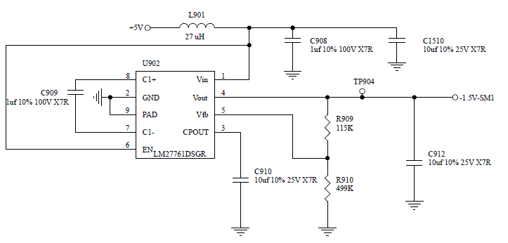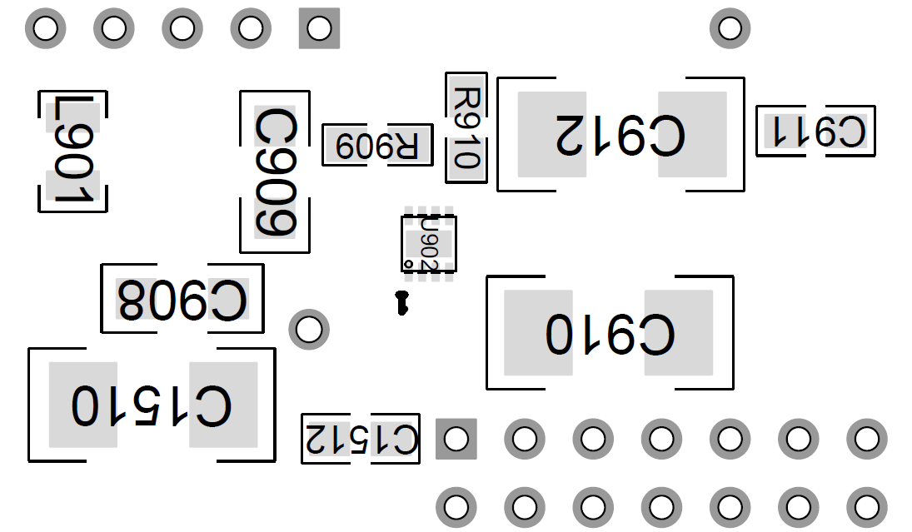

Vout= U902-4= 0.77

Vfb= 0.41

VC1+=3.57

Vin= 5.08

Disconnect inverter:

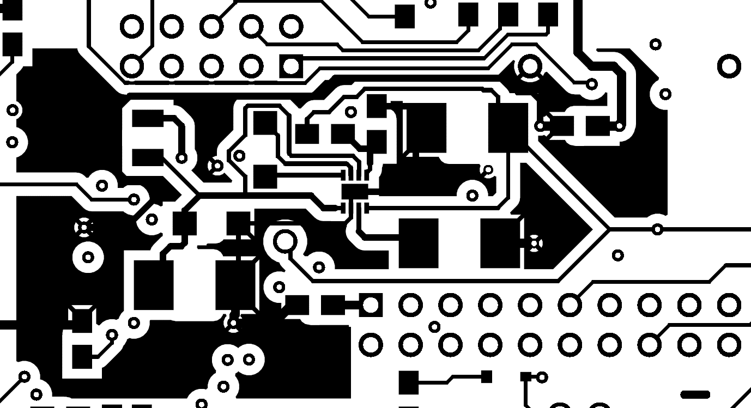

X

Cut

Vfb



VOUT

VC1+

Vout= U902-4= -2.31V

Vfb=U904-5= -1.87

(load side voltage)=TP904= 1.66V

VC1+= U902-8= 4.48

Vin=U902-1=5.04

Load side of DC/DC inverter:

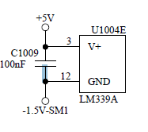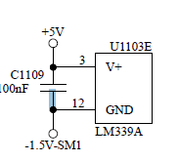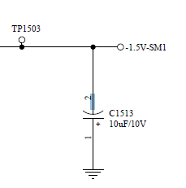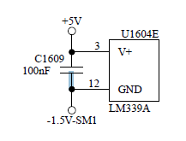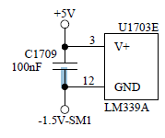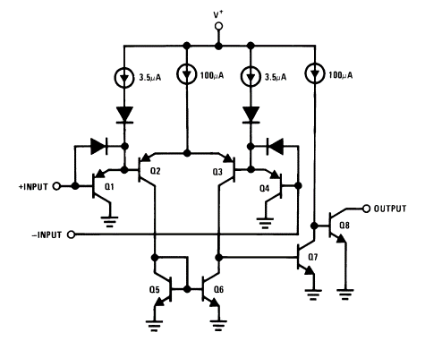

↓Functional diagram of LM339A(V+=+5V)