现象：我们在测试时，发现输出电压纹波较大，如图 1所示。而输出电压纹波较大是由于稳态时，占空比不稳定导致(突然增大)。测试条件 为：输入300V，输出13V，满载(输出电流110mA)。

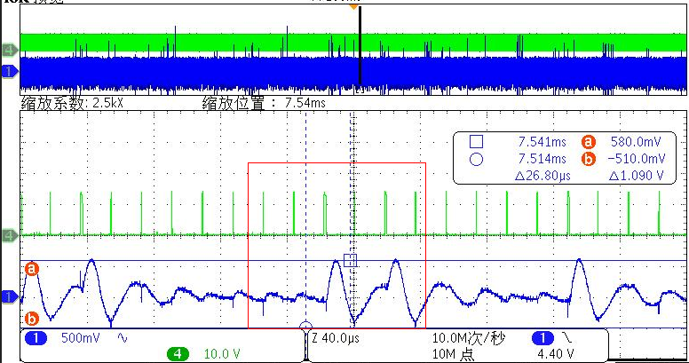

                                                                                   图1 (CH4:VGS, CH1:Vo(交流))

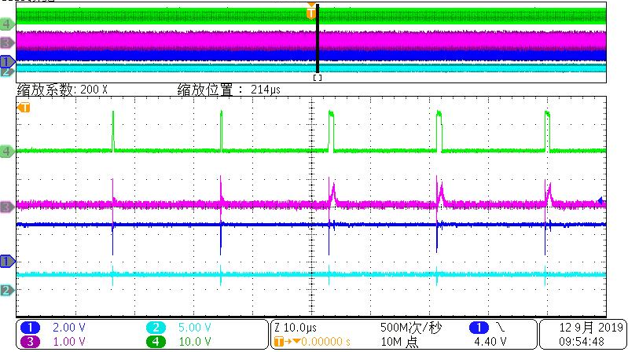

                                                                                         图2 (CH1:VFB, CH2:Vcomp, CH3:VIsense, CH4:VGS )

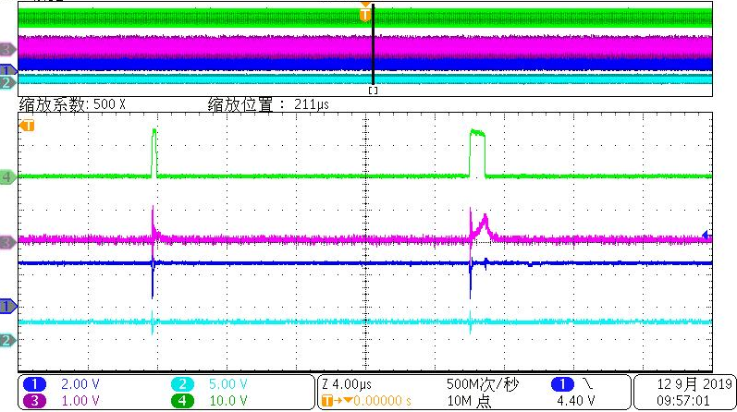

                                                                                              图3 (CH1:VFB, CH2:Vcomp, CH3:VIsense, CH4:VGS )

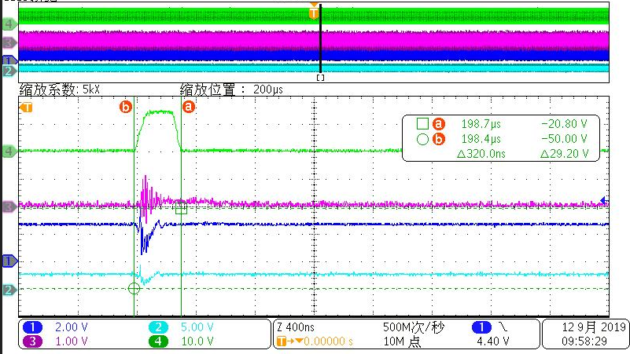

                                                                                 图4 (CH1:VFB, CH2:Vcomp, CH3:VIsense, CH4:VGS )

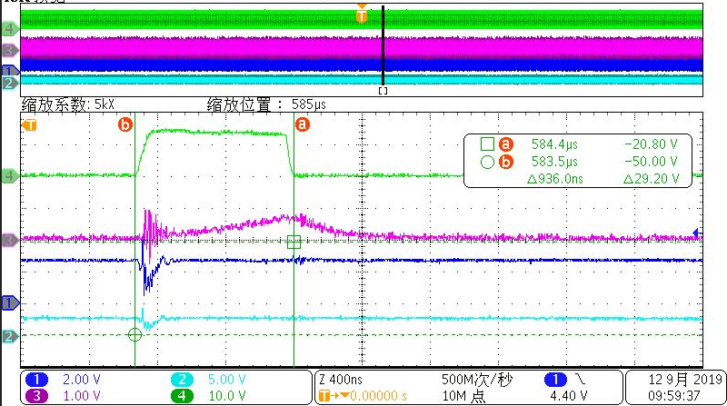

                                                                                图5 (CH1:VFB, CH2:Vcomp, CH3:Visense, CH4:VGS )