+12..v--

_ 2. v --,-0-,-" _

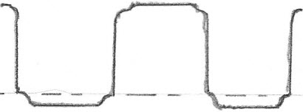

VeL PIN7

+9v---

-IV-

-I

r

I
I

DuTPUT PIN &

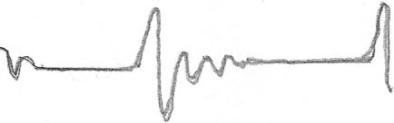

RfN(;- pn1c.l:l
~ !r'^{S}

'3 N1d .1fld.J...()O

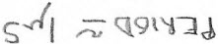

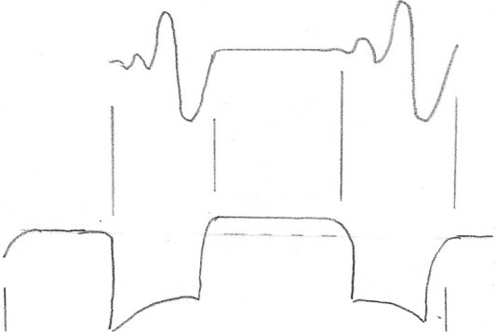

S'W5

