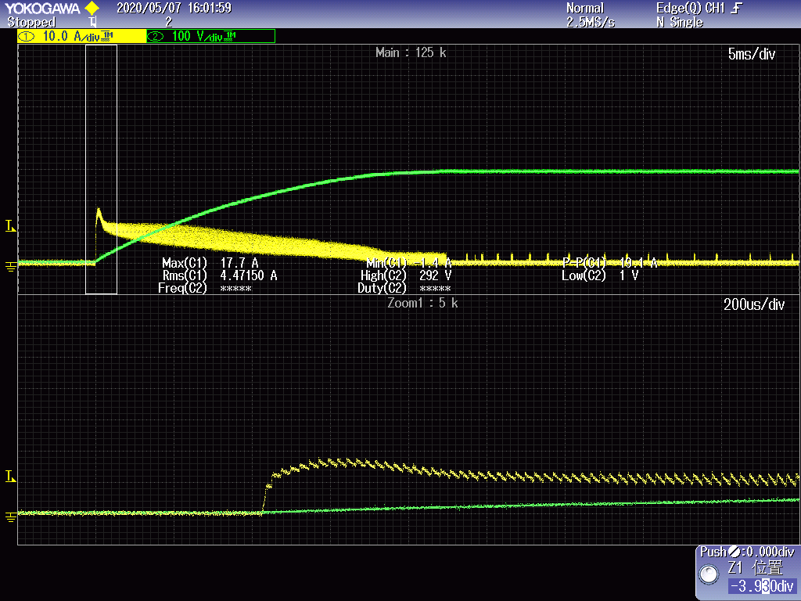

CH1：buck current CH2：output voltage

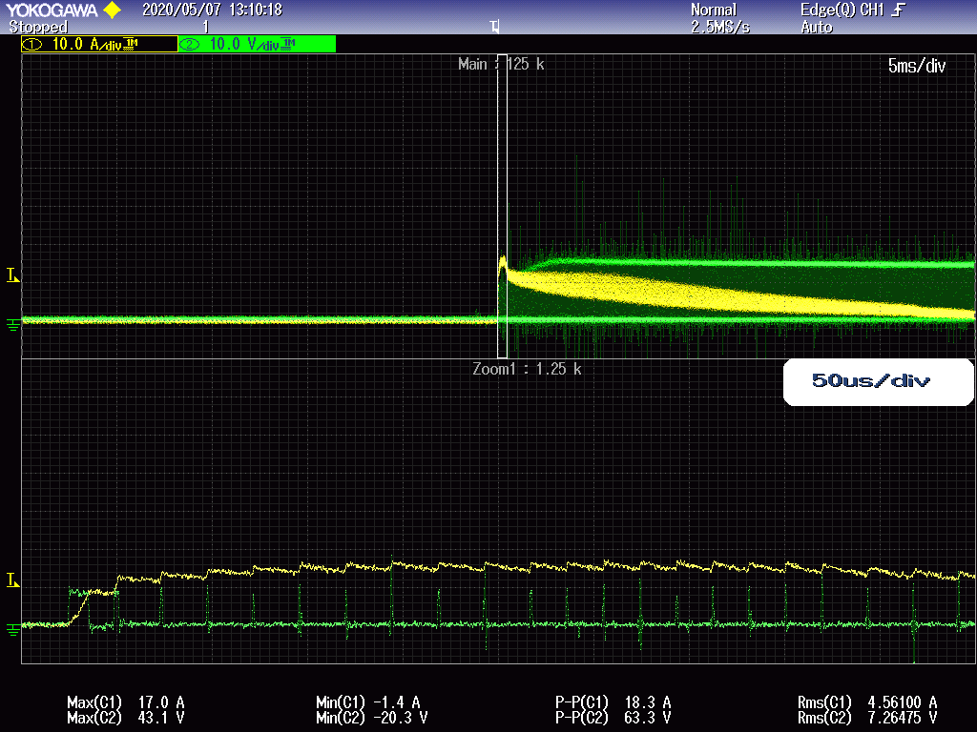

CH1：buck inductor current CH2：Gate driving voltage

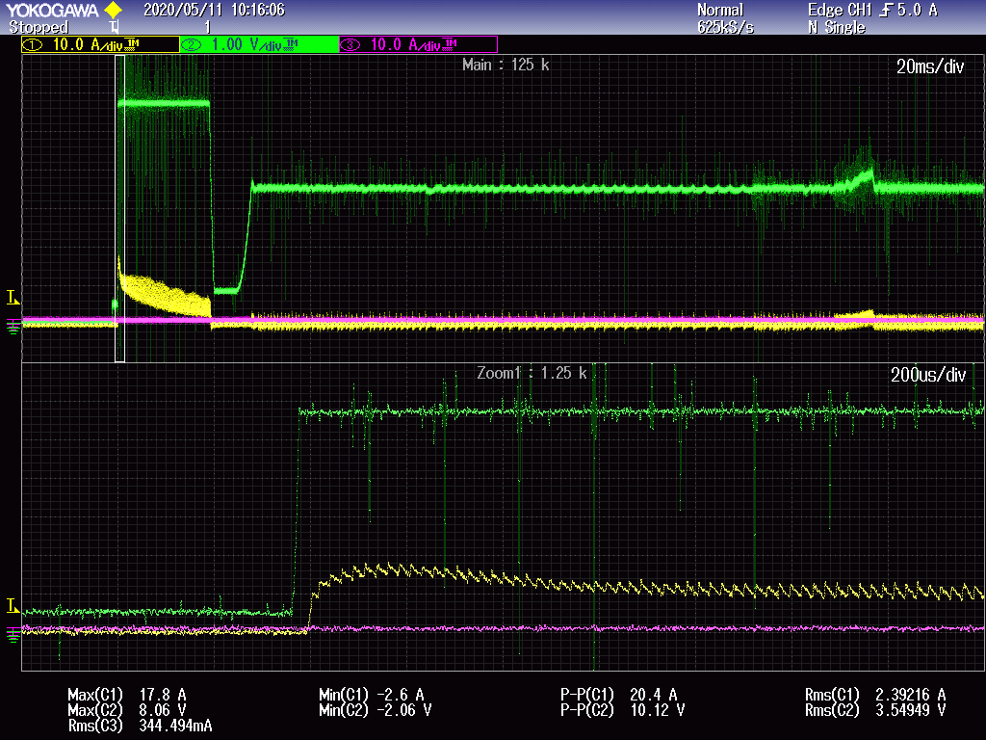

CH1：buck inductor current CH2：UC3843 COMP Pin voltage

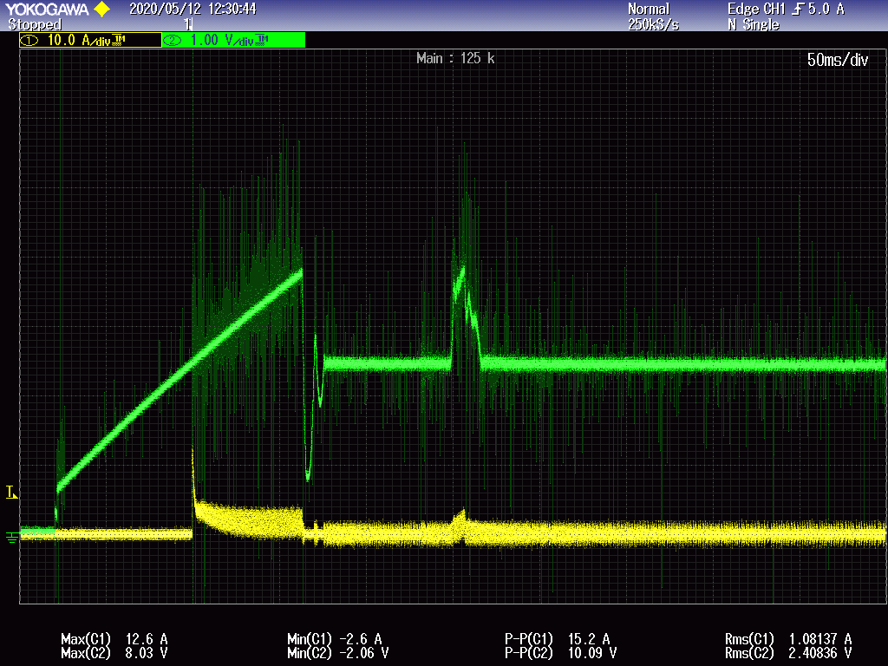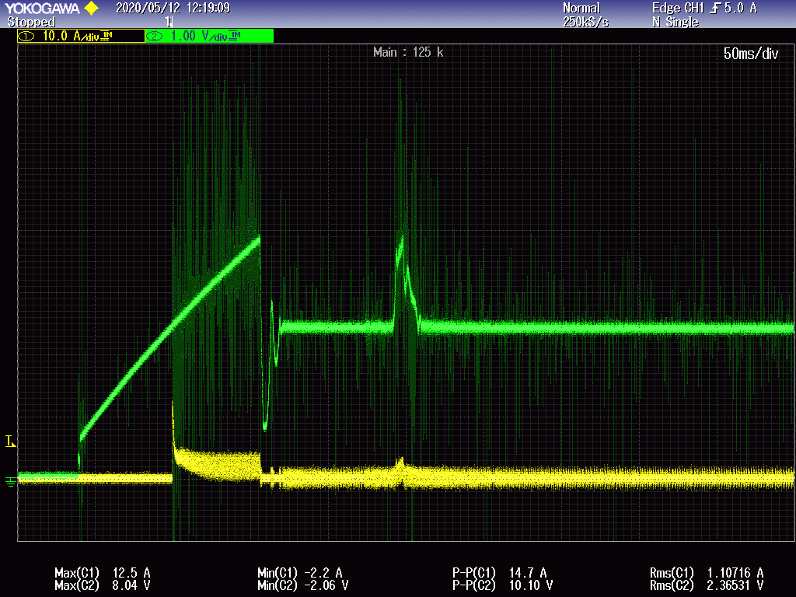

CH1：buck inductor current CH2：UC3843 COMP Pin voltage

The below 2 scope is take with Soft-Start circuit.