schematic

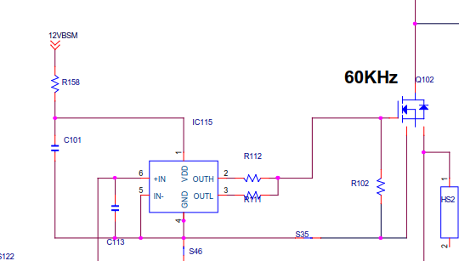

PFC_VGS Abnormal waveform

CH1: PFC_VGS

CH2: Iin

CH3:PFC_VDS

CH4: 27511_VDD

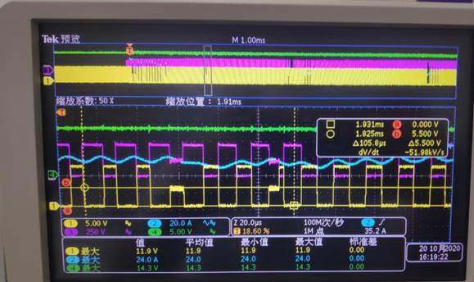

CH1: 27511 Pin3

CH2: PFC_VGS

CH3: Iin

CH4: 27511 Pin2

