***UCC27712 Inverter Board Testing***

***Waveform***

1. **Before applying the voltage to the Motor(no current through the Winding)**

**In scope:**

Yellow- HO with resp to HS

Blue - LO With resp to GND

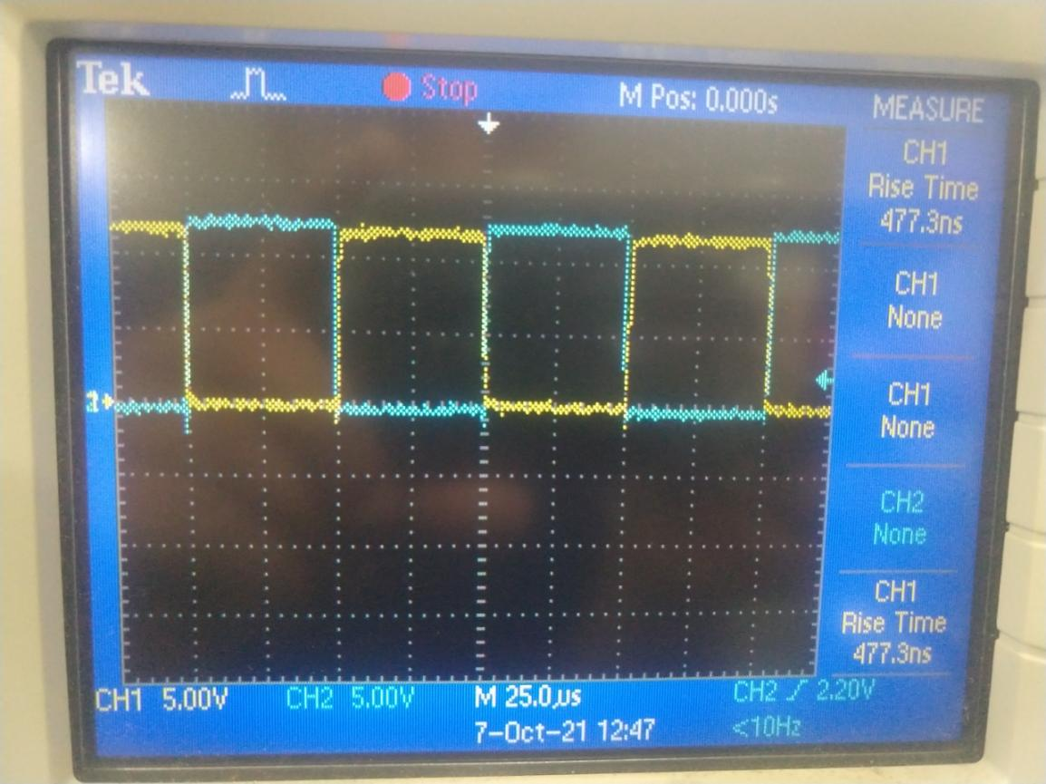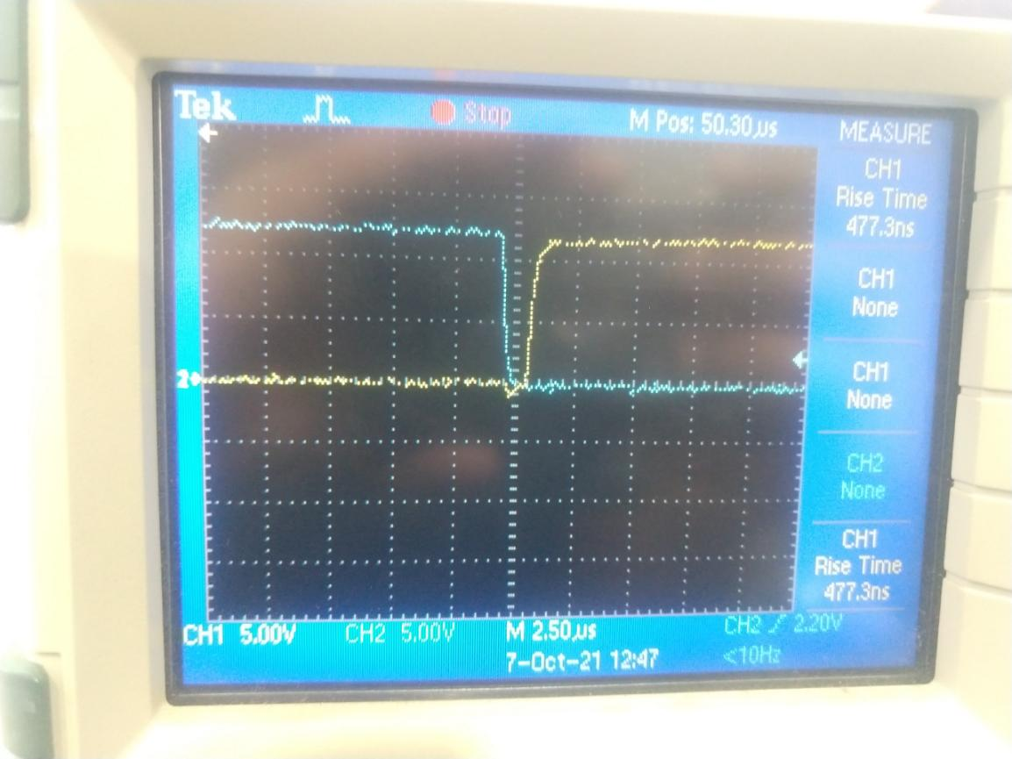 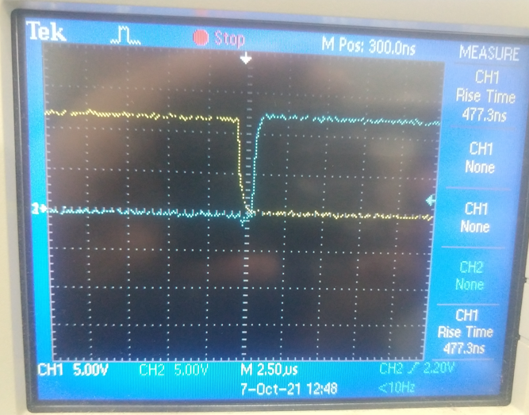

1. **Boostrap Volatge**

Yellow - HB with resp to HS

Blue - HO with Resp to HS

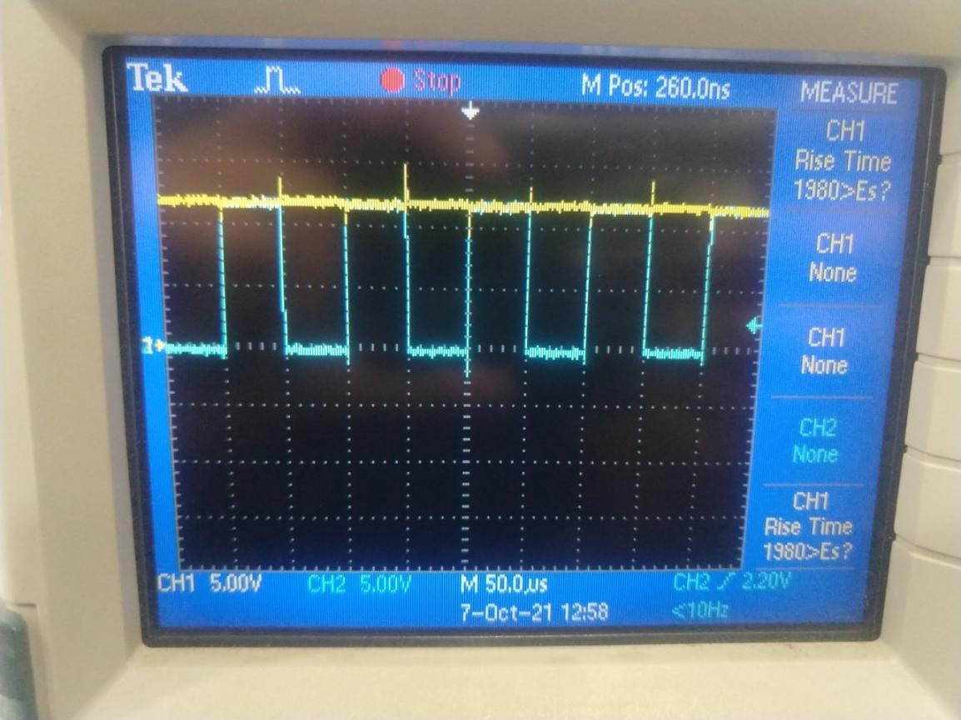

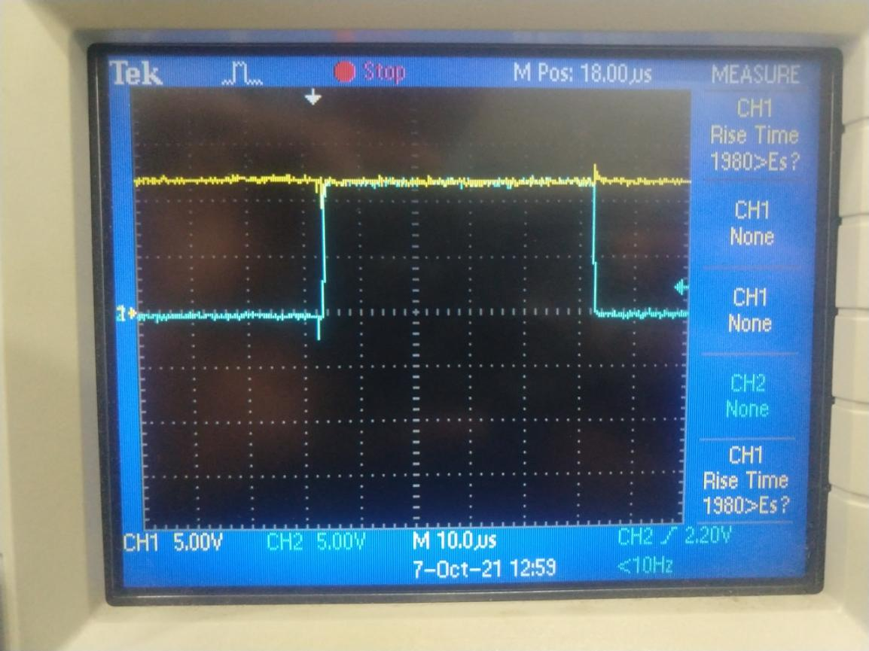

1. **After we start to Push the current into the Motor**

Yellow - HB with resp to HS

Blue - HO with Resp to HS

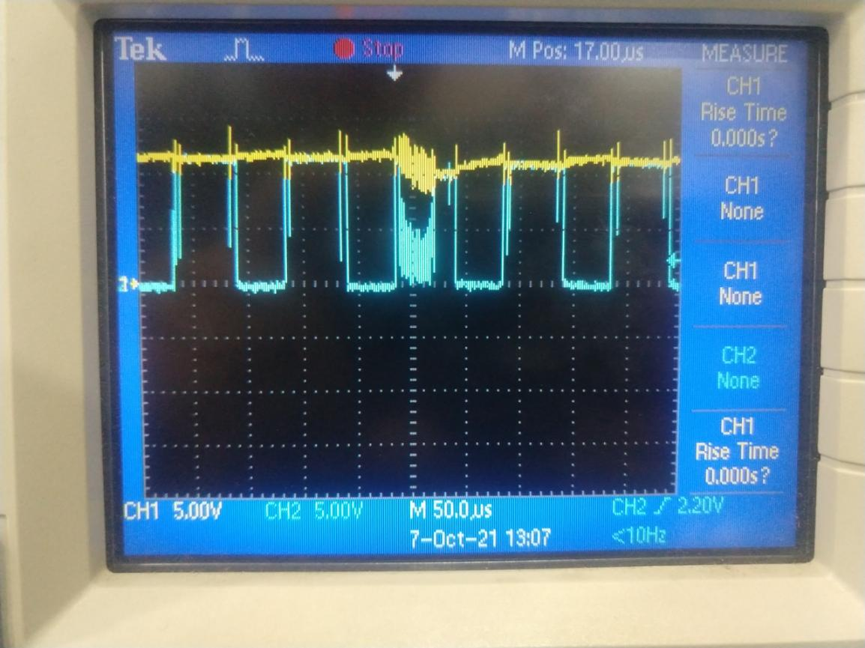

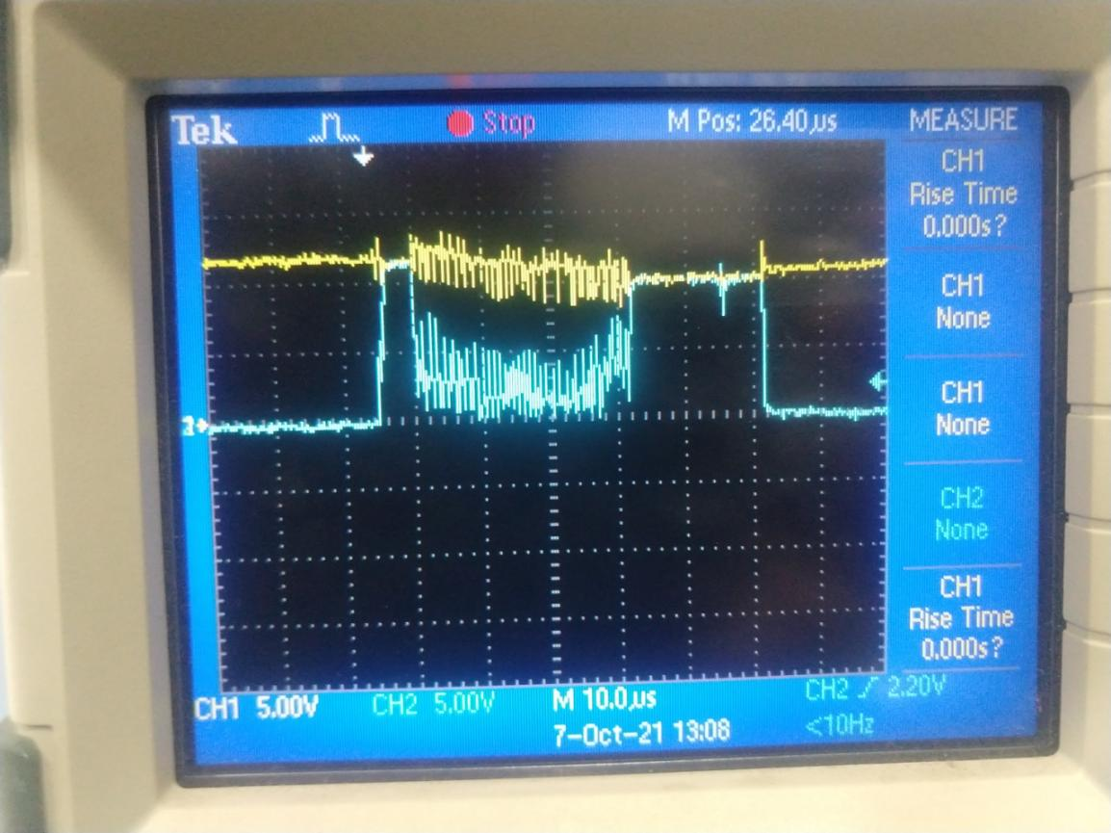

**4)Gate Driver Output (Motor Running)**

Yellow- HO with resp to HS

Blue - LO With resp to GND

