***UCC28070 300-W Interleaved PFC Pre-Regulator Design***

I tested the demo board and found that under 90Vac conditions, input w is too large

But at 230Vac is ok

How can I adjust to achieve an empty consumption less than 0.5W

Vin : 90Vac, Vout: 390Vdc ,Iout : 0A

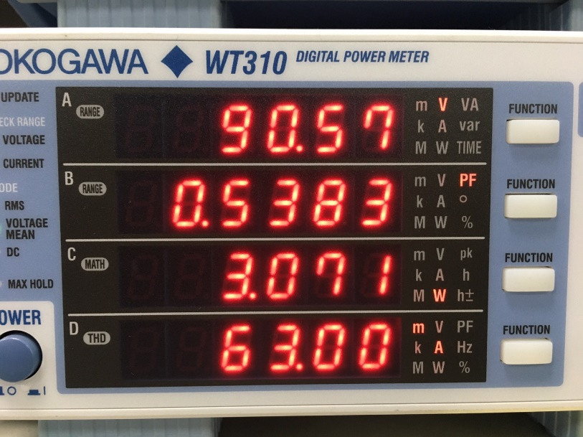

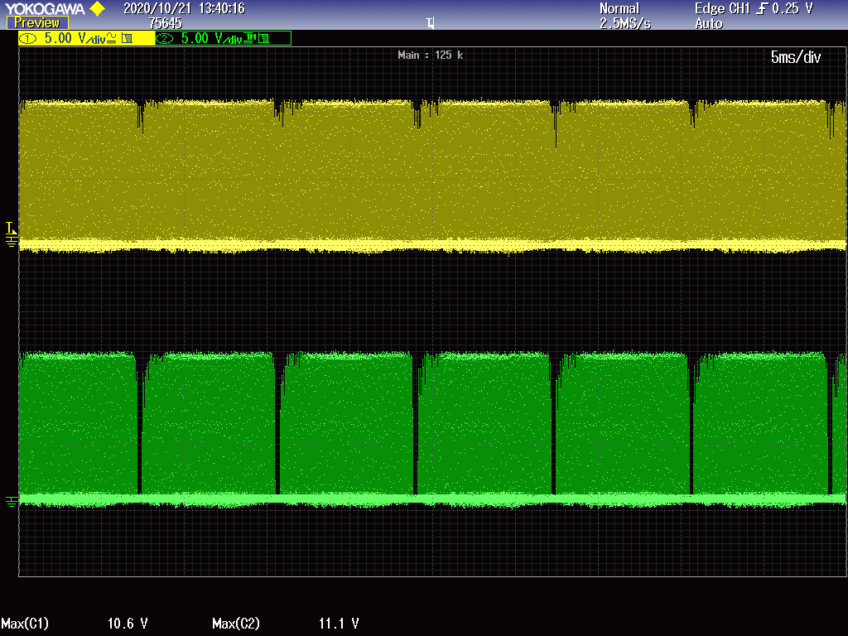

Yellow :GDB

Green:GDA

Vin : 230Vac ,Vout: 390Vdc ,Iout : 0A

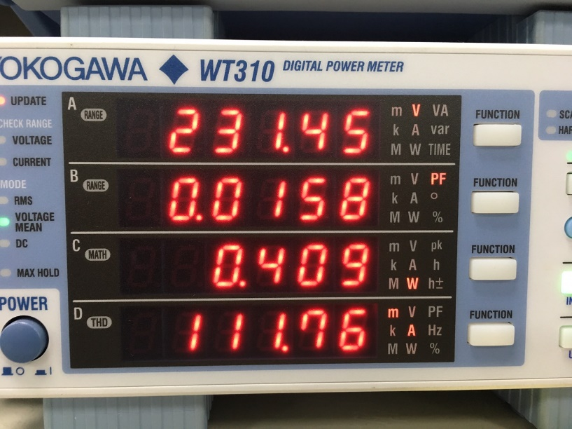

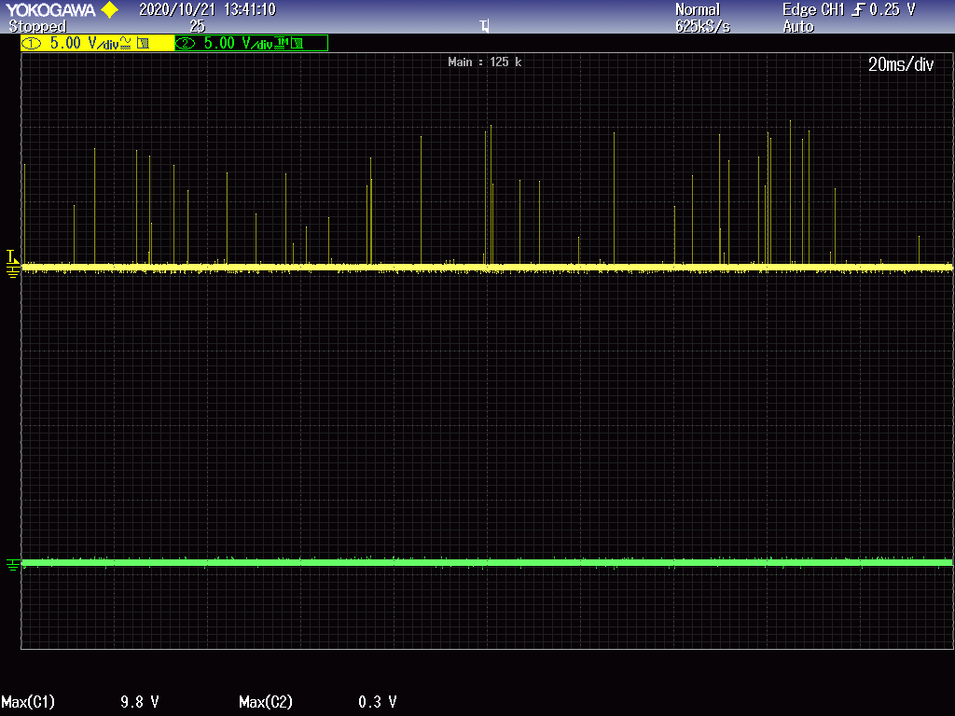

Yellow :GDB

Green:GDA