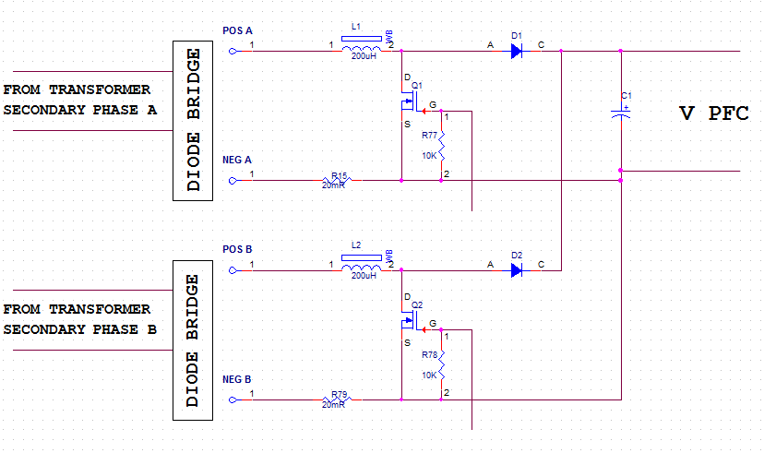
Hi John,
I need to build two phase PFC from two separate secondary windings of the three phase transformer.
This input isolation transformer is the medical laser machine part and has limited dimensions.
One transformer phase is loaded with 3KW chiller.
We can use second & third transformer phases only for 6KW power supply.
I am going to use two separate secondary transformer windings and two PFC (one in each phase) with one common output capacitance. Each PFC has its current loop and preregulator, but we need to do one common voltage regulator for these two preregulators.
I use preregulator UCC2818 in other project. I prefer to use it in this project also if it possible. If it is not possible – what preregulator can I use? How can I build common voltage regulator for two chips?
I am waiting for your answer.
Thanks,
Shlomi

