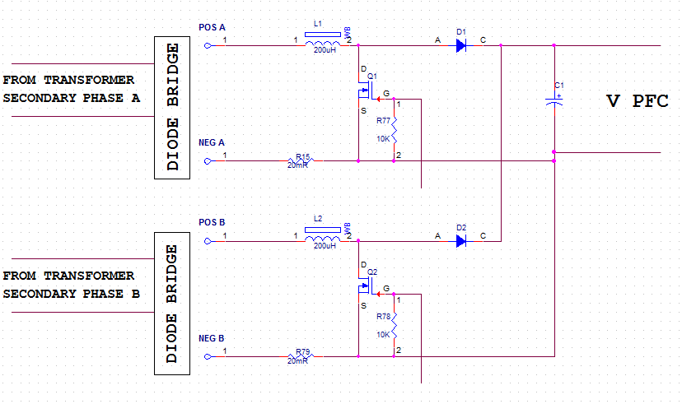
Hi Team,
I need to build two phase PFC from two separate secondary windings of the three phase transformer.
The third transformer phase is loaded and cannot be used.
I use two PFC preregulators UCC2818 – one for each phase. How can I build common voltage regulator for two chips?
I am waiting for your answer.
Thanks,
Shlomi

