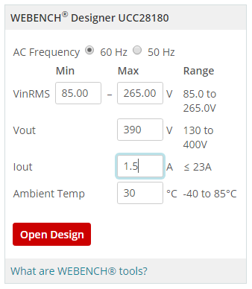
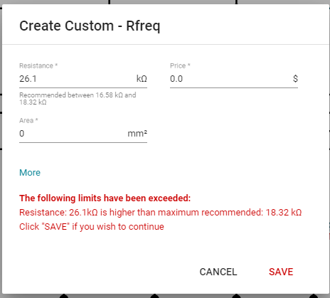
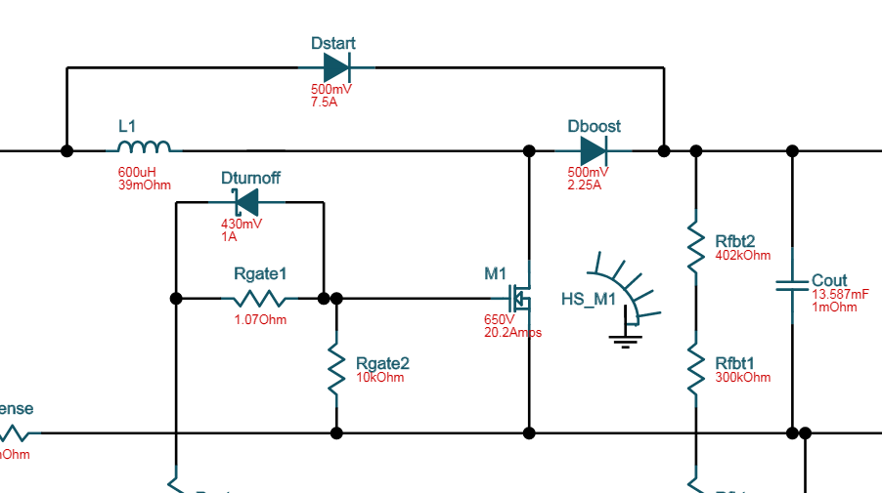
My design shows current and voltage drop on the boost and start diodes. The start is 7A. The data sheet shows these selections in the design example as reversed.
I am able to exchange the inductor. No indication that it will not simulate. In fact I get an FET temp warning so it did something.
I did not change the voltage divider resistors.
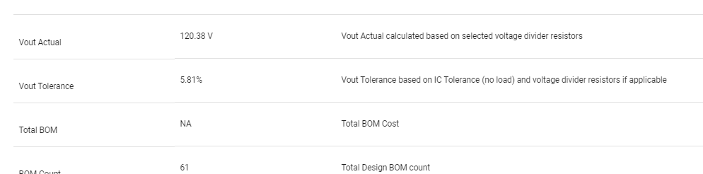

Simulation is not enabled for my design.
The summary is showing 180Khz yet I specifically overrode to 65Khz. Resistor is 34K. This is NOT 180Khz
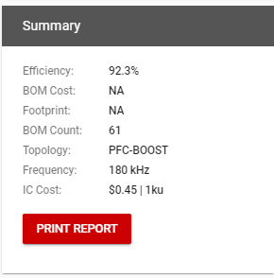

Attached design.

