The customer designs the circuit by referring to the Demo board, but the circuit cannot be started. Capacitance parameter selection is the same.
Now the customer wants to know what is the minimum starting voltage of Vhv? It's not marked in the manual.
- The test VDD is this waveform, varying between 9-19V, Vhv customer power supply test 24V and 48V, VDD waveform is like this.
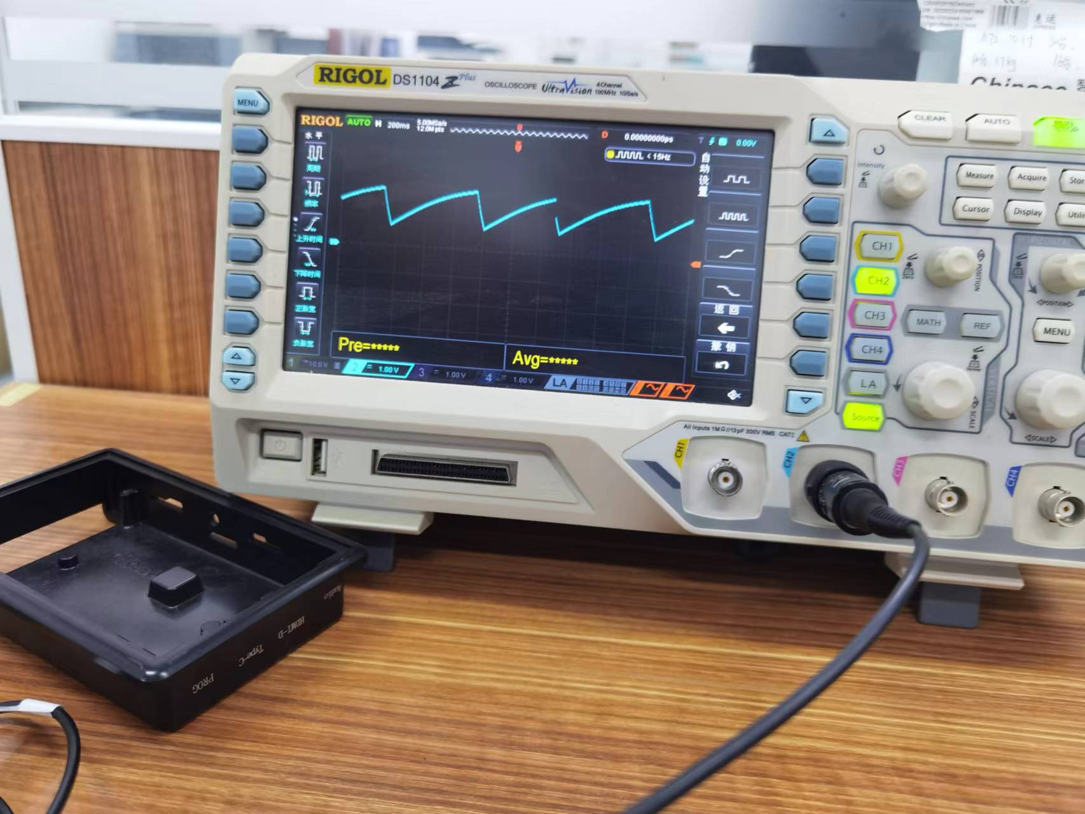

- To achieve the input DC 40-550V, the output is 12V/ 1A, the primary side of the transformer is 32 turns, the auxiliary side is 5 turns, and the auxiliary side is 7 turns. What is the resistance configuration of UCC28740?

