UCC28950 questions

Please refer to TI SLUA560C UCC28950 600W, Phase-Shifted, Full-Bridge Application Report for the following discussions

1. Page 7, formula (34)



According to slup 169, Design And Application Guide for High Speed MOSFET Gate Drive Circuits, page 2-4, cited below.

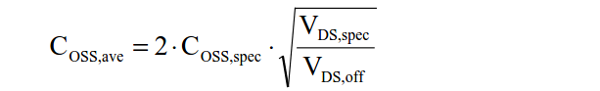

We do not know why the multiplier “2” is missing in formula (34)

* I think you are correct that the 2 should be in the equation.
* This is just an estimate to get you close to give you an estimate to where to set your delay.
* The application note will have you fine tune the delays at 10% load if I remember correctly.
* The newer FETs have Coss(tr) the average Coss switch capacitance during transients so you don’t have to calculate it anymore.
* Acknowledged with thanks.

2. Page 8, formula (39)

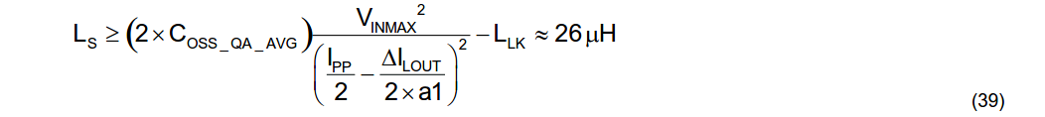

Ls is selected to achieve ZVS at 100% load down to 50% load based on the primary FET’s average total Coss at the switch node.

We would like to know if the multiplier “2” before COSS_QA_AVG is for the requirement of achieving ZVS at 100% load down to 50% load.

> This equation is based on (1/2) LI^2 = 1/2CV^2

> The total capacitance as the switch node should be 2*Coss_QA_AVG because the capacitors across the FETs will appear to be in parallel to the switch node. The 1/2s cancel out.

* Understand that the total capacitance at the switch node should be 2*Coss_QA_AVG because the capacitors across the two FETs will appear in parallel to the switch node. We know the equation is for achieving ZVS at 100% load down to 50% load. By the way, if we want to achieve ZVS at 100% load down to 25% load, then what we need to do is to change the multiplier “2” before COSS_QA_AVG to “4”. Is it correct?

3. Page 11, formula (62)



We believe that VdsQE should be two times the value obtained above because it is a center tapped secondary.

>The FETs source is tied to ground so that formula is correct.

* Refer to UCC28950 Excel Design Tool: SLUC222D dated 2018/7/27, VdsQE has been changed from 19.5V to 39.05V and there is a multiplier “2” in the equation. We believe UCC28950 Excel Design Tool: SLUC222D dated 2018/7/27 is correct.

4. Page 11, formula (65)



We thought that there was a typo, Vds_spec should be in the numerator and VdsQE should be in the denominator. And we need multiplier “2” in formula (65), too.

> I believe you are correct and I will notify the applications team to fix this in the application note when they have a chance.

* Acknowledged with thanks.

5. Page 19, formula (120)



We believe that the multiplier “2” before COSS_QA_AVG is also for the requirement of achieving ZVS at 100% load down to 50% load. Is that correct?

* The 2*Coss_QA_AVG is correct.
* If we want to achieve ZVS at 100% load down to 25% load, then what we need to do is to change the multiplier “2” before COSS_QA_AVG to “4”. Is it correct?

6. Page 22, formula (137)

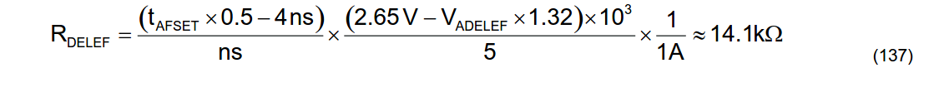

We believe that the multiplier “0.5” after tAFSET is a typo. The multiplier “0.5” is not needed.

* This equation came from the systems engineer and is the same as equation 161 in the data sheet. So I believe it is correct.
* Refer to UCC28950 Excel Design Tool: SLUC222D dated 2018/7/27, there is no multiplier “0.5” after tAFSET in the equation. We believe UCC28950 Excel Design Tool: SLUC222D dated 2018/7/27 is correct.