**UCC3818ADR小载或空载异常问题**

1. Input 230Vac， 5% load，waveform abnormal；
2. Input 110Vac，5% load，waveform is OK

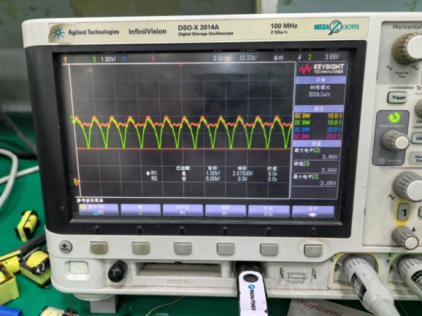 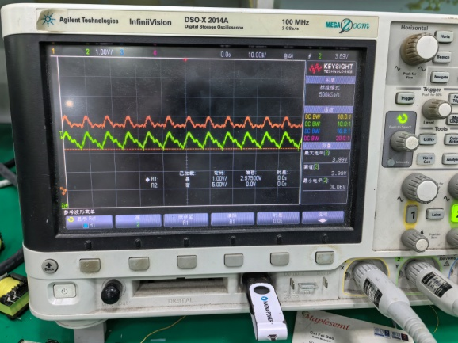

OK IC，CH1：PIN5 CH2：PIN3 NG IC，CH1：PIN5 CH2：PIN3

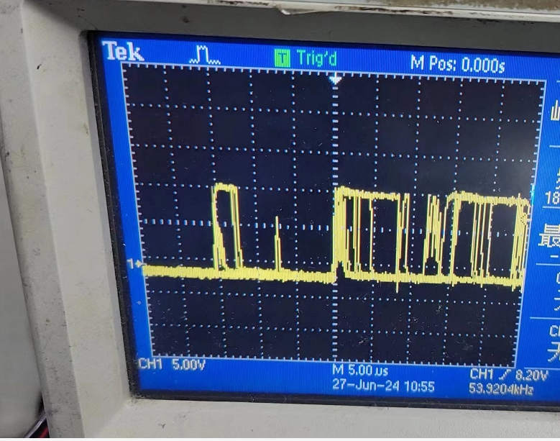 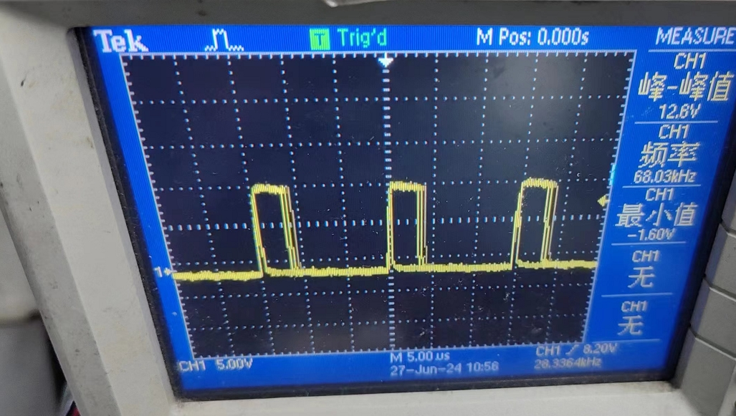

NG IC，CH1: MOS管Vgs OK IC，CH1: MOS管Vgs

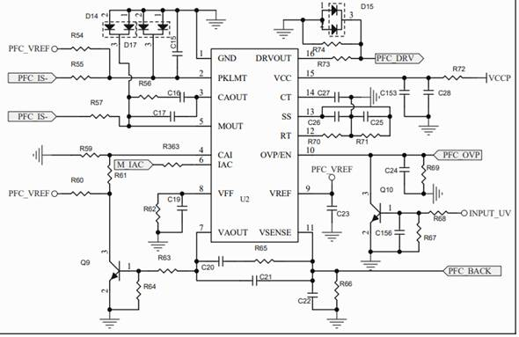

Change PIN3 around component parameters, and remove R61, the issue is not solved.

Change C20,C21,R65,r59,r57,r70 parameters, the issue is not solved

更改PIN3外围参数，去掉R61没有改善；C20、C21、R65更改；R59、R57更改；R70等参数更改。改大或改小都没有任何改善。

PCBLAYOUT as below：

