I use UCC39002 demo HPA027A designed chare electric current circuit; two power module output voltage Vout=12V,Iout(max)=50A, use Vout+ as sampling and the sampling resistor is 1mΩ, CSO amplification times set is 100, Power supply voltage adjustment range ΔV=0.6V;  
 1.full load, There will be times (tens to hundreds of milliseconds) when the current is very uneven, then circuit can share; waveform as below;  
            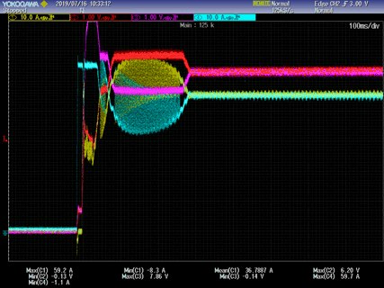

2.Underloading (below 7A, load mode are CC or CR) the output current of the two power sources keeps oscillating, as below;  
            