BOARD POWER DISTRIBUTION LOGIC

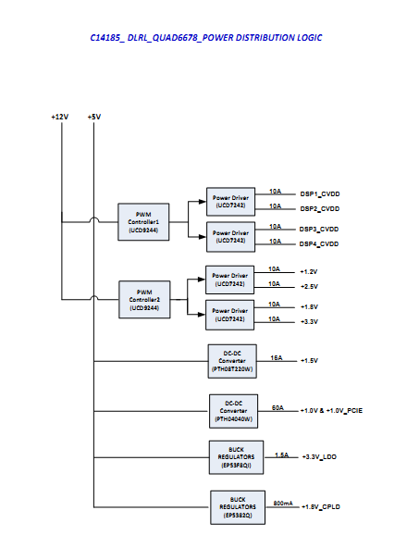

UCD9244-1d-2d-configuration

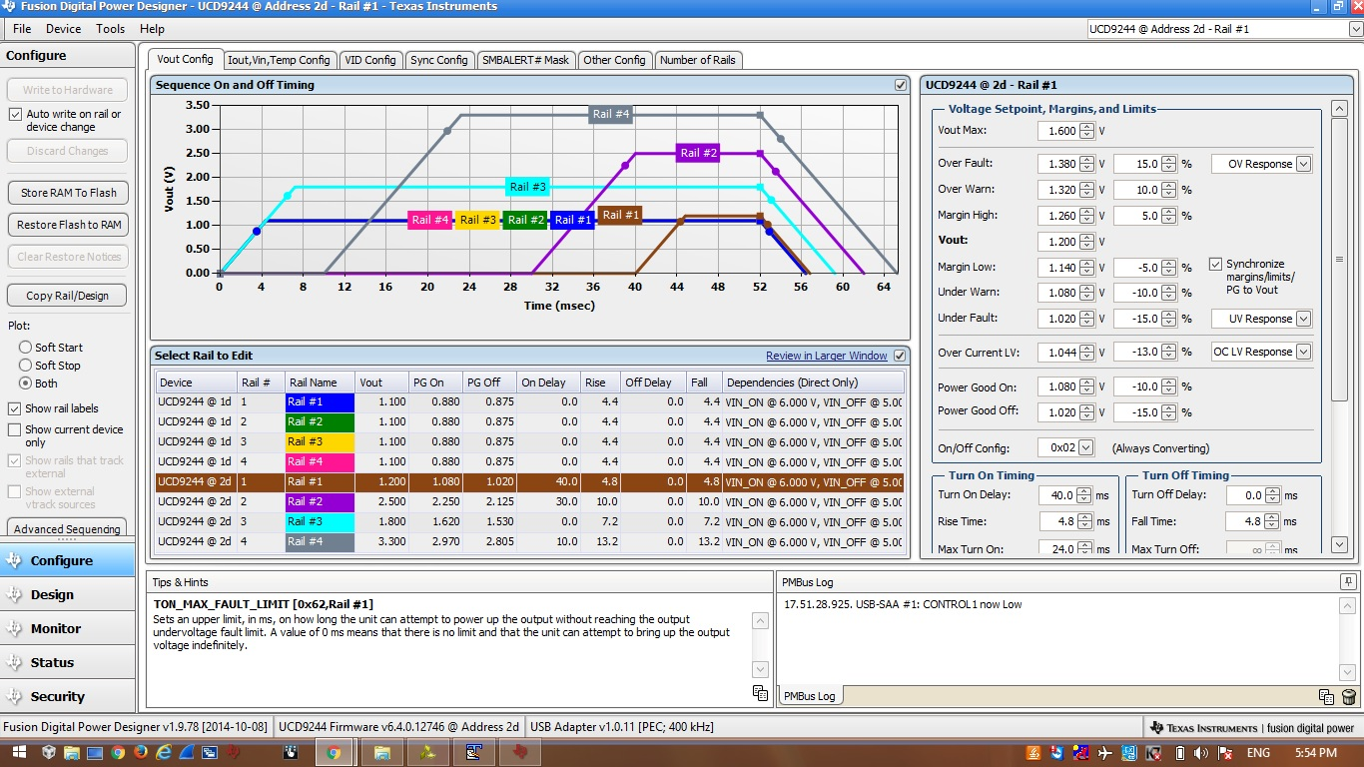

UCD9244-1d-MONITOR

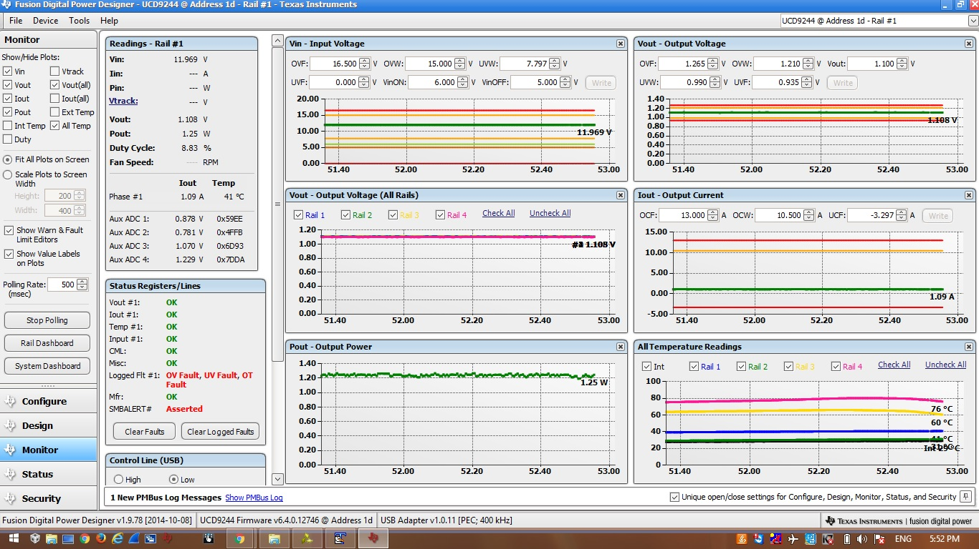

UCD9244-1d-RAIL1-Status

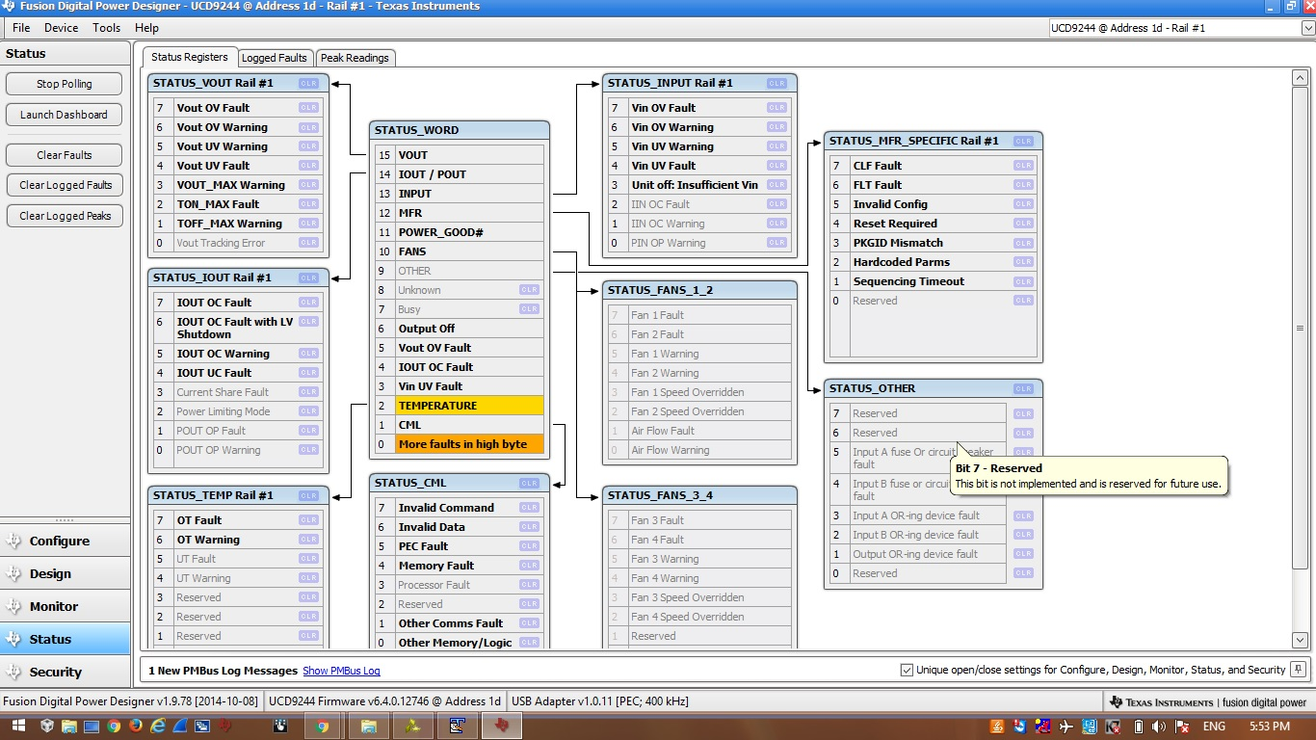

UCD9244-2d-ALLRAIL-Status

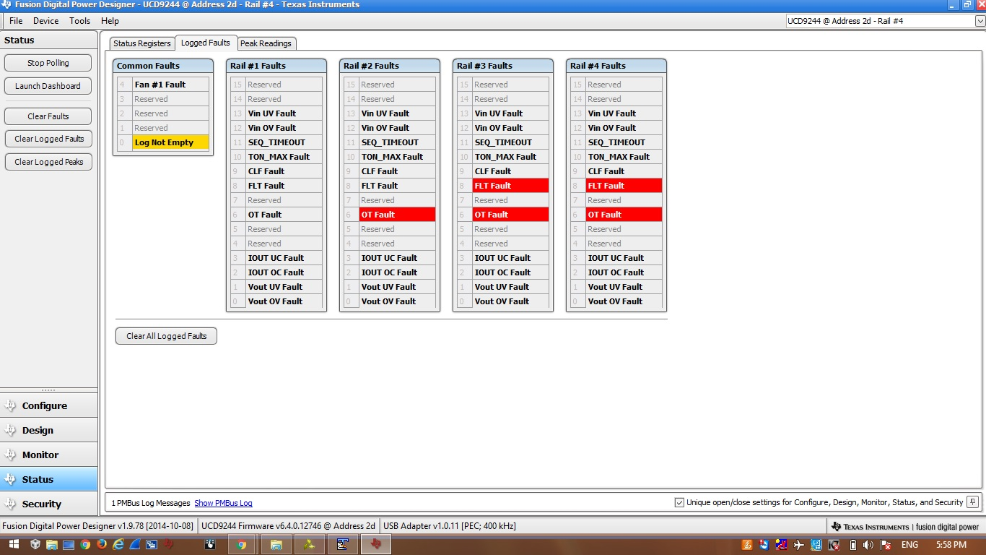

UCD9244-2d-MONITOR

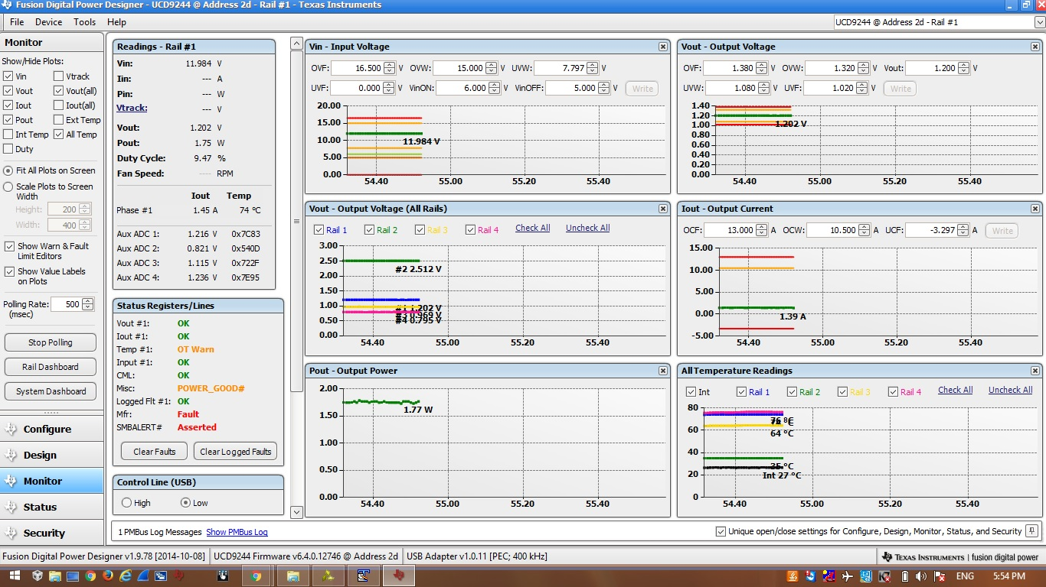

UCD9244-2d-Rail1-Status

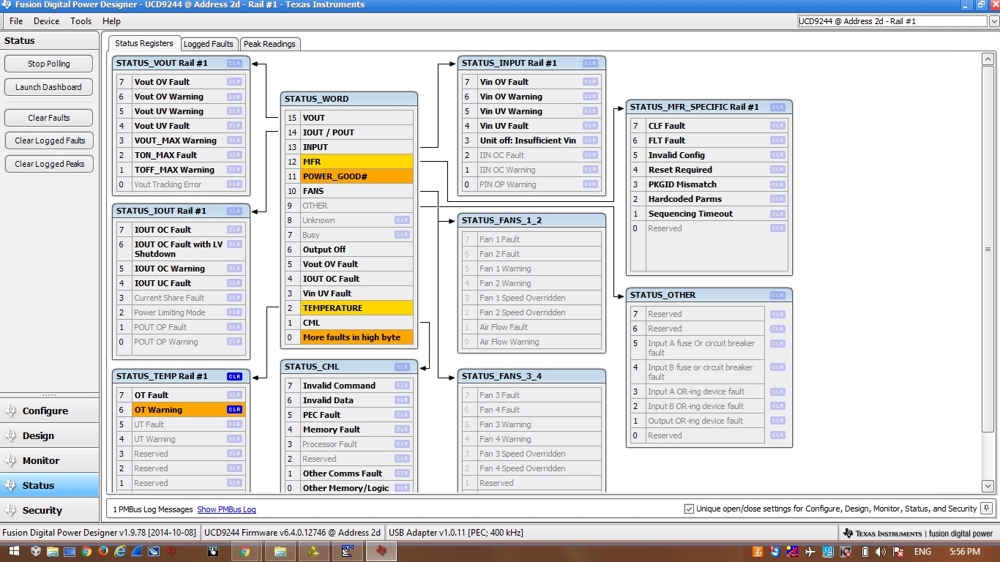

UCD9244-2d-RAIL2-STATUS

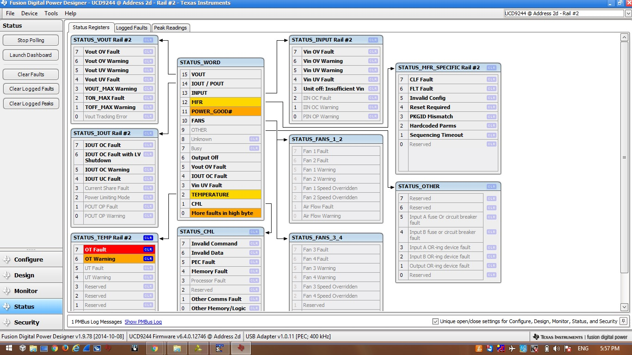

UCD9244-2d-Rail3-Status

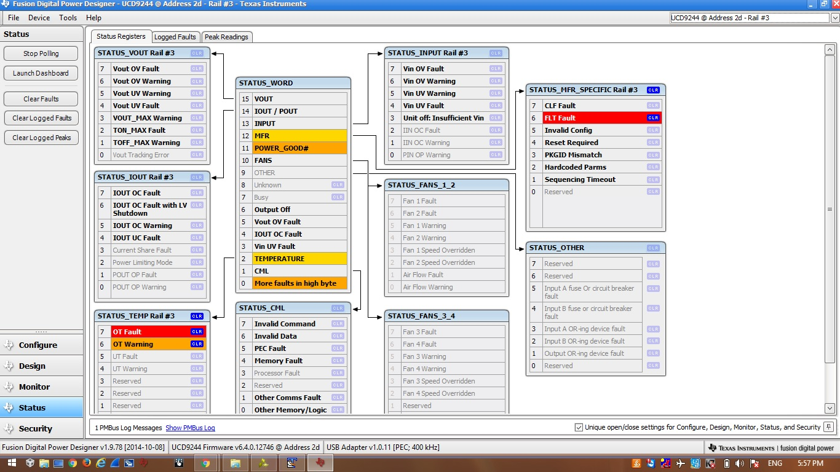

UCD9244-2d-Rail4-Status

