USB Problem Test
CC1 Plug-in Harness Cold Start Waveform, VBUS has voltage
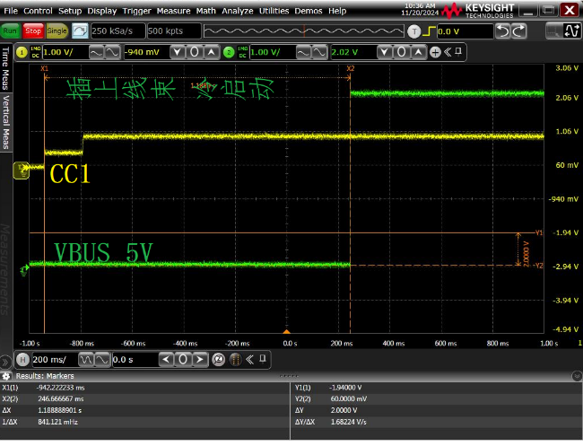
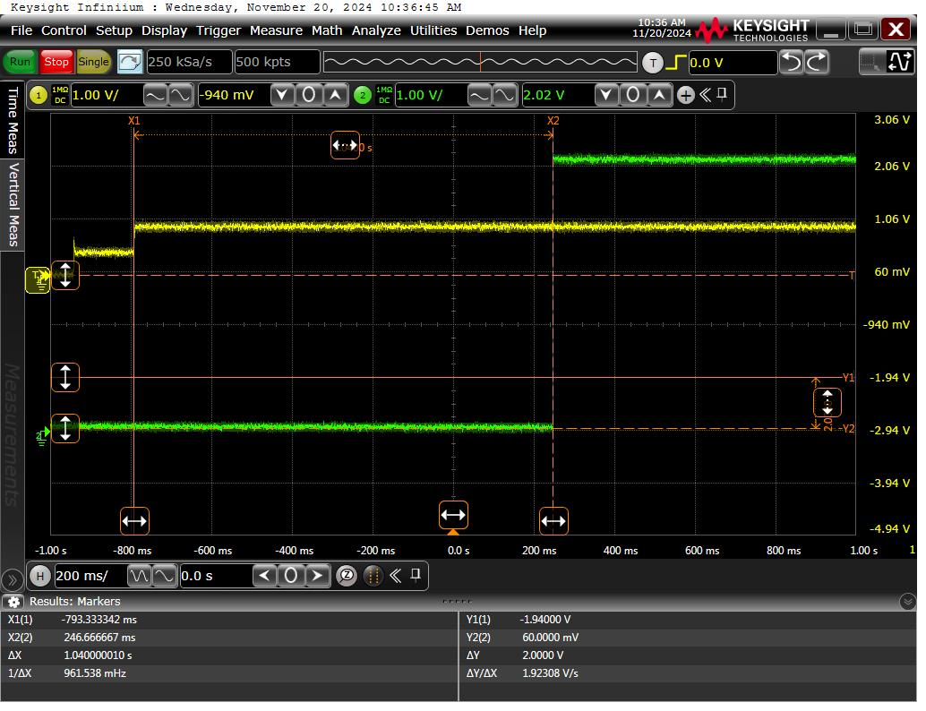

Hot-plug harness CC1
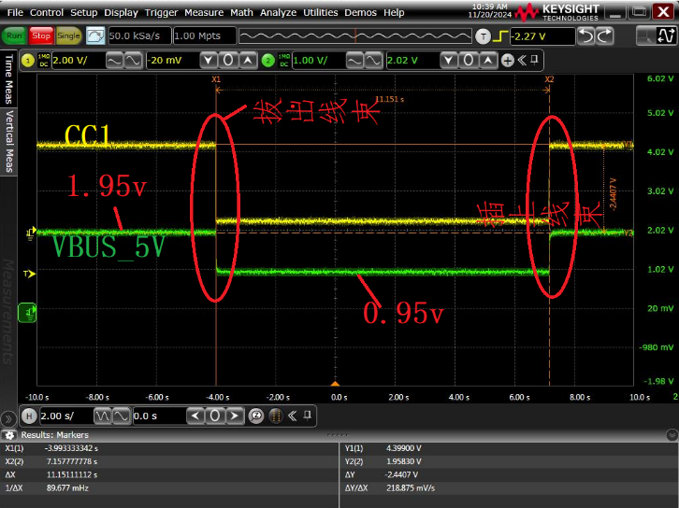

CC2 Plug-in Harness Cold Start Waveform, VBUS has voltage
Yellow: CC2 Green: VBUS_5v
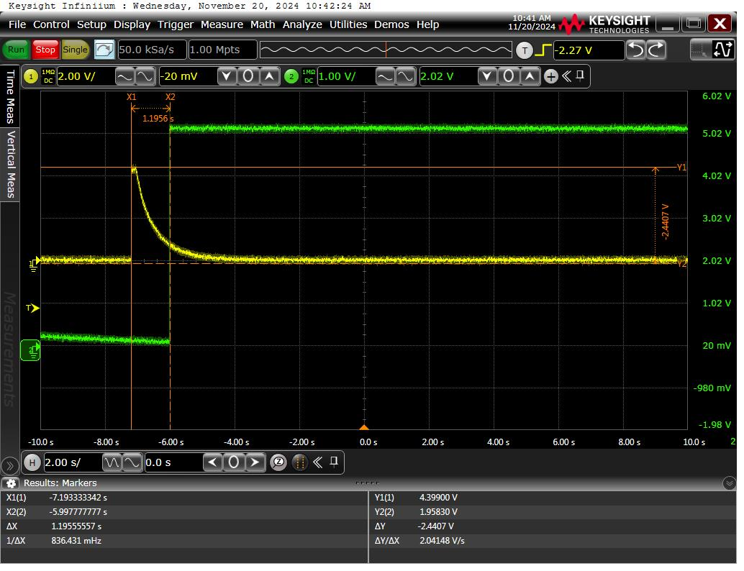

CC2 Hot Plug Harness Waveform, VBUS has voltage 