Application Notes
Using TPS6594xEVM and GUI for PMIC Programming
and Debug on Customers Application Board

- Connecting TPS6594xEVM I2C port to customer board.
  - To disable the PMIC on the TPS6594xEVM
Pictures below show how to remove R58 from the bottom side of the EVM to disable the PMIC on the TPS6594xEVM.
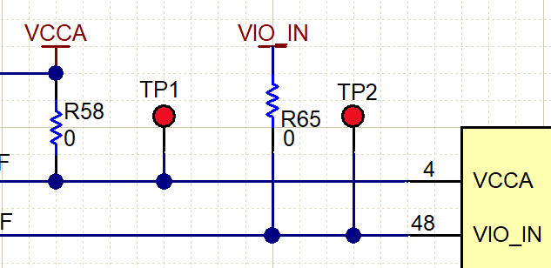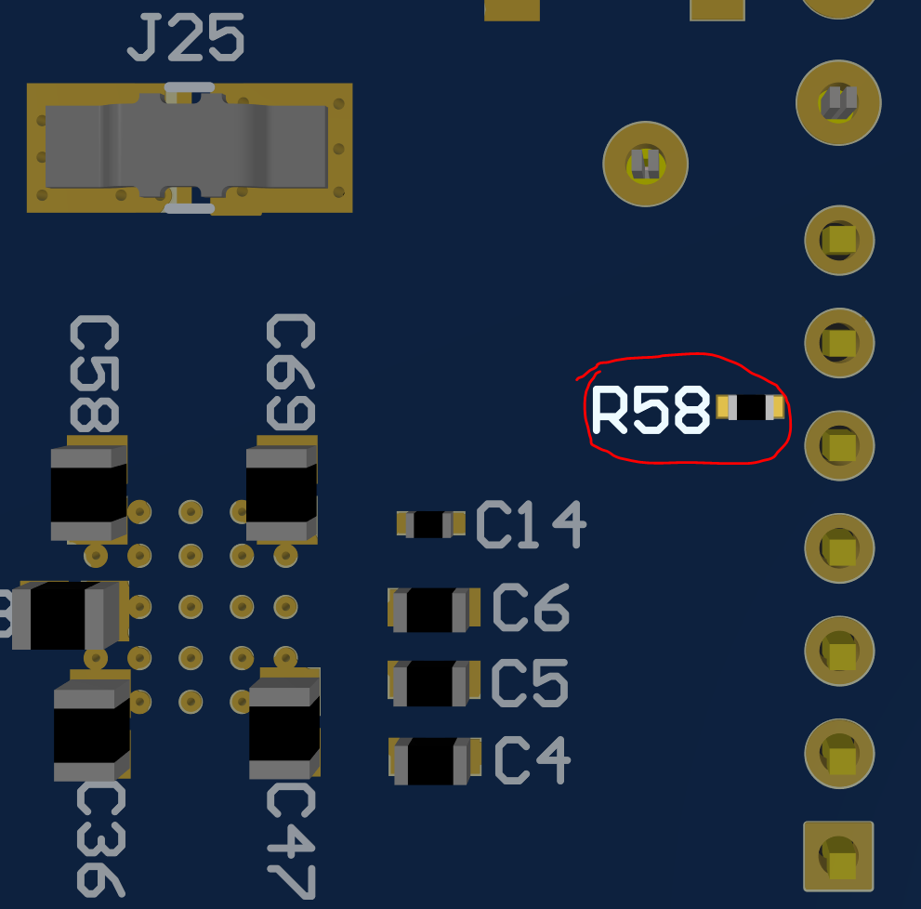

  - Connect the EVM I2C port1 to customer board.
Pictures below show where to wire the I2C port1 signals to connect to customer board.
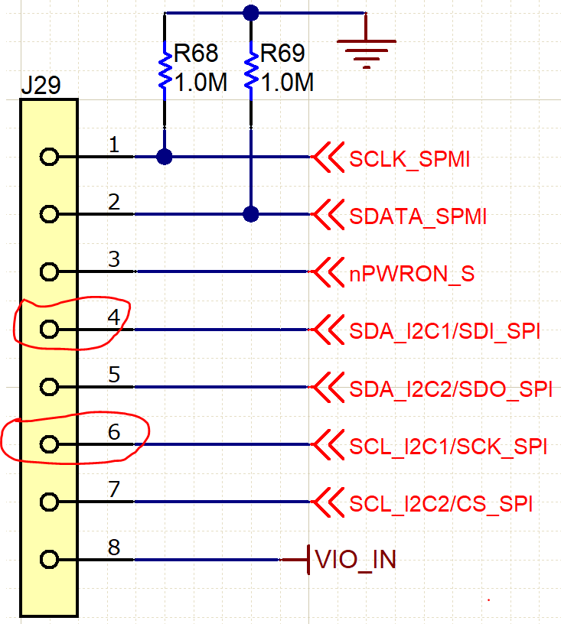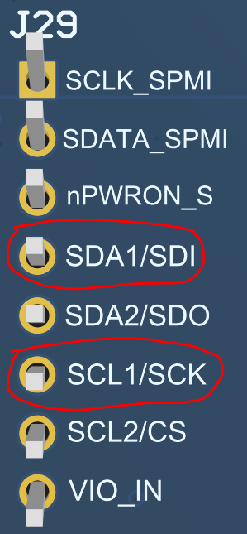

  - Please make sure use same VIO level between EVM and customer board.
Picture below gives the option to select different VIO level on the EVM:
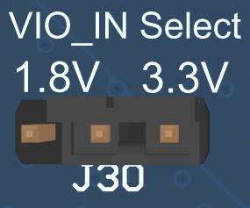

- Launch the Scalable-PMICs-GUI 2.0 tool to program or access internal registers for debug.
Please refer to the Scalable-PMICs-GUI 2.0 User Guide for more details of checking the internal registers for debug.

IMPORTANT NOTICE AND DISCLAIMER
TI PROVIDES TECHNICAL AND RELIABILITY DATA (INCLUDING DATASHEETS), DESIGN RESOURCES (INCLUDING REFERENCE
DESIGNS), APPLICATION OR OTHER DESIGN ADVICE, WEB TOOLS, SAFETY INFORMATION, AND OTHER RESOURCES “AS IS”
AND WITH ALL FAULTS, AND DISCLAIMS ALL WARRANTIES, EXPRESS AND IMPLIED, INCLUDING WITHOUT LIMITATION ANY IMPLIED WARRANTIES OF MERCHANTABILITY, FITNESS FOR A PARTICULAR PURPOSE OR NON-INFRINGEMENT OF THIRD PARTY INTELLECTUAL PROPERTY RIGHTS.
These resources are intended for skilled developers designing with TI products. You are solely responsible for (1) selecting the appropriate TI products for your application, (2) designing, validating and testing your application, and (3) ensuring your application meets applicable standards, and any other safety, security, or other requirements. These resources are subject to change without notice. TI grants you permission to use these resources only for development of an application that uses the TI products described in the resource. Other reproduction and display of these resources is prohibited. No license is granted to any other TI intellectual property right or to any third party intellectual property right. TI disclaims responsibility for, and you will fully indemnify TI and its representatives against, any claims, damages, costs, losses, and liabilities arising out of your use of these resources. TI’s products are provided subject to TI’s Terms of Sale (www.ti.com/legal/termsofsale.html) or other applicable terms available either on ti.com or provided in conjunction with such TI products. TI’s provision of these resources does not expand or otherwise alter TI’s applicable warranties or warranty disclaimers for TI products.

Mailing Address: Texas Instruments, Post Office Box 655303, Dallas, Texas 75265
Copyright © 2019, Texas Instruments Incorporated

