VCELL 16 measurements.

Using bqStudio, the following measurements were taken. Cells 1-3 matched exactly with my software reading the same registers as well as reading the actual cells with a voltmeter. Cell 16 was read with the voltmeter to be 3.7V while reading the ADC, it shows 4.116V, a 0.415V difference.

What is interesting is that the Stack voltage read by bqStudio matched the voltmeter at 14.61V ad 14.67V respectively. So that kind of proves the cell is at 3.7V because if you add up Cells 1-3 as well as 3.7V, you get 14.67V!

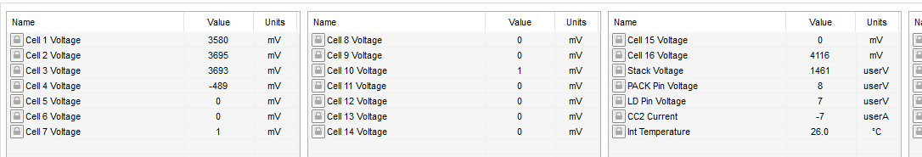

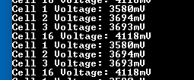

Below is the schematic for a 4 stack. Pins VC15-VC4 are connected together shown by the red line. VC3 is connected to VC15 via C143 which emulates your drawing on the right.

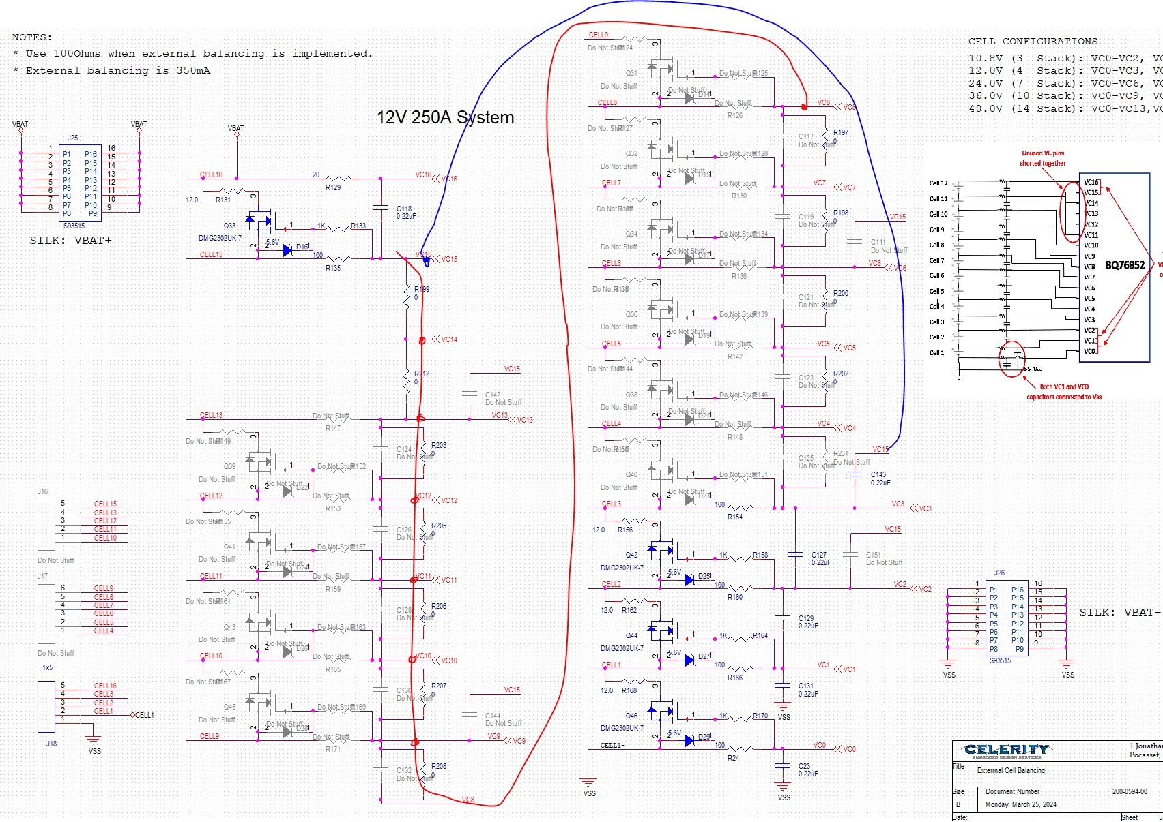

I measured across C131 (VC1 and VC2) using a voltmeter and that read 3.58V which matches the readouts. The same for C129 (3.696V) and C127 (3.698V). But when I measure C116 (between VC15 and VC16) I measure 4.054V. but I would expect 3.7V. But then I measured the voltage across C143 which is the cap between VC3 and VC15 and that measured 0.36V which then explains the 4.054V since 3.7V+0.36V is 4.06V, close enough!

The voltage drop across R129 (20 Ohm resistor between CELL16 and VC16 is 0V which is expected. I also measured between VC4 and VC15 and that was 0V as well.

So it seems as if somehow the bq76952 is providing a little extra voltage somewhere, or I have a incorrect register setting (which I don’t think since I can read Cells 1-3 fine or I have a problem with my schematic but it does match the setup in your diagram.