Video Data Hub (VDH)

Design a device which will have USB-C Power Delivery port (DRP) capable of charging a laptop while simultaneously supporting data and video transmission from USB-C to an HDMI display port.

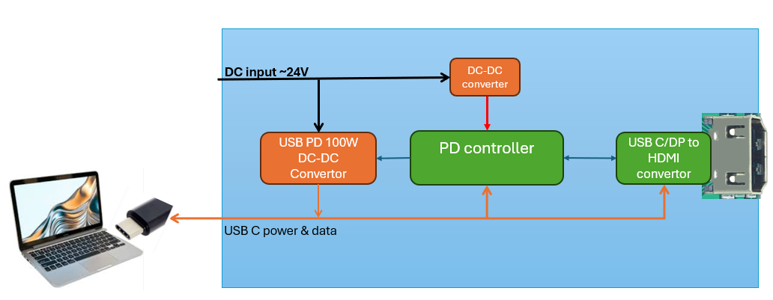

Shall have one USB-C port supporting power sourcing upto 100W and data transfer rates of 20Gbps.

Shall have one HDMI port capable of transmitting video and audio signals from connected source to an external display. This port shall comply with HDMI 2.1 or higher standards and support resolutions up to 4K at 75Hz.

The video output technology shall be fully compatible with host devices that support DisplayPort Alternate Mode (DP-Alt Mode) and Thunderbolt protocols.

