* [Jan 18, 2019 4:48 PM](https://e2e.ti.com/support/power-management/f/196/p/763217/2826003" \l "2826003)

In reply to [Dalip Singh](https://e2e.ti.com/support/power-management/f/196/p/763217/2825859#2825859):

Hi Dalip,  
  
The ultimate value of 'voltage divider' will shift after calibration because a separate 'voltage offset' is not utilized in this device.   
  
Please perform calibration in this order:  
  
1. CC Offset and Board Offset  
2. Voltage Calibration [training.ti.com/bq34z100-g1-voltage-calibration](https://training.ti.com/bq34z100-g1-voltage-calibration)  
3. Current Calibration [training.ti.com/bq34z100-g1-current-calibration](https://training.ti.com/bq34z100-g1-current-calibration)  
  
The videos above should describe the parameters of concern. Please let me know if this resolves your issue.  
  
Sincerely,  
Bryan Kahler

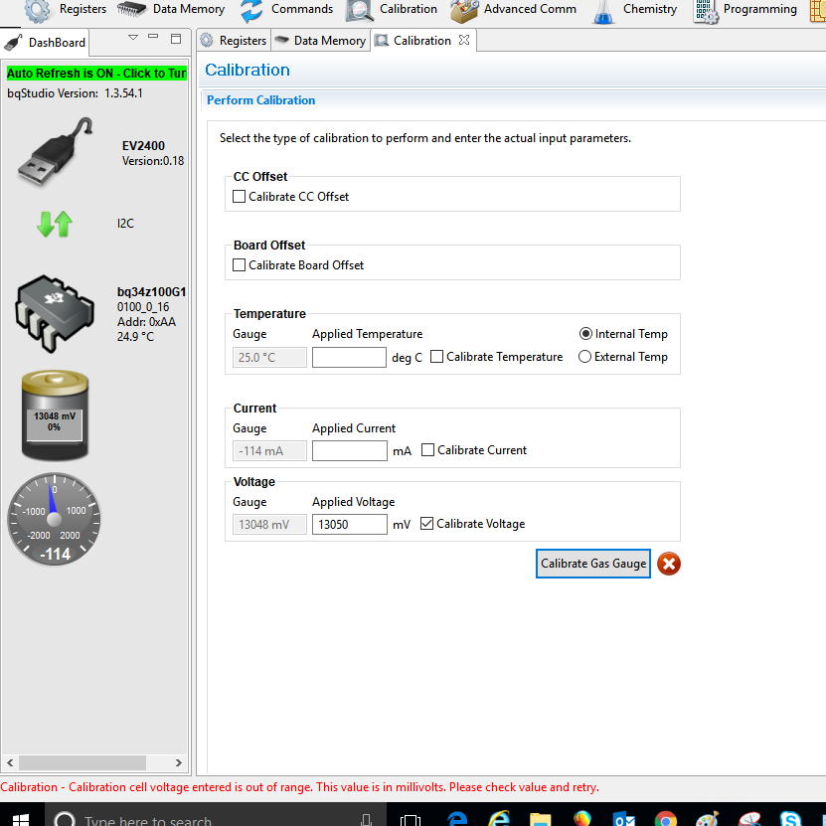

When I enter the battery voltage I measure, it complains about it being out of range. This has been very consistently happening. I tried to change the value to something really low but it always reports voltage as being out of range. What can be causing this?