I have used **TI WEBENCH® designs**to design a DC/DC TPS54531DDA

I'm getting different results when simulating Stability Analysis.

Once doing the simulation alone

Once when the tool offers me its stability components.

I inserted the components into my design, but I'm getting different results while simulating and when using the "Re Comp" tool

                I'm using 2 options for the feedback resistors. (2 feedback options)

•         Vout = 5.25

•         Vout = 4.00

The design has according to "Operating Values" DC Gain of 67[dB] and Phase Margin of 60[°] for Vout = 5.25[V]

The design has according to "Operating Values" DC Gain of 68[dB] and Phase Margin of 59[°] for Vout = 4.00[V]

Please see image below (For the case of 5.25[V])

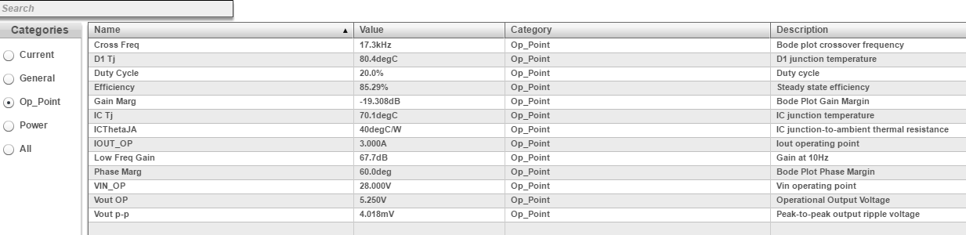

Can I ask you to check that, and if so how can I point you to the Link?

If not here is an image of my design

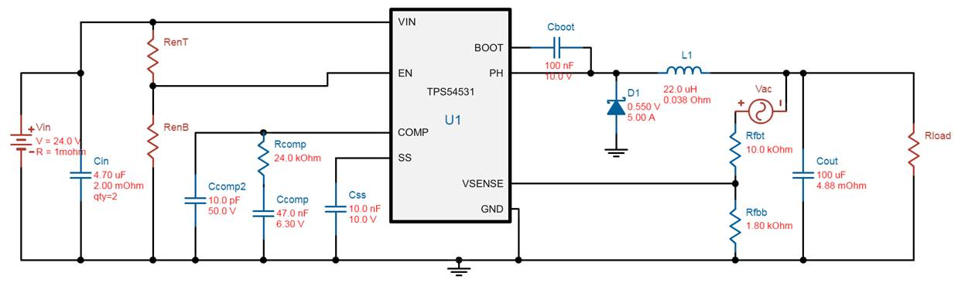

Input Voltage = 24[V]

Output Voltage Option A = 5.25[V]

Output Voltage Option A = 4.00[V]

Current Consumption 3[A]

If any information is needed please advise.