Your tool is broken. First, your documentation Slua359 indicates that I can enter 4 values such as

“10 32 54 76”

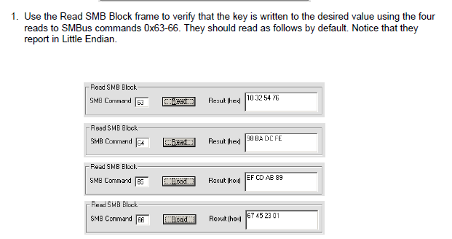

Using you tool I can only input 6 characters with no spaces, I can not enter the last two.

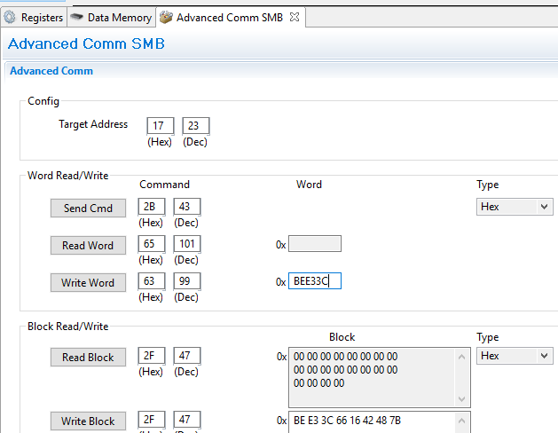

If I try to use Block Read and Write, no matter what I enter, it only reads all zeroes. I don’t even see the default values

I am being told each time that the operation is successful

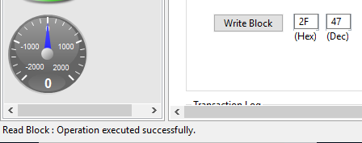

What’s wrong with this system?