Why does the ZVS behaviour of the two legs of the bridge differ. ?
This is because there is a significant difference in the circuit configuration for the PA (Passive to Active) and AP (Active to Passive) transitions.
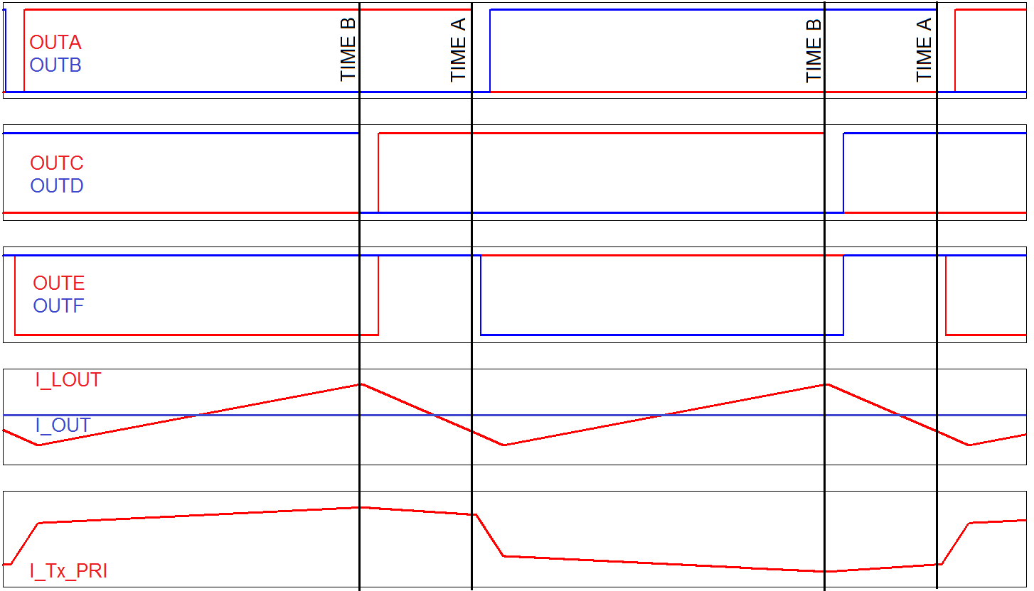
Consider the PA transition, these happen at the start of a power transfer cycle and are marked TIME A above. During the freewheeling interval just prior to the PA transition the transformer is short circuited on the secondary by the SRs (or Diodes) and on the primary by QA and QC or QB and QD. The consequence of this is that the transformer voltage is clamped at zero and only the energy stored in the shim inductance (L_{S}) of the primary circuit is available to drive the transition. This energy is given by:
$$E_{PA}= \frac{1}{2} L_{S} {\left(I_{MAG_PK}+I_{LOUT_MIN}\frac{N_{S}}{N_{P}}\right)}^{2}$$
the PA transition, the transformer is not short circuited and as a result the energy in the shim, magnetizing and output inductors all contribute to driving the ZVS transition. This energy is given by: The AP transitions happen at the end of a power transfer cycle and are marked TIME B above. Unlike
$$E_{AP}= \frac{1}{2} L_{S} {\left(I_{MAG_PK}+I_{LOUT_MAX}\frac{N_{S}}{N_{P}}\right)}^{2}+ \frac{1}{2} L_{OUT}{\left(\frac{N_{P}}{N_{S}}\right)}^{2} {\left(I_{LOUT_MAX}\frac{N_{S}}{N_{P}}\right)}^{2}+ \frac{1}{2} L_{MAG} {I_{MAG_PK}}^{2}$$
This asymmetry has a couple of consequences
- As the load current decreases the PA leg will lose ZVS before the AP leg because E_{PA} is always less than E_{AP}.
- The AP transition takes less time than the PA transition.
A PSFB circuit using diode rectification will behave the same as one using Synchronous Rectification.
Centre tapped, current doubler and single winding secondaries will all exhibit this behaviour.

