**Dear WM:**

In the document of " tiduc43a 20-Series Battery Management Module Reference Design", Figure 7 as follow:

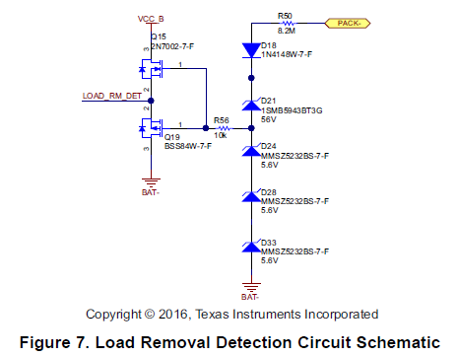

Is the circuit suitable for load wake-up?

If the battery is 16 s, Is D21,D24,D28,D33 steady voltage equal to the total battery voltage? How to choose?

Can D24, D28,D33 replace it with a zener diode ?

Why D21 package is SMB,SMA is ok?